J.R. Tucker Lighting Console Guidebook

Author: Jacob Sherrod

Last updated: April 2023

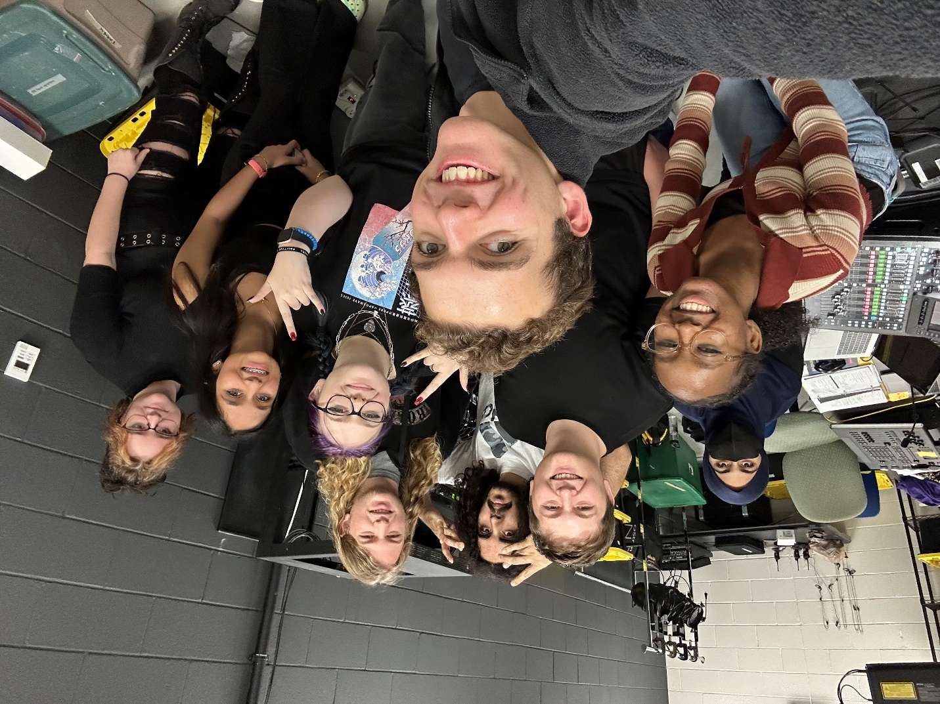
↑ This MF right here ↑

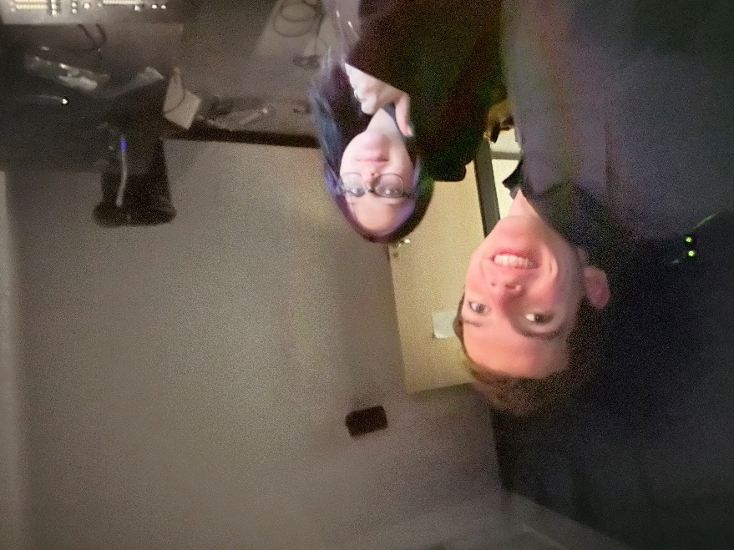
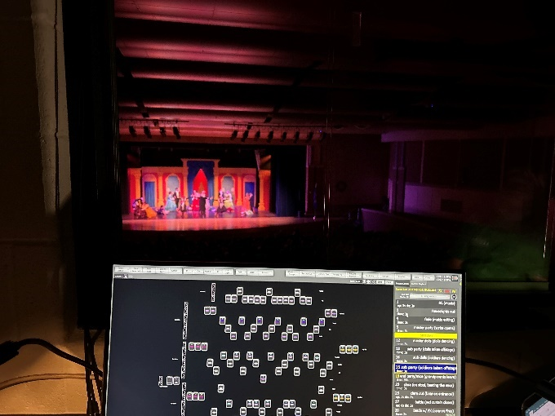
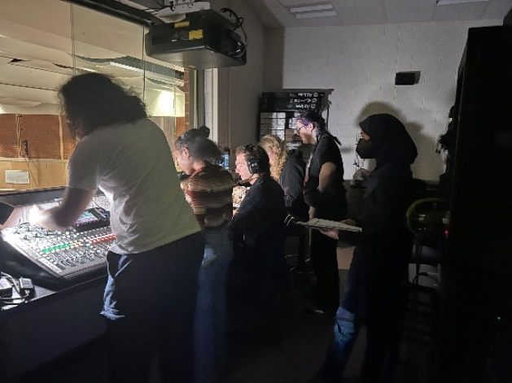
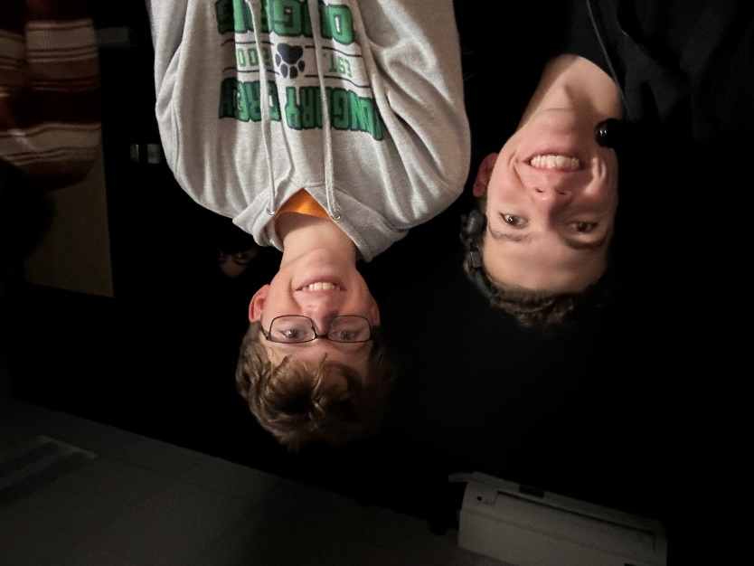
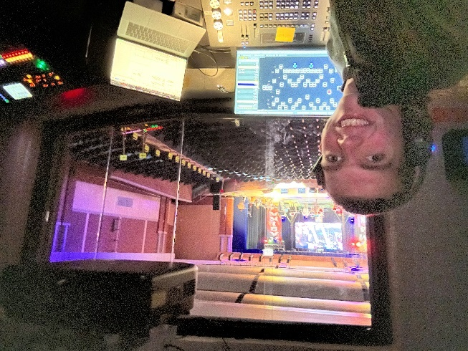
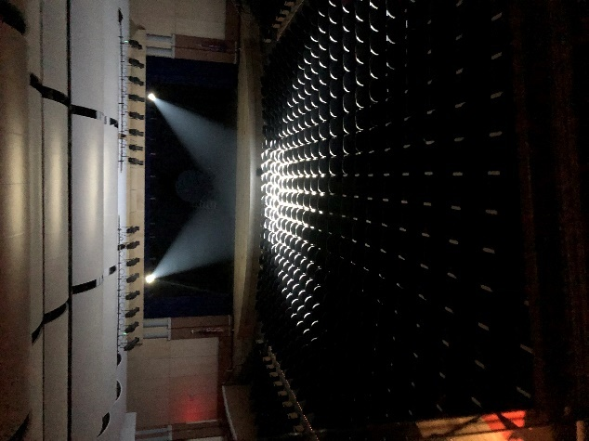

Contents

J.R. Tucker Lighting Console Guidebook 1
Contents 3
General 6
About this guidebook 7
The Tucker operational model 8
Varilite 8
Our fixtures 8
Normal operations 8
Using the console 9
File system 9
Console Diagrams 10
What does this do? 12
Console Windows 12
Live 20
Views 20
Options Specific to Live Views 27
Sidebar Cue List 32
Fixture Control 33
Generic Color Chooser 39
Go & Stop 41
Main Functions 42
Selection/Attributes 45
Park & Release 50
Undo 51
Record & Update 52
FX Library 56
Copy 57
Blind 59
Groups 60
Group Options 61
Recording Groups 63
Group Detail 65
Live Groups 65
Cue List 66
Cue List 66
Cue List Properties 67
Cue List Detail 71
FX List 73
Palettes 74
Live Palettes 76
Patch 77
Channel Chart 77
DMX Universes 80
Fixture Library 80
Function Groups 80
Cue Playbacks 84
FX Playbacks 85
Macro Editor 86
DMX View 87
Submasters 88
Shortcuts 91
More 92
Control Panel 99
Options 104
System Properties 105
I know what I want to do; how do I do it? 116
Turning the board on and off 116
Creating a new showfile 116
Starting a new show 116
Operating a show 116
Index 118

General

About this guidebook
- This should be a living document – update it to meet your needs and reflect your knowledge.
- This guidebook is organised into four parts. First, the General section is just good information to have. How do I do it? contains information on how to achieve desired operations. What does this do? is a list of all console functions and their descriptions. Finally, Index is a reference portion for all of the terms. This guidebook is for the light board in the Tucker auditorium only.
- Command line information is written with nonbreaking spaces, inserted through CTRL + SHIFT + SPACE in Word.
- Most command line shortcuts are outside of the scope of this guidebook, as is anything that I feel that I wouldn’t use in a million years while working at Tucker.
- Many of the screenshots were taken on the equivalent PC software, so the layout/images may be slightly different, but the functions are the same.
- In the header, this text: “File” ‘.filetype’ Screen Option Console Button [Command line] describes the formatting. A file in the system will, for example, have quotation marks around it.
- The console buttons are basically just shortcuts to add text to the command line; that is why, for example, [Update] and Update are used interchangeably, as they have the exact same function. Pressing certain buttons may change the command line input to something that looks strange, but rest assured, it will almost always work as intended. However, sometimes the command line will need to be clicked to allow for certain keyboard inputs, including the input of non-capital letters.
- Pressing Ctrl+click on any figure label transports the user to that figure, which is why they are used ubiquitously throughout this document.
- The word section is used exclusively for the main sections found on the bottom of the screen; other words are somewhat interchangeable.
- On the command line popups, there are numbers — I wrote most of these down, but I don’t know how to use them to access the things contained in the popups or how, in some cases, to choose the mode that I want for me when trying to use the command line popups. This may be related to the fact that all of my settings say Cue Only and Active Recording, so the console may not want to change it up on me accidentally.
- I will not comment too much on the color changes possible in System Properties; this would have made the guidebook so much harder to write so I will just ignore them.

The Tucker operational model

Varilite
- Here at Tucker, our lighting system is designed around Varilite products. They own many brands, including the brands that make our lights; Strand, which makes our console and the two network nodes; and Vision.net, which produces the architectural lighting controls and the TOM lightbox. Their support, and assistance given from the county, can be spotty, so it falls on students to maintain the systems with which we have been entrusted.

Our fixtures
- Fixtures (lights) have attributes, which can include intensity (brightness), position, color, etc. Not all of the fixtures have all of the attributes. Our lights run off of a networking standard called DMX; DMX information moves along the network in ‘packets.’ One channel of DMX encodes for one attribute about one fixture, for example, intensity, color, or position. One desk channel is basically a grouping of one or many DMX channels. One universe of DMX has 512 DMX channels, because the dipswitches for lights have 512 options for their address: $2^{8} = 512$ . Some of the fixtures have special screens that are used instead of the dipswitches to indicate Up to 30 lights can be daisy-chained together with DMX cables, which are quite similar, and somewhat interchangeable with, 5-pin XLR cables. Only the center here pins carry data: the fourth and fifth pins are just extra.
- Our board has 10 universes but is only authorized to run 4. We can get around this limitation because most of our lights are Varilite products. This means that we are allowed to assign Varilite fixtures to universes that we otherwise would not be able to use. These universes are sent over a single Ethernet cable via a standard called sACN (streaming Art Control Network). We are authorized to patch more fixtures into the first four DMX universes (1-4); the next six (5-10) are Strand Advantage, which we can only use because they have only Varilite fixtures patched to them. The toggle for this is located in System Properties (Figure 163). Our network runs on StrandNet, which allows it to talk to the Vision.net stations and the TOM box.
- Some of our fixtures are slightly mispatched — namely, the COLORado Q40s — because there is not an option in the Fixture Library (Figure 127) for them; this leads to some issues with the color of these fixtures not matching with what the console thinks it is outputting. They are blue-shifted, so they think of white as blue, and so on and so forth.
- Our fixtures are hung on electrics. There are four numbered electrics over the stage, with numbers increasing as they get closer to the back wall, plus the FOH 1 and 2 electrics and the tormentors. The tormentors, which are on the side, have nothing hung on them.

Normal operations
- Productions in the auditorium that involve stage lighting usually follow a cuelist-based programming model. We program the lights that we want for the first look and record them in cue 1. We then program the second look and record it in cue 2. Cue numbers can be decimals and can start at 0 (which is not recommended due to software issues) and go to 999999.999. We normally stay within the confines of a single cue list. Additionally, the lights that we have are most often more than sufficient to illuminate the stage, so we don’t often patch additional fixtures into the board. Changes to this model can be and have been made, but most productions do not require a great deal of deviation.
- One important deviation from that model is the use of submasters for mid-level productions such as the one-act festival. Channels and attributes are stored in submasters for at-will adjustment.
- We run the console in cue-only mode, on which more is explained in Figure 42. Most of our lights do not have separate dimmers, as they are intelligent lights with internal dimmers; only the house and aisle lights have separate dimmers.
- If the console’s registration key is lost, and it tries to say that DMX output will be lost in however many minutes, turn the console on and off again.

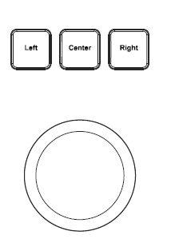
Using the console
Figure 1
Trackpad
- The board is designed around the GUI (Graphical User Interface); i.e., all operations can be achieved by clicking a button on the screen. These buttons can also be activated with the trackball (Figure 1); Left means left click, and so on and so forth. Right means right click, but a right click can also be achieved by touching and holding on the GUI. Additionally, common operations have buttons located on the physical console. Finally, most operations can also be achieved by typing commands into the command line; however, after a certain level of complexity, it becomes faster to use the touchscreen to select options, rather than try and remember all of the different commands and numbers for command line operation. It is most efficient to use a combination of touchscreen options, console buttons, trackball and mouse operation, and keyboard keys to achieve the desired effects.
- The encoder wheels and submaster controls (especially 7-10) do not work very well, and it is often preferable to adjust those data types via the GUI.
- The mouse wireless connector is connected to the top of the console, and the mouse lives behind the screen when not in use.

File system
- User-created files and programs are to be stored in the Documents folder. Showfiles have the .NEO file prefix. Magic sheets, which are the diagrams of the stage lighting, are stored with the .MSF file prefix. The active show, which is somewhat of a showfile where unsaved changes are temporarily stored, uses the .FDB file suffix. .NPS holds packed showfiles, which are like showfiles but with the console’s settings included.
- The NEO console runs on Windows 7.

Console Diagrams
(Figure 2 & Figure 3)
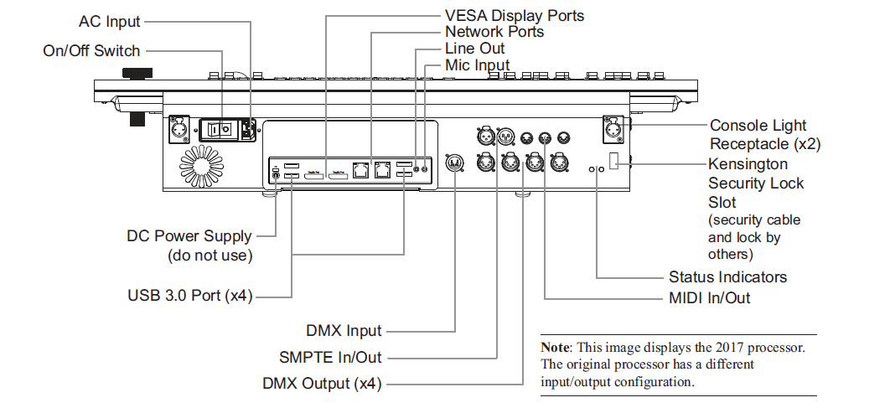
Figure 2

Out of all of these ports, we use the AC Input (IEC to Edison connector plugged into APC battery backup), On/Off Switch, Littlite Light Receptacles, one of the DisplayPorts (connected to touchscreen monitor), two MIDI cables connected to the sound board, and the Ethernet RJ-45 network connectors (one running behind sound board and through the hole in desk connected to the red internet jack below there and one connected to the ‘lighting network’ jack next to TOM box). Finally, we have a USB wireless mouse, stored on top of the screen mount, that connects to a USB port on the top of the console as shown in Figure 3.
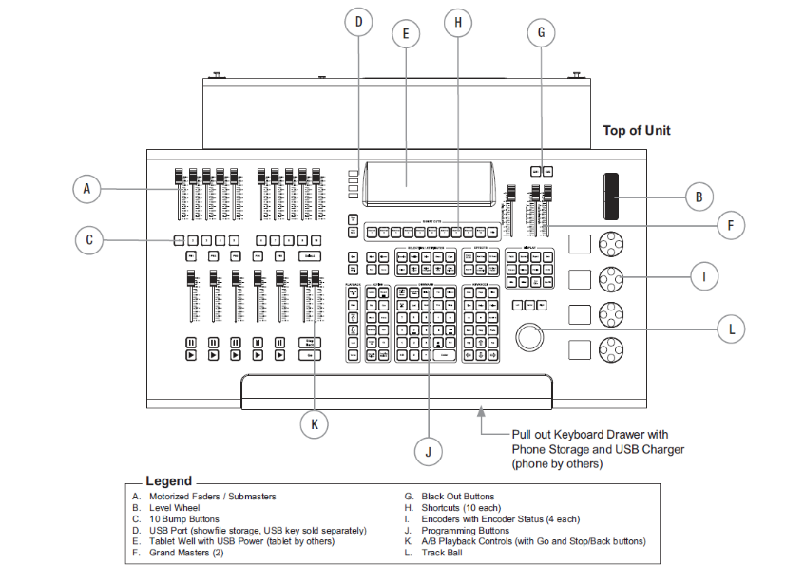
Figure 3

- 10 Motorized Faders / Submasters are discussed in Figure 140.
- Level Wheel can be used to change the intensity of selected fixtures or change numbers in a number entry field. It is discussed in greater depth in Figure 142.
- 10 Bump Buttons, when pressed, can bump the submasters (0) to their full level. They are discussed in greater depth in Figure 140.
- 4 USB Ports are identical to those seen in Figure 2.
- Tablet Well is a good place for sticky notes related to the current show.
- 2 Grand Masters (GM) can be assigned to many groups of lights. At Tucker, we assigned GM 1 to the house lights and GM 2 to lights 3 through 500; this means that channel 2, the aisle lights, is assigned to neither. They are discussed in greater depth in Figure 142.
- Black Out Buttons are like the bump buttons from C but for the grandmasters. They are discussed in greater depth in Figure 142.
- 10 Shortcuts are buttons used to engage shortcuts and are discussed in Figure 143.
- Encoders with Encoder Status can be used to change fixture attributes. The screens next to them display what is being changed and its level.
- Programming Buttons are described elsewhere in this guidebook.
- A/B Playback Faders are user-customizable.
- Track Ball is pictured in Figure 1.
- The Master Fade Time slider, in between the Grandmasters (F) and Shortcuts (H), is used to increase the fade time of user-inputted lighting changes. It is on a non-linear scale.
- The Pull out Keyboard Drawer is somewhat of a secret. Further, there is another USB port in there. We store the flash drive with the default showfiles and magic sheets here, along with sticky notes. Writing utensils are no longer stored here, as we lost some highlighters when we shipped back the old console; we now store them on the ledge below the window.

What does this do?

Console Windows
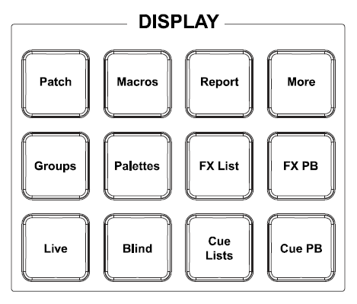
The lighting console is organised into 15 different sections, most of which are accessible by the function (F1-F12) keys on the keyboard. On the GUI, their function key shortcut is listed in the upper left corner of the section buttons, if applicable.
Figure 4
Display keys
All of the sections have their own section in this guidebook, but some may just be references to other sections for ease of access to information.
Further, the console’s display keys (Figure 4) can be pressed to open that section. They are listed here for searchability: Patch, Macros, Report, More, Groups, Palettes, FX List, FX PB, Live, Blind, Cue Lists, and Cue PB. Report does not open a section, but instead pulls up the Reports screen (Figure 150).
Description | Picture
For the sections that take up the whole window, on the bottom are the buttons to access the different sections, while on the top are the buttons to access section-specific functions. On the very bottom of all of the sections, links to the other sections are listed (ones that don't fit are moved into the More (Figure 19) display). On top of that, there is, in order from right to left, the NEO logo, a live vs. blind mode indicator, a Q: symbol for the current cue, and the command line. The Demo mode seen between the command line and the next options is only applicable to NEO for PC, which is where the screenshots are being taken.
Figure 5
Bottom of Screen
- Master Fade Time allows the user to adjust the Master Fade Time Slider (Figure 142).
- Shortcut Page allows the user to adjust the shortcuts being activated when a Shortcut Button (Figure 3) is pressed. Having this field at 0 would allow the user to activate shortcuts 1 through 10, while having it at 1 would allow shortcuts 11 through 20 to be activated, and so on and so forth. Submaster Page is the same, but for the submaster sliders (Figure 3), while Playback Page is the same, but for the playback sliders (Figure 3).

To the extreme top right, the console has a green arrow saying Window Layout Manager. This function is described more in Figure 155.
The Live (Figure 6) view is the most important and is where most of the time programming is spent.  Please see Figure 21 for more information. | 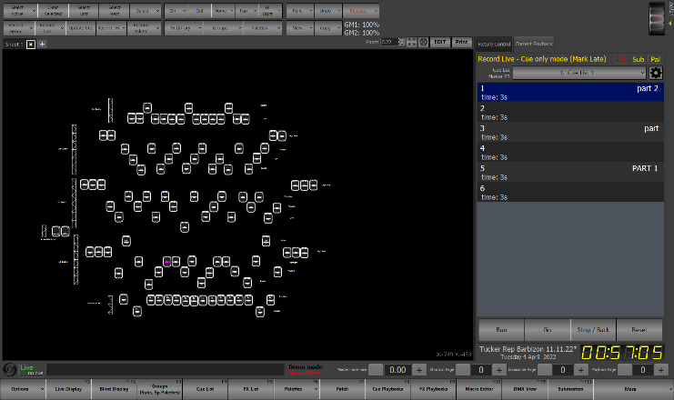  Figure 6  Live
The Blind (Figure 7) view allows the user to do most of the same things as in the Live view. However, making changes to the current cue in blind automatically updates the cue without the need to record it.  Please see Figure 95 for more information. | 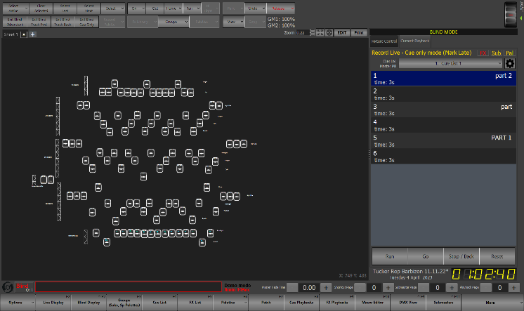  Figure 7  Blind
The Groups (Figure 8) display shows all of the groups in the current show file.  Please see Figure 96 for more information. | 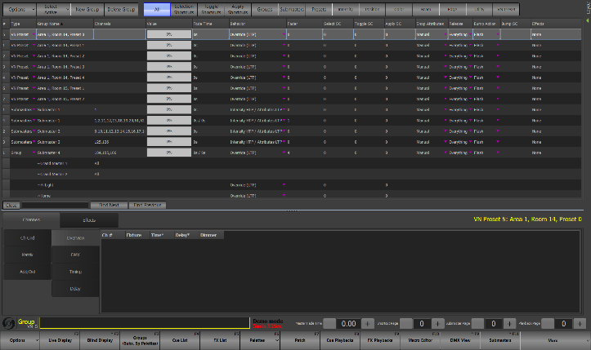  Figure 8  Groups
The Cue List (Figure 9) display shows all of the cues in the current cue list in the current show file.  Please see Figure 106 for more information. | 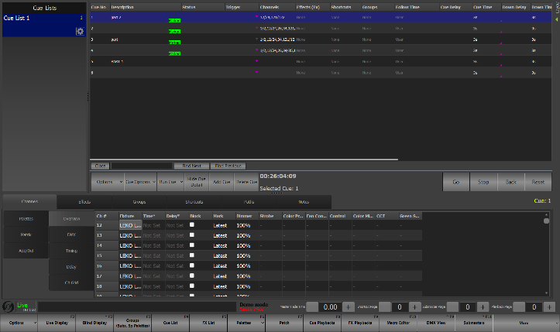  Figure 9  Cue List
The FX List (Figure 10) window helps to create and control effects.  Please see Figure 115 for more information. | 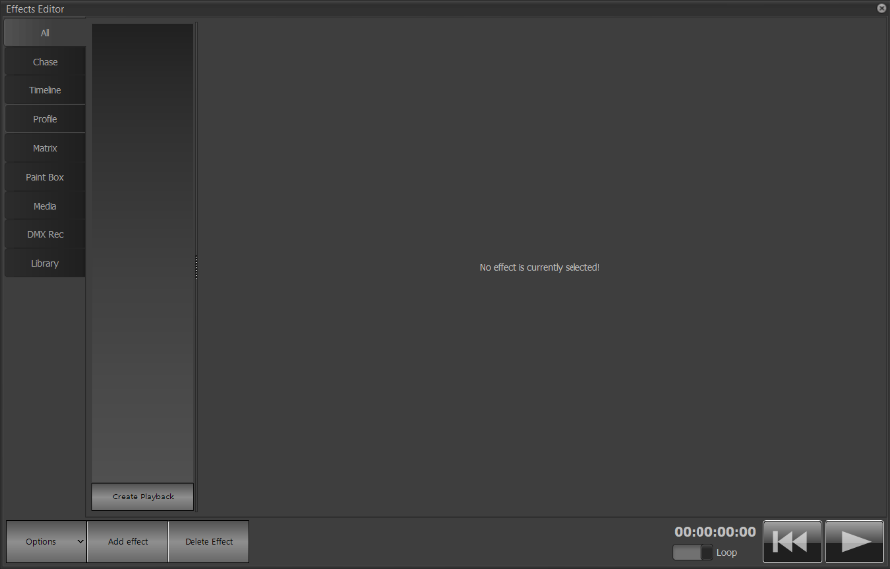  Figure 10  FX List
The Palettes (Figure 11) window allows the user to view, edit, and record palettes.  Please see Figure 116 for more information. | 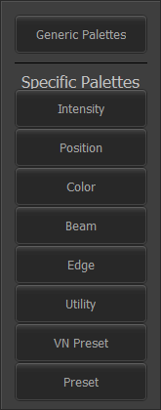  Figure 11  Palettes
The Patch (Figure 12) is perhaps the most dangerous window for the user to be in. It allows the user to change the networking of fixtures on the network, thus having the most potential to cause problems. When leaving this window while not having attempted to make changes, always click Revert to last saved patch.  Please see Figure 122 for more information. | 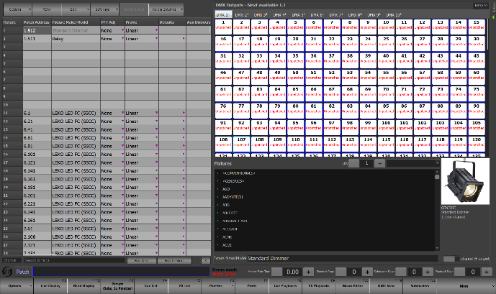  Figure 12  Patch
The Cue Playbacks (Figure 13) window allows the user to control cue playbacks.  Please see Figure 133 for more information. | 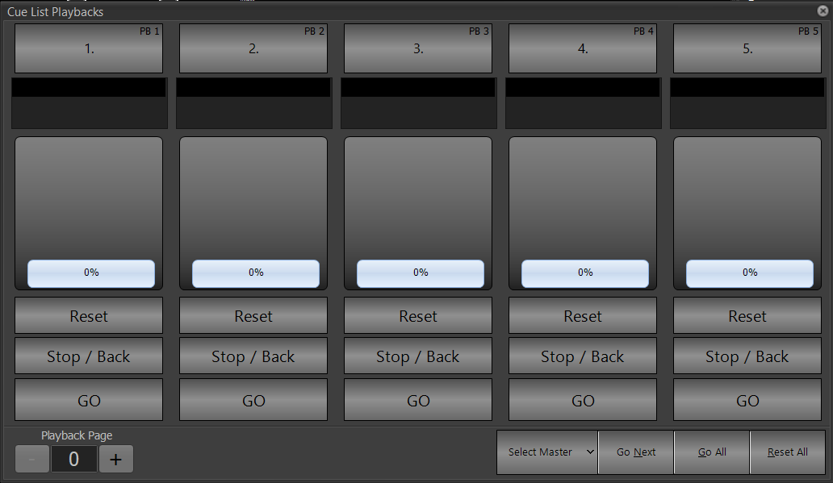  Figure 13  Cue Playbacks
The FX Playbacks (Figure 14) window allows the user to control and create effects.  Please see Figure 134 for more information. | 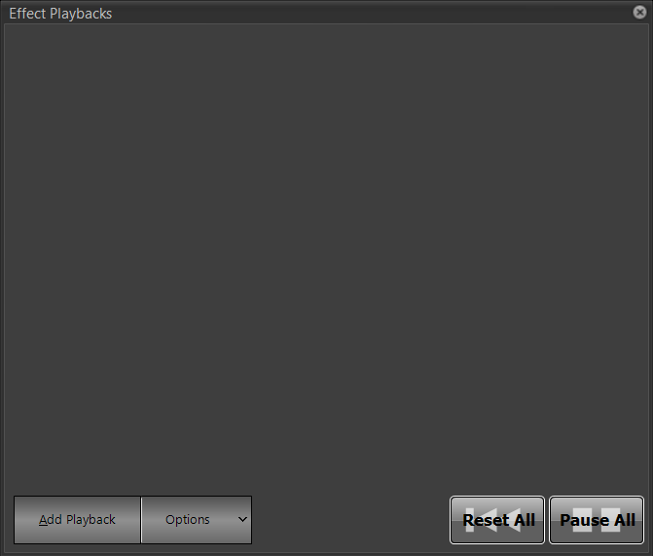  Figure 14  FX Playbacks
The Macro Editor (Figure 15) window allows the user to create complex programming and operation shortcuts.  Please see Figure 136 for more information. | 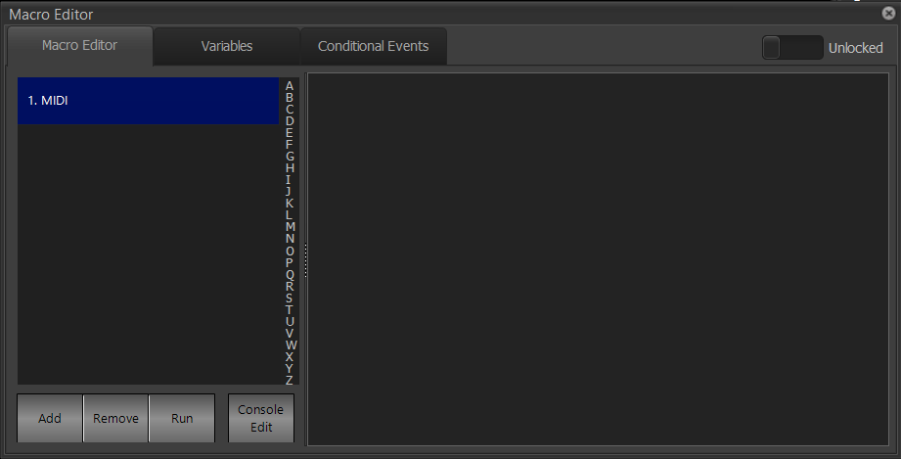  Figure 15  Macro Editor
The DMX View window (Figure 16) allows the user to see all of the DMX universes that are being received and output by the console.  Please see Figure 137 for more information. | 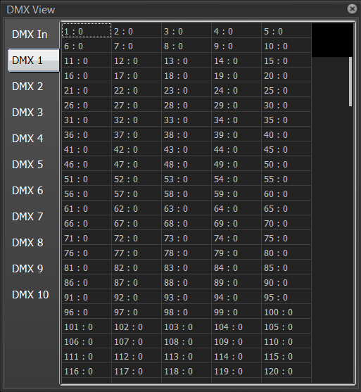  Figure 16  DMX View
The Submasters window (Figure 17) allows the user to see the state of various submasters. Please see Figure 138 for more information. | 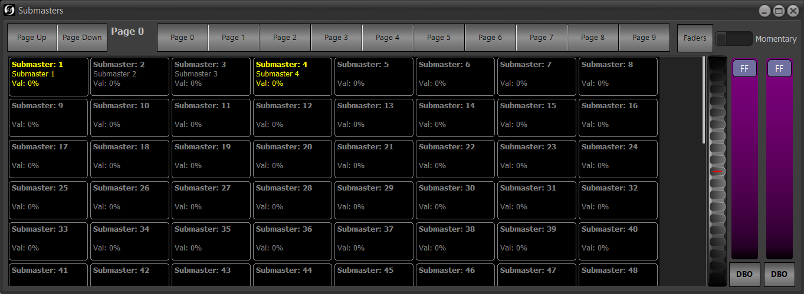  Figure 17  Submasters
The Shortcuts (Figure 18) window allows the user to see the shortcuts that they have made.  Please see Figure 143 for more information. | 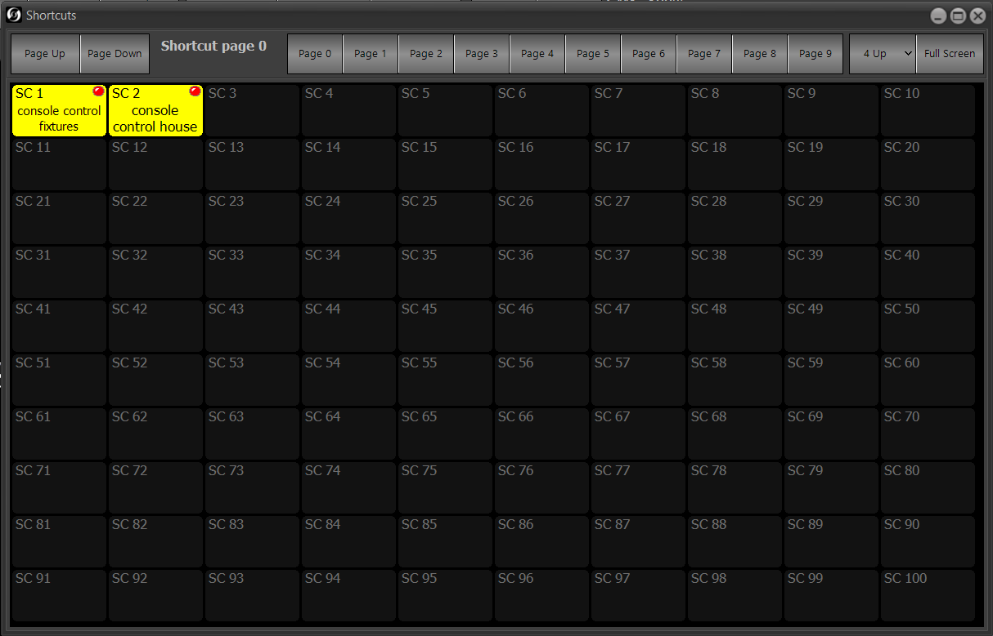  Figure 18  Shortcuts
The More (Figure 19) window allows the user to access many console options. Please see Figure 146 for more information. | 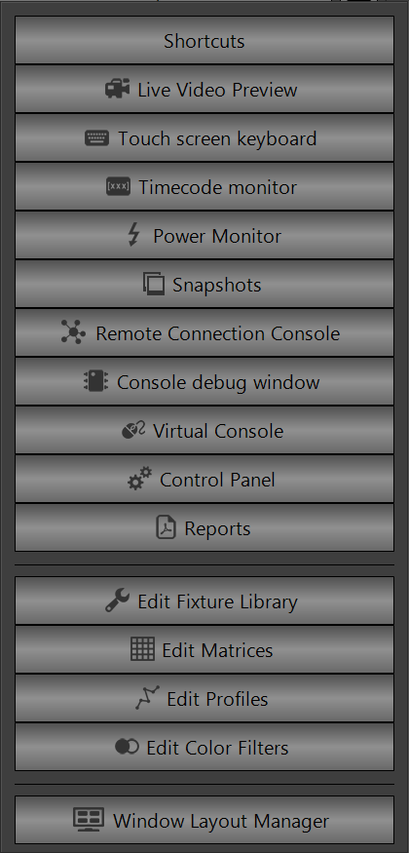  Figure 19  More
The Options (Figure 20) window allows the user to access multiple options, including the option to turn off the console. Please see Figure 161 for more information. | 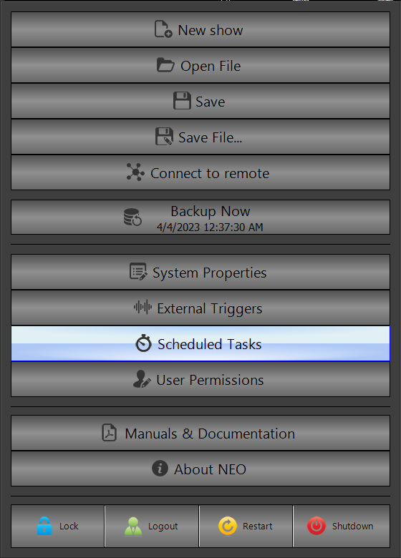  Figure 20  Options

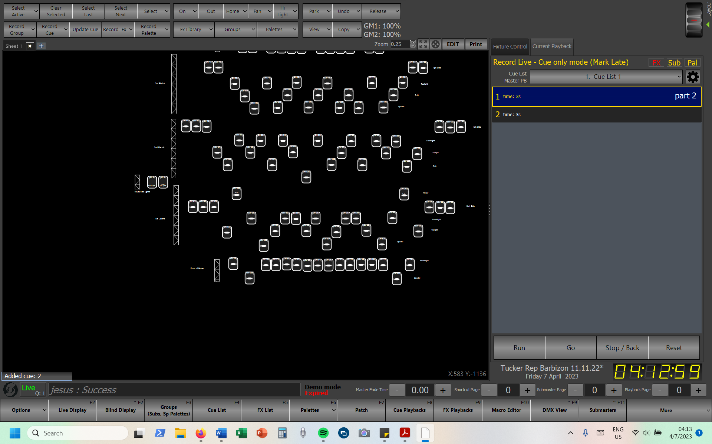
Live
Figure 21
Live
In the Live View, the function groups described below are at the top. On the side is the sidebar cue list/fixture control (Figure 42), while in the middle is the customizable view.

Views
(Figure 22)
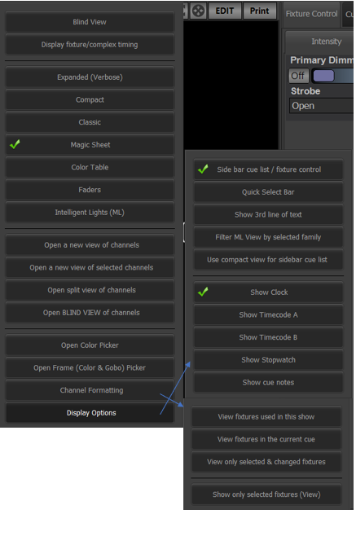
- Blind View brings the user to the Blind section (Figure 95).
Figure 22
View Options
(both right-side windows not displayable at same time)
- Display fixture/complex timing puts the user in a Classic view with a yellow sign over the cue list (Figure 42) saying Fixture Timing Mode (not pictured). It apparently allows the user to change the time between cues in a complex manner. However, this is not necessary for what we do at Tucker.
- The list of view types is discussed in the chart below.
- Open a new view of channels opens a popup (not pictured) that allows the user to open an entirely new window of a selected view over the Live view; selecting one of the options will put that window on the top of the current view; the size of the window can be changed at will. Open a new view of selected channels does the same, but only with the currently selected lights.
- Open split view of channels allows the user to split the screen between the current view and one of the four channel-based views: Expanded (Verbose), Compact, Classic, and Intelligent Lights (ML).
- Open Blind View of channels opens a window allowing you to specify what type of view you would like to enter Blind (Figure 95) mode in; however, I see no reason to use this.
- Open Color Picker opens the Generic Color Chooser (Figure 52-Figure 60).
- Open Frame (Color & Gobo) Picker opens a window (not pictured) with a list of all the preprogrammed colors and gobos.
- Channel Formatting opens a list of options to the bottom right of the window in Figure 22; however, both windows are not displayable at the same time in the software. All of the options below open up a textbox over the sidebar (Figure 42) describing what they do and stay true until deselected.
  - View fixtures used in this show will remove any fixtures without data in the current show, unless the Magic Sheet (Figure 28) view is open.
  - View fixtures in the current cue is a poorly understood, and/or glitchy, option that will display only those fixtures, other than those in the Magic Sheet (Figure 28), which have data in the currently-running cue.
  - View only selected and changed fixtures displays any fixtures, other than those in the Magic Sheet (Figure 28), which were changed from the cue, submaster, etc. instruction and/or changed.
  - Show only selected fixtures (View) displays only those fixtures that have been selected; this is of course, only applicable outside of the Magic Sheet (Figure 28).
- Display Options opens a list of options to the bottom right of the window in Figure 22; however, both windows are not displayable at the same time in the software.
  - Side bar cue list / fixture control opens up the side bar cue list and fixture control bar, pictured in Figure 42. This option is selected by default and is highly recommended.
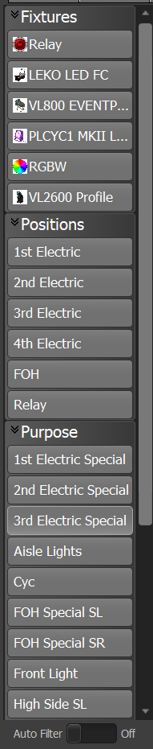
  - Quick select bar opens up another sidebar on the left, as pictured in Figure 23. It allows the user to select fixtures by the fixture type (Fixtures), position (Position), or purpose (Purpose) as identified in the Patch section (Figure 122). It allows the user to select a subset of fixtures; for example, selecting 3rd electric and High Side SL would only select the high side lights on stage left on the third electric. Color and Generic also refer to columns in the channel chart, but are not used at Tucker. The Auto Filter toggle turns on View only selected and changed fixtures from Figure 22.
Figure 23
Quick Select Bar
  - Show 3rd line of text is an option that, when selected, allows the Position, Unit Number, Purpose, and Color Description fields from Patch (Figure 122) to populate into the Classic view.
  - Filter ML view by selected family allows the user to only see certain attribute families in the Intelligent Lights (ML) view, but it is unclear how to select an attribute to sort by.
  - Use compact view for sidebar cue list will display a smaller sidebar cue list/fixture control (Figure 42), so that more fixtures can be displayed.
  - Show Clock will show the clock on the bottom of the sidebar. This setting is on by default and highly recommended. When on, it displays below the cue list/fixture control in the sidebar (Figure 42).
  - Show Timecode A and Show Timecode B will display two (extremely vertically compressed) timecode counters below the clock in the sidebar cue list. They are used to monitor internal and external timecode — basically computerized clock data — and show it to the user.
  - Show Stopwatch will display a stopwatch (Figure 24) above the cue list in the sidebar (Figure 42). Its usage is self-explanatory.
Figure 24
Stopwatch
  - Show cue notes will show the cue notes from the Cue List (Figure 106) section below the cue list for the current cue.
  - Lock Cell Size and Enter the column count (not pictured) are options only available in Display options when in the Expanded (Verbose) or Compact views. The first one has an unclear function, but it seems that it just changes the cell height almost imperceptibly after scrolling. The second one gives a field (not pictured) that allows the user to enter the number of columns that they would like to see in the current view. When changed from the default, to, for example, be 20 columns wide, it displays Enter the column count (Current: 20). The issue with it is that it stays the same between the two views, so what may be overly narrow in one of the views could be overly wide in the other.
List of Views
Only patched fixture numbers show up in the Live section, except for the Faders (Figure 30) view, which displays all fixture numbers.
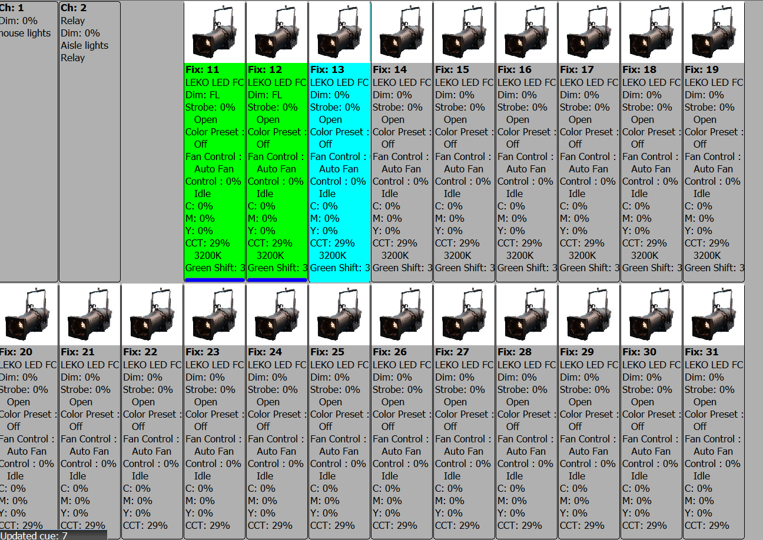  Figure 25  Expanded (Verbose) | The Expanded (Verbose) view (Figure 25) is where every attribute of a fixture can be seen, along with its picture. Green-highlighted fixtures with a blue bar along the bottom have an increased intensity, while blue-highlighted fixtures are selected. Additional information from the Channel Chart (Figure 123) window will be displayed here, if entered there.
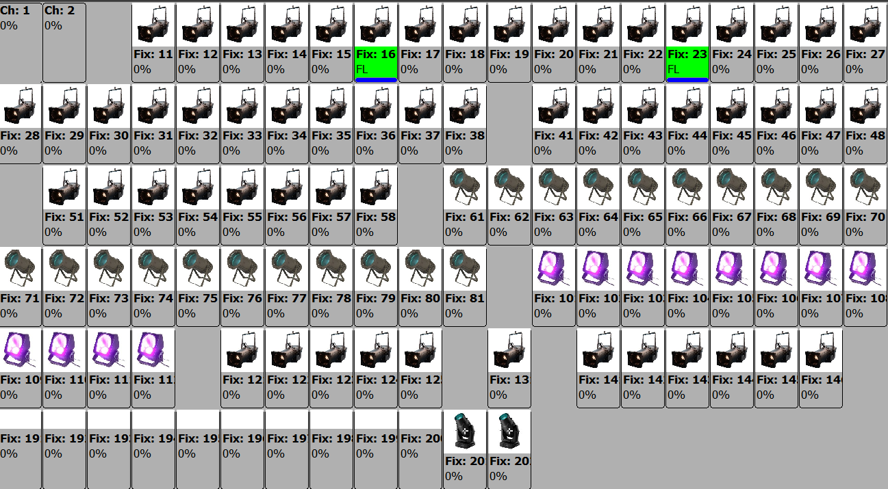  Figure 26  Compact | The Compact view (Figure 26) is less detailed than the first, with only fixture pictures and intensities displayed. However, the same blue and green highlight rules and blue bar rules apply here.
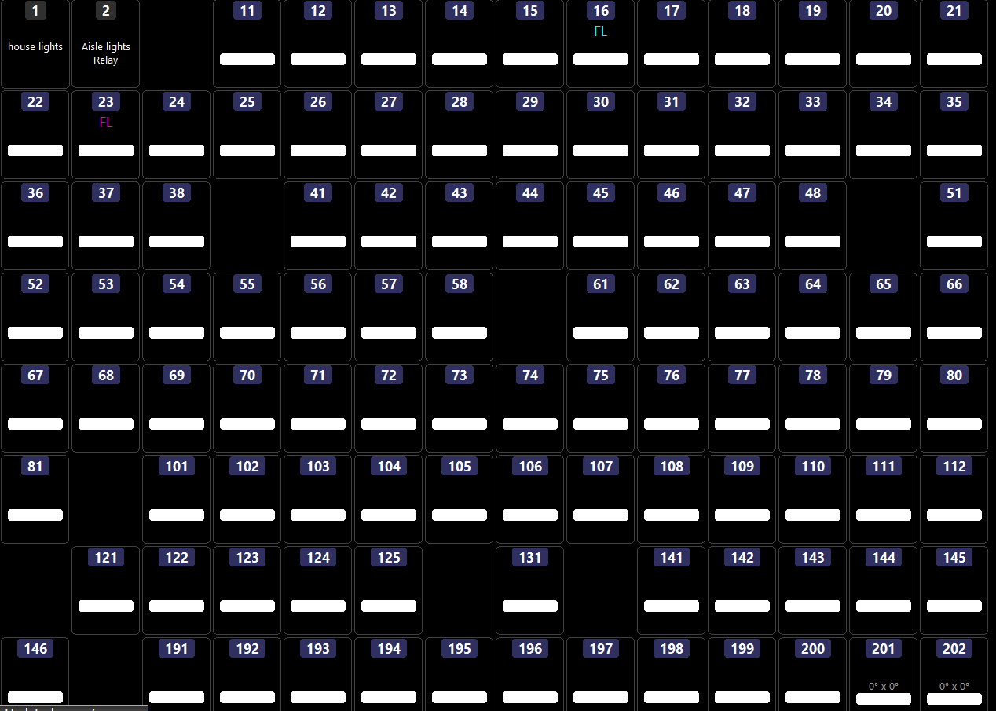  Figure 27  Classic | The Classic view (Figure 27) is most similar to that of the old Tucker console, an ETC Express 48/96, which is the console that freshman Jacob learned on, along with a junior named Tati; they received training from a senior named Asta. With Ayaan to run the sound board, they were all set.  Anyway, this view displays the color of a fixture in the bar on the bottom and the intensity in the middle. Selected fixtures are outlined in red. The rules for the fixture labelling are described below in Figure 41.
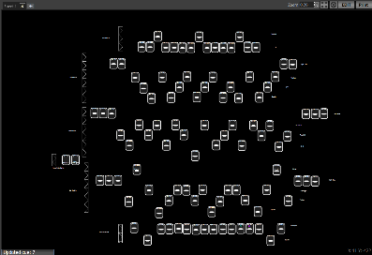  Figure 28  Magic Sheet | The Magic Sheet view (Figure 28) allows the user to customize (Figure 38) the layout of the lighting rig. More information is given below.  This view displays the color of a fixture in the bar on the bottom and the intensity in the middle. Selected fixtures are outlined in red. The rules for the fixture labelling are described below in Figure 41.
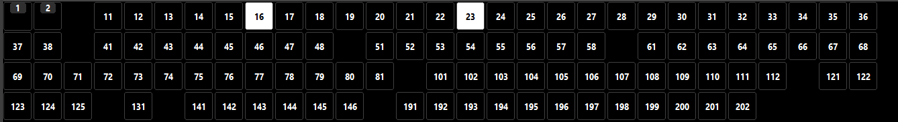  Figure 29  Color Table | The Color Table view (Figure 29) shows a list of fixture numbers and their respective colors. Selected fixtures are outlined in red.
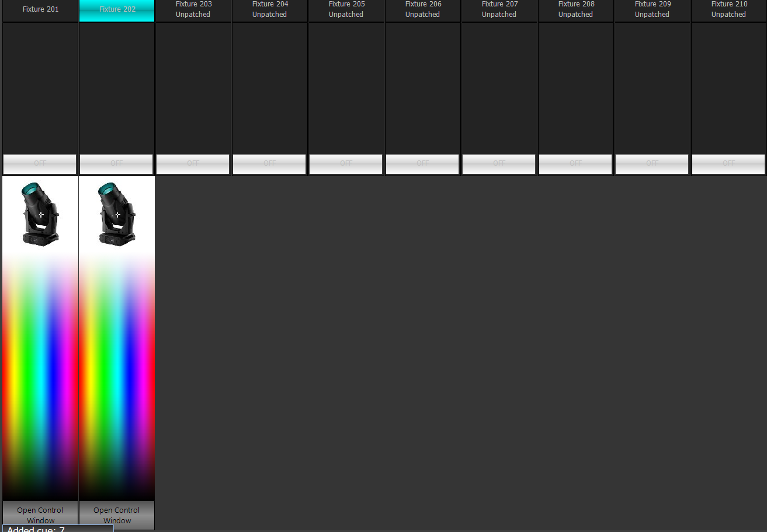  Figure 30  Faders | The Fader view (Figure 30) allows the user to se a list of ten fixtures. This is not really useful for us, but if desired, the Up and Down buttons, along with the Page entry box, allow the user to specify the list of ten fixtures that they would like to see. It displays all fixture numbers, not just those patched. The top white button can be used to drag intensity up and down. The fixture number will have a color behind it, showing the color that the user can pick off of the bottom color selector. Open Control Window opens the Fixture Control portion of Figure 42. Selected fixtures are not shown.
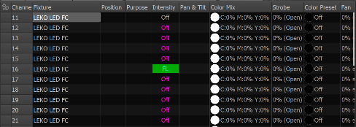  Figure 31  Intelligent Lights (ML) | The Intelligent Lights (ML) view (Figure 31) shows a tabled description of all the lights that have more than the intensity attribute; this includes every fixture at Tucker, except for the aisle and house lights. Selected portions of the chart have a white background.  The gear button in the corner opens up a popup as described in Figure 33.  Pressing the white box in the furthest-left column next to the name of the fixture type will expand/collapse all of the fixtures of that type. How this grouping is made is determined by the options in Figure 33.
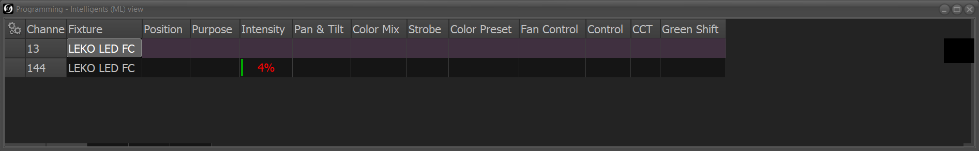  Figure 32  Programmer | This view is only available when choosing to open a new view of channels, or from the options of the previous view. It displays only fixture data that has been changed from the cue, submaster, etc.  It is similar to the previous view in that selected cells are white; however, rows with selected cells are maroon.

Options Specific to Live Views
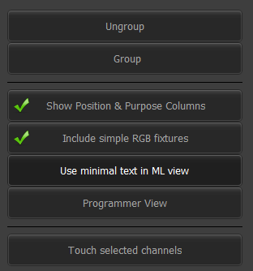
The options window opened by the gear in the top corner of the Intelligent Lights (ML) (Figure 31) view is pictured in Figure 33.
Figure 33
Intelligent Lights (ML) Options
- Ungroup ungroups all of the fixtures from one another.
- Group opens up a window (not pictured), allowing the fixtures to be grouped together by position, purpose, or fixture type, which are all things entered into the patch menu (Figure 123). When Include simple RGB fixtures is changed, the window opens changes to only allow fixtures to be grouped by fixture type.
- Show Position & Purpose Columns is a checkbox to display the position and purpose information, entered in the , in the fixture columns.
- Include simple RGB fixtures takes out fixtures that are patched as simple color-and-intensity fixtures from this view. Functionally for Tucker, this means that the Q40 panels would be removed from this view, as their patch data is not entirely correct.
- Use minimal text in ML view removes some of the text from things like the fan control column, making more columns visible and making the list easier to read for an experienced programmer.
- Programmer view displays only the fixtures that are selected and/or changed in a view similar, but not identical, to the Programmer view (Figure 32).
- Touch selected channels is discussed in Figure 64.
The Magic Sheet (Figure 28) can be customized to the preferences of the user. At Tucker, all fixtures that are on one electric are put next to each other, identified as being on the same electric by being next to a truss (Figure 38). All fixtures of the same type on an electric have their own row. Both the electric number and the fixture type are identified next to each row. The location of the fixture plot in relation to the viewscreen is shown in the X and Y display (Figure 34) in the bottom right corner of the Magic Sheet.
Figure 34
Magic Sheet X & Y
The Zoom (Figure 35) level is adjustable in the entry box in the top right of the Magic Sheet. The arrows beside it allow it to be adjusted up or down, depending on their direction. The next button, with the outward-facing arrows, allows the diagram to be fit to the size of the view screen. After that, the button with the inward-facing arrows opens up a window as seen in Figure 36. The function of the Edit button is described in Figure 38, while the Print (Figure 35) button is not useful at Tucker as we do not have an attached printer.
Figure 35
Zoom
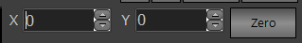
Figure 36: The X and Y entry boxes allow the user to specify the x- and y-values of the center of the magic sheet view, while the Zero key puts zeroes in those boxes, allowing for the magic sheet to return to its ‘home’ state. The box opens up with the current x- and y-values highlighted to allow for them to be replaced quickly.
Figure 36
Pan
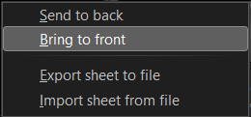
A new showfile will have only one Magic Sheet, called Sheet 1. Different sheet tabs can be made with the plus button to the right of the sheet label. A showfile must have at least one Magic Sheet. Right-clicking the Magic Sheet will open a dialog as seen in the bottom half of Figure 37. Clicking Send to back (Figure 37) will send selected objects on the sheet behind other items, while Bring to front will do the opposite. Export sheet to file saves the current layout in a selected folder with the .MSF prefix, while Import sheet from file will open up a new tab with the imported magic sheet; both of these use a file dialog (not pictured). Export to and import from “Default Magic Sheet.MSF” for consistency’s sake.
Figure 37
Magic Sheet Organisation
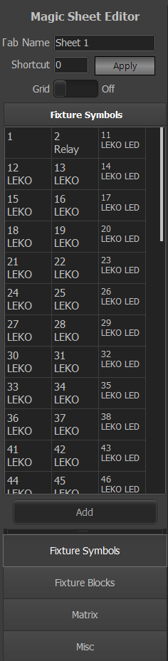
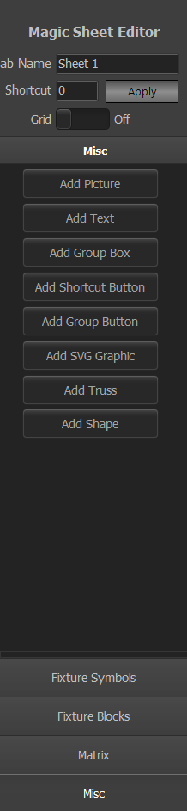
The Edit (Figure 35) button opens up windows as seen in Figure 38
Figure 38
Magic Sheet Edit Windows
- The window that is first opened up when the Edit (Figure 36) button is pressed is pictured on the right side of Figure 38. The tab can be renamed with the Tab Name box on the top. A shortcut can be applied — to do what, I do not know. The Grid switchbox will apply a grid of dots (not pictured) to the Magic Sheet, which can be helpful in aligning boxes; however, the dots change position and scale when the sheet is zoomed in or out, thus decreasing their usefulness. They also do not make the objects on the sheet ‘snap’ to them. When on or more objects are selected, a Delete Selected (not pictured) button appears, that allows the object to be deleted.
- On the bottom are four options for types of objects that can be added. The Add button above the list when the first two options are selected allows the fixture — only one can be added at a time — to be added to the Magic Sheet
  - Fixture Symbols opens up a list of all of the patched fixtures. When using this option, fixtures are added to the Magic Sheet with little diagrams of what they supposedly look like. It is pictured on the left in Figure 38. There is a window (not pictured) that opens on the Edit window that allows their position to be changed, along with making them small, medium, or large. The type of symbol that appears depends on the Fixture make / model column in the Channel Chart (Figure 123).
  - Fixture Blocks is the more useful of the two and is the option that we use at Tucker. It opens an identical list to the one pictured for Fixture Symbols and allows the addition of simple rectangles to represent fixtures to the Magic Sheet.
  - Matrix allows the user to add a matrix, but matrices are not useful to us at Tucker as I believe that they are for pixel mapping – the assignment of fixtures to video pixels.
  - Misc gives multiple options to the user for objects to add.
    - Add picture opens up a window (not pictured) allowing the user to select a picture to add to the Magic Sheet. Add SVG Graphic has a similar function, but for SVG graphics only, which seems weird.
    - Add Text allows the user to add text to the Magic Sheet. At Tucker, this is used to label the electrics and the fixture type for each electric.
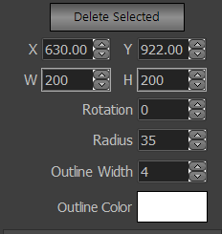
    - Add Group Box allows a box to be added to the Magic Sheet, and opens a window (Figure 39) on the Edit window (Figure 38).
Figure 39
Add Group Box
      - Delete Selected has a function as described in Figure 38.
      - X and Y allow the position in x- and y-values of the box on the sheet to be adjusted. W and H allow the width and height of the box, respectively, to be adjusted. Rotation allows the rotation, in degrees, of the box to be adjusted. Radius allows the box to become increasingly ovular. Outline Width adjusts the width of the outline of the box. Outline Color opens up a color window (not pictured) that allows the user to pick from a limited subset of colors for the outline of the box.
    - Add Shortcut Button opens up a window that allows the user to add a link to a shortcut on the sheet. Add Group Button does the same, but for groups.
    - Add Truss opens up a window (not pictured) that allows the user to enter a value for the length of a truss image to be added to the sheet. As the reader will remember, trusses are used at Tucker to demarcate the electrics. Interestingly, the truss can be resized after being put on the sheet, so the primary value entry is not as important.
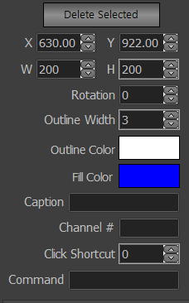
    - Add Shape opens up a window (not pictured) of a small list of shapes that can be added to the sheet. Selecting a shape opens up a window on the Edit window (Figure 38) seen in Figure 40.
Figure 40
Add Shape
      - X, Y, W, H, Rotation, Outline Width, and Outline Color have functions identical to those described in Figure 39. The exception is that Outline Width outlines the shape itself, and not a box. Caption allows the user to input text to be displayed to the upper left of the shape. Channel # allows the user to define a channel (only one) that the shape will select when the shape is clicked. Click Shortcut does the same thing, but for a shortcut. Command has an unclear function.

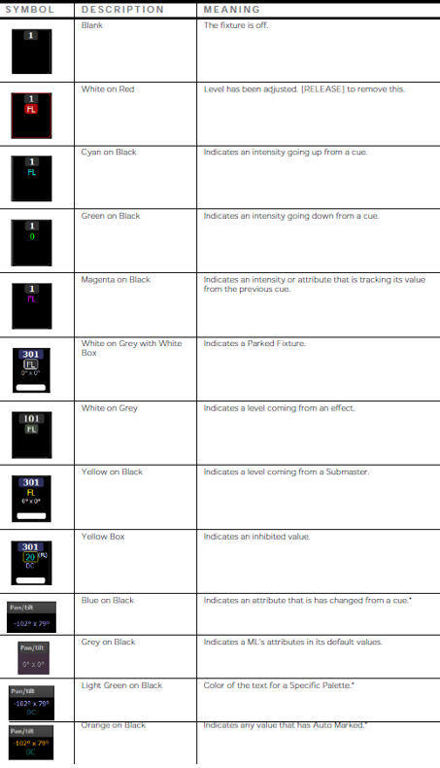
The symbology for certain views of the Live section is discussed in Figure 41. For example, a yellow box around a value means that that value is being limited by something; in this case, often a grandmaster being pulled down.
Figure 41
Fixture Labelling (screenshot from manual)
Often from a grandmaster. (Figure 117)
A cell showing a channel with a non-linear dimmer profile (Figure 125) will also list that in the cell.
The following sentence is included for searchability: the colors used here are white, red, blue/cyan, green, light green, black, magenta/purple, grey/gray, yellow, and orange.

Sidebar Cue List
(Figure 42)
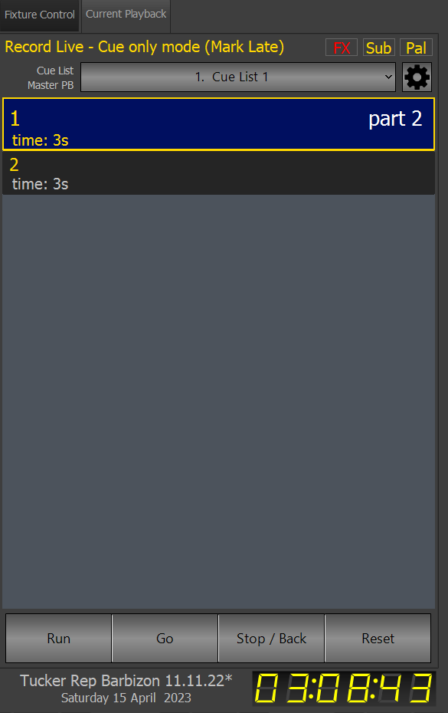
The sidebar cue list/fixture control, in conjunction with the Magic Sheet (Figure 28), is where the user will spend the majority of their time. The current cue is outlined in yellow, while the selected cue (or the cue loaded next with the Load button (Figure 62) ) is highlighted in blue. Right-clicking here will open up a dialog of options (not pictured) that are a small selection of what is offered in the Cue List (Figure 106) section. This window can be opened with Side bar cue list / fixture control in the Views (Figure 22) menu. The individual cue displays can be made smaller with Use compact view for sidebar cue list, also in the Views (Figure 22) menu. There are two parts to this screen: Current Playback, seen in Figure 42, and Fixture Control, seen in Figure 45. Display fixture/complex timing from the View dropdown (Figure 22) will display above the parts. If the option is not clicked, selecting a light in the Live section will cause a popup (not pictured) to appear for fixture control.
Figure 42
Sidebar Cue List
The following items are seen when Current Playback is selected.
- Record Live, at the top, is an indicator of what the console is recording. It can record active, selected, changed, and live. They are pretty self-explanatory, but I would recommend recording live.
- The mode indicator displays the recording mode for the cue list. Cues can be recorded in Tracking, Cue Only, Trackback, Smart Block and Block mode, but Cue Only is the simplest and most easily maintainable as it assumes nothing about other cues based on the current cue.
- In the parentheses is an indicator of the Mark mode. Mark Off, Mark Early, and Mark Late are the options, but I don’t know what they do.
- The red FX button determines whether running effects are included when cues are recorded; red means that they won’t be, while yellow means that they will. This can be changed by clicking the indicator or by marking Include running effects (Figure 87). Sub and Pal have the same function, but for submasters and palettes respectively.
- Below these are three indicators describing various behaviors of the cue list. To the left is an indicator for the playback faders (Figure 167), in the center is an identification of the current cue list, and to the right is a gear button that opens the Cue List Properties window (Figure 110).

- The following information describes Figure 43. Below that is the cue list. A cue that is currently running will have a green line that goes to the right across its top. If a non-3-second time is specified in either the Cue Time or Down Time windows in Figure 87, then two left-aligned lines will go across the screen. The top one, heading to the right, will be for the cue time; the bottom one, starting at the right and going to the left, will be for the down time. On the bottom of the cue, up: describes the Cue time; dn: describes the down time; and dly: separates the up and down time with a forward slash (not pictured), where the Cue Time is at the front and the Down Time is at the back. All of these values are editable in Figure 87.
Figure 43
Cue
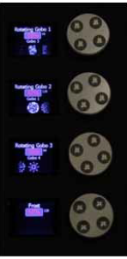
- Finally, at the bottom of the Current Playback screen, there are four buttons that allow the user to move between cues. Run, Go, Stop / Back, and Reset are discussed in Figure 61.
Figure 44
Encoders

Fixture Control

Encoder Wheels
(Figure 44)
The console will assign certain vital fixture variables to the Encoder wheels depending on which page of Fixture Control the user is on; their images also get assigned to the adjacent screens. At Tucker, all of the encoders have issues, but the best two are the top two. Oftentimes, pan and tilt will get assigned to one that works and one that doesn’t; in these cases I like to use the Level wheel to modify the text field assigned to the nonfunctioning encoder and use the functioning encoder for the other variable. Holding Shift (Figure 63) and oprating the encoders will allow them to control the attributes more finely. Every once in a while, when shutting down the console, a Looney Tunes cartoon will appear on the bottom encoder screen.

Intensity
(Figure 45)
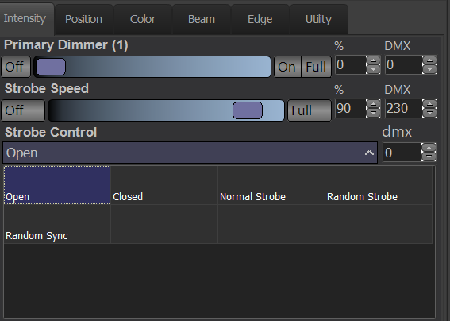
Fixtures are controlled, in general, with the sidebar in the Live (Figure 20) section. Click on Fixture Control and the screen pictured to the right (Figure 45) will appear. If Sidebar cue list / fixture control (Figure 22) is not enabled, then clicking on and attempting to control a fixture will produce a weird window (not pictured) without all of the same options as on the sidebar.
Figure 45
Intensity Control
Keep in mind that all of the fixture types have different options for control; the screenshots in this part of the guidebook were taken of the moving lights, which have the most controllable attributes and thus the most options here.
For all sliders in Fixture Control, Off moves the slider to a value of 0; I am not certain about this, but it does seem that On and Full do the same thing. % shows the percent out of a 100 of the attribute, while DMX shows the actual value being sent to the light; often out of 256. Text can be entered in the fields, the up and down arrows can be used to make minute adjustments, and the slider itself can be used to adjust the attribute.
- Primary Dimmer controls the light’s intensity, or brightness. Keep in mind that some lights at Tucker receive two feeds of DMX for their intensity, allowing for more minute adjustments; 65,535 is the total allowable DMX value in these cases as 256 x 256 = 65,535. Double-clicking a light will change it from 0 to 100 intensity and back again, while using the Level Wheel (Figure 3) or mouse scroll wheel can also change the intensity of selected fixtures. The Level Wheel’s sensitivity can be adjusted with Figure 168. Keep in mind that double-clicking does not work in Blind (Figure 94).
- Strobe Speed is separate from effects — data is sent to the lights telling them to make themselves flash, rather than the console sending a separate signal each time that it wants the light’s intensity to change — and this controls the speed of that. Strobe Control (also sometimes listed as Strobe) allows the user to control the method in which the light strobes; the options are Open (to disallow strobe), Closed (which has an unknown function), Normal Strobe, Random, and Random Sync (I don’t know what it syncs with).

Position
(Figure 46)
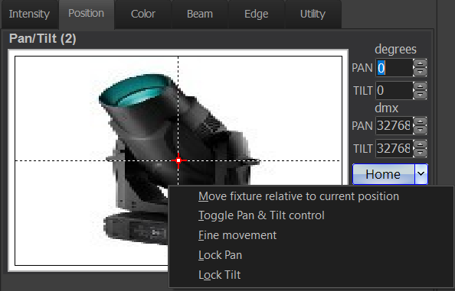
The white box with the picture of a moving light and a red arrow in the middle can be used to control the light. Click on the red arrow and drag it around the white box to make gross adjustments to its pan and tilt, or click anywhere in the box to move the light there. Pan controls the light’s orientation in one direction, while Tilt controls the other; using both in tandem allows the user to position the light anywhere on stage. The actual Pan and Tilt values are shown in the boxes to the right. Clicking on Home will return the light to a Pan and Tilt of 0 x 0, which at Tucker makes it face straight down.
Figure 46
Position Control
Keep in mind that the light can make multiple rotations, so if you can’t move the light anymore in one direction, try decreasing the value of that directional attribute by 360 degrees. Also keep in mind that sometimes, when going from a cue with moving lights to one without, it is often best to wait a cue to return the fixtures to their Home position so that the lights don’t flash across the stage as they are moving. While sometimes the console will figure this out in its own, it is best to do it manually.
Clicking on the arrow next to Home brings up a set of options, shown to the bottom right of the figure.
- Move fixture relative to current position is poorly understood, as is Toggle Pan & Tilt Control.
- Fine movement is a toggle that allows the user to use the same force in their control movements and get finer control over the fixtures. It makes the white box’s control movements slower.
- Lock Pan & Lock Tilt allow one or both attributes to be locked, allowing movement along a single axis. If both are locked, then the light cannot be moved via the white box as neither option disallows movement by changing the text value in the associated fields.

Color
(Figure 47)
- For some fixture types, above the three sliders, there is a list of Color Presets (not pictured) that use a different DMX stream than the controllable color variables. This means that the light’s color can be changed without it displaying in the Color Mixing sliders.
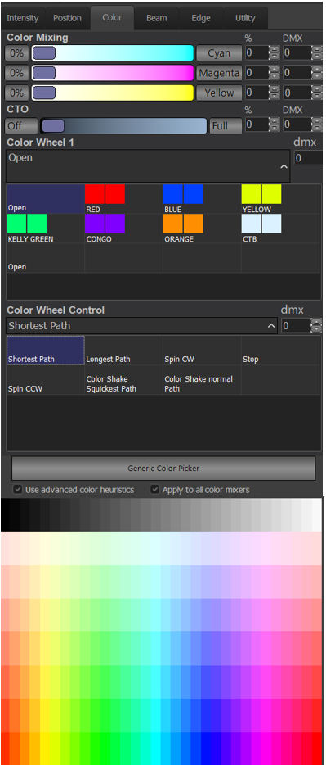
- The three sliders govern the color variables. This is a screenshot of the movers, but there are multiple variable combinations for light control. CMYK lights start at white, with all sliders at 0, and stands for Cyan, Magenta, Yellow, and Key (black). RGBA & RGBW lights start at white as well, but their sliders are at 100, meaning that if all sliders are moved to 0, they will output no light. The acronyms stand for Red, Green, Blue, and Amber/White, respectively.
Figure 47
Color Control
- The CMYK lights at Tucker also have a CTO slider, which stands for Color Temperature Orange; the higher the number is, the more orange is added to the light’s color; they also have a Green Shift (not pictured) option, to control how green-shifted the light is.
- The Color Wheel is a physical wheel with glass filters in it, intended to produce a certain color of light.
- Color Wheel Control controls the color wheel’s operation. Shortest Path makes the wheel take the shortest path from one fixture to another, while Longest Path does the opposite. Spin CW makes the wheel spin clockwise, while Spin CCW does the opposite. Stop makes it stop. Color Shake Quickest Path and Color Shake Normal Path allow the colors to be shaken, which is poorly understood. It may have something to do with putting two colors in the beam at one time.
- Generic Color Picker opens up the Generic Color Chooser (Figure 52-Figure 60).
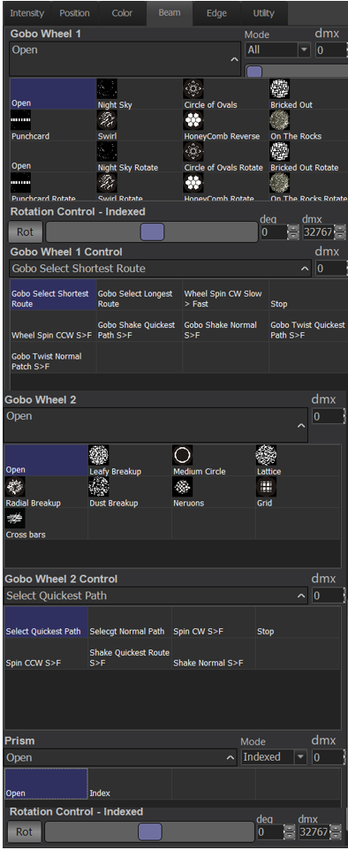
- Use advanced color heuristics is a recommended setting as it allows the console to take the colors that the user selects from the Generic Color Chooser (Figure 52-Figure 60) and change other colors, like CTO and whatnot, to make the color look closer to the user’s intention. Apply to all color mixers is closely related as it allows the first setting to apply to all of the light’s color settings.
Figure 48
Beam Control
- The rainbow below these buttons gives the user a set of colors from which they can pick for selected lights.

Beam
(Figure 48)
We did not figure out the Beam section until very late in my senior year, so I will not attempt to describe things that I don’t know about.
The Gobo wheel allows filters (gobos) to be applied on the light. The Prism allows the light’s output to be tripled. Rotation Control allows the light and its gobo pattern to rotate. Mode opens a dropdown that allows the user to specify if they want indexed (immobile) or rotational gobos, or just all of them.
The Rotation Control slider allows the user to specify how fast they want the rotation to be. There is a Gobo wheel 1 control; it is remarkably similar to that of Color (Figure 47).
Prism, and its associated dropdown, have a few options for how the prism functions, as well as its rotation.

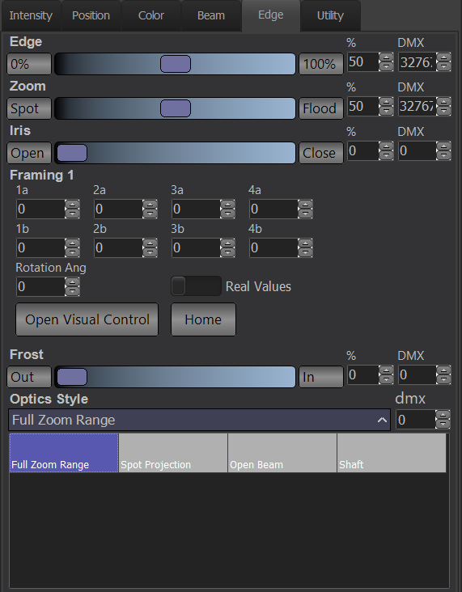
Edge
Figure 49
Edge Control
(Figure 49 & Figure 50)
- Edge controls the sharpness of the beam’s edges.
- Zoom controls the size of the beam.
- Iris controls a shutter around the beam.
- Frost smooths the edges of the beam.
If trying to make the beam look the same at a different circumference, one of the other variables must be changed as well. Frost is not as necessary for that as Edge and Iris.
- Framing is not discussed here and instead in Figure 50, as is Open Visual Control.
- Optical Style is a control channel for further control of these attributes but is poorly understood.
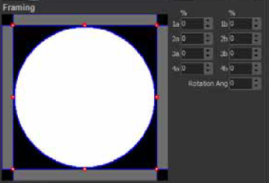
Figure 50
Framing Control
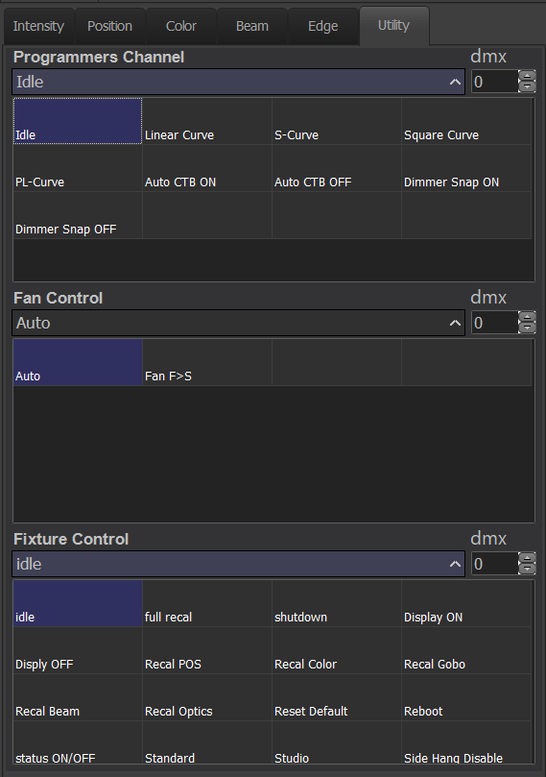
- When Open Visual Control is pressed, it opens a window similar to Figure 50 in order to control the framing. It is recommended that the user not mess with any of the text fields, and instead use the framing window to adjust the beam of the light. Use the red buttons to make the beam smaller, similarly to sizing a shape in Microsoft Office.
Figure 51
Utility Control

Utility
(Figure 51)
The options seen here vary widely across fixtures, so I shall not attempt to explain them all; the only useful information that I can provide is that the fixture’s fan, onboard dimmer profiles, and display/computer can be controlled to some extent from this section.

Generic Color Chooser
(Figure 52-Figure 60)
The Generic Color Chooser window is used to control colors, both of the lights and of certain options in the software. In some fixture control windows, this is also known as the Generic Color Picker. It is a window that pops up when clicking the associated button in Figure 47. On the bottom left, there is a square with a representation of the chosen color. Next to that, there is a listing of the RGB and CMY values. Select selects the color for use, while Cancel closes the window.
Show Colors are colors that have been created as part of the show’s palettes. Selecting a channel and clicking Add current color to show will add the color of that fixture to the list of show colors. Clicking Auto Create has the same function as Create Default Show Colors (Figure 118). | Palette Colors are a duplicate of those in the chart at the bottom of Figure 47.
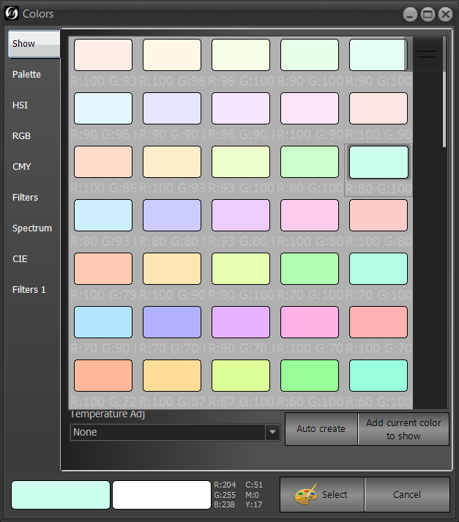  Figure 52  Show Color Chooser | 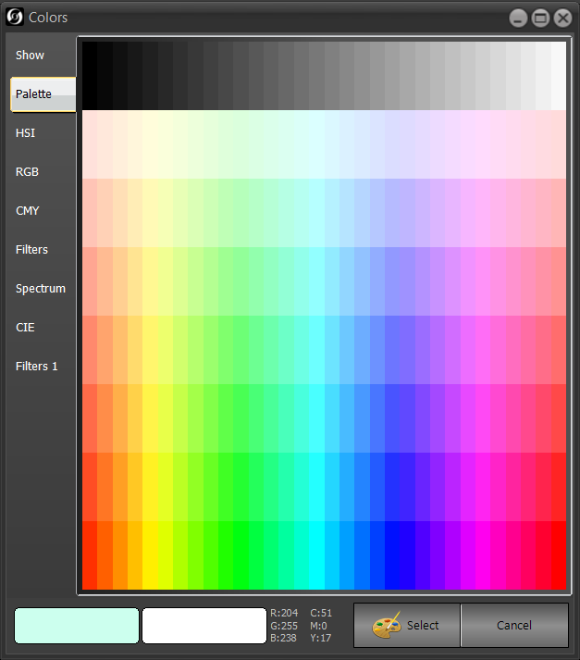  Figure 53  Palette Colors
HSI Colors stands for Hue, Saturation, Intensity. | RGB stands for Red, Green, Blue.
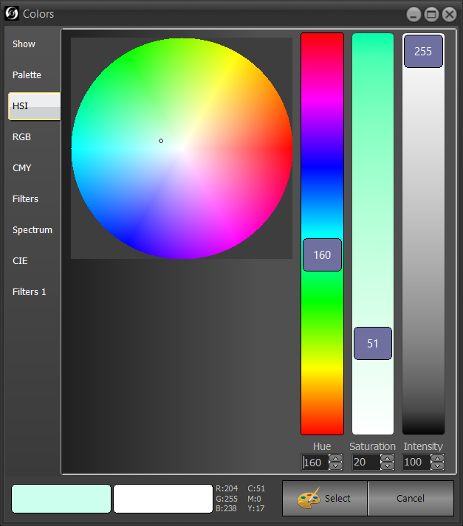  Figure 54  HSI Colors | 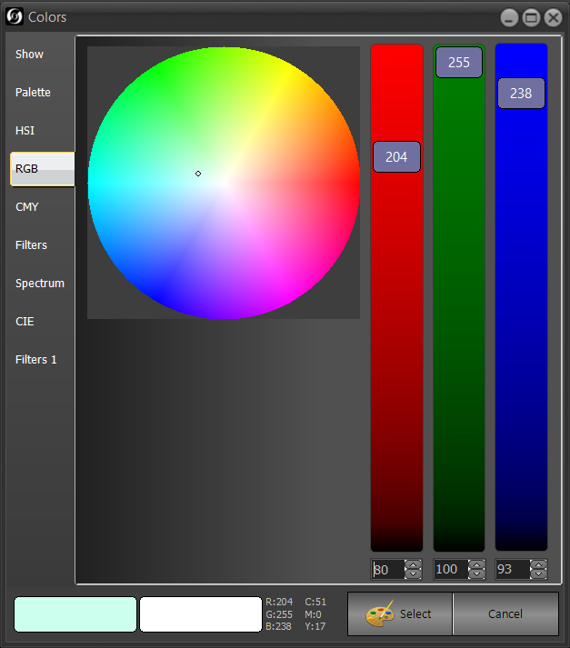  Figure 55  RGB Colors
CMY stands for Cyan, Magenta, Yellow. | The Color Filters are useful when looking for a specific color that the user does not want to have to create themselves, or when an outside group (the ballet) comes in with a spreadshet of gel names. Use the Brand dropdown at the top to choose the gel brand, whether that be Apollo, GAM, Lee, or Rosco.
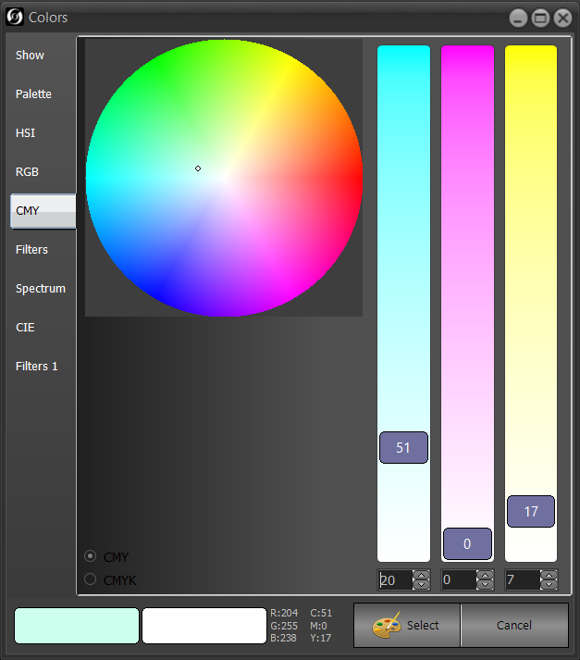  Figure 56  CMY Colors | 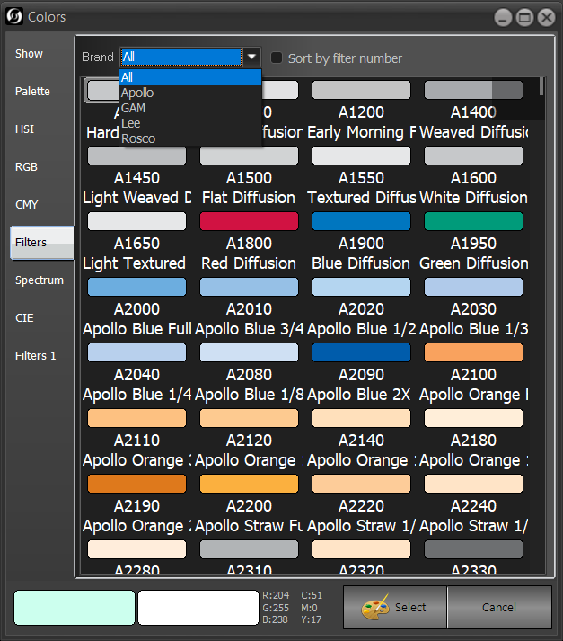  Figure 57  Filter Colors
The Spectrum Colors and the CIE Colors are remarkably similar; however, their shape is different, and CIE Colors has more options on the top, whose usefulness is limited to advanced computer needs, and not ours at Tucker.
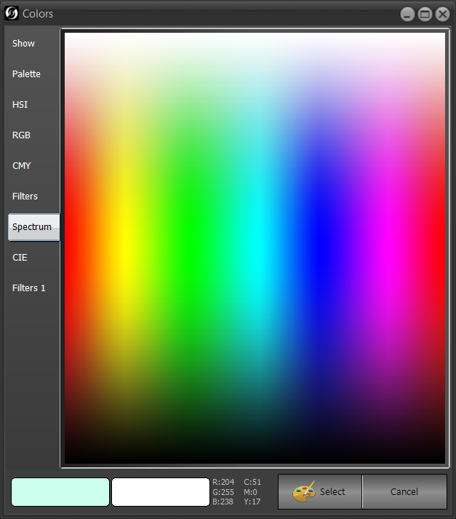  Figure 58  Spectrum Colors | 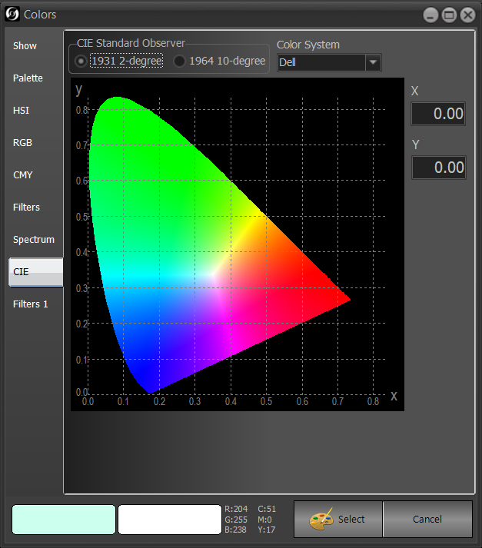  Figure 59  CIE Colors
A selected fixture may have colors of its own, and when that is the case, they will appear in Filter Colors.
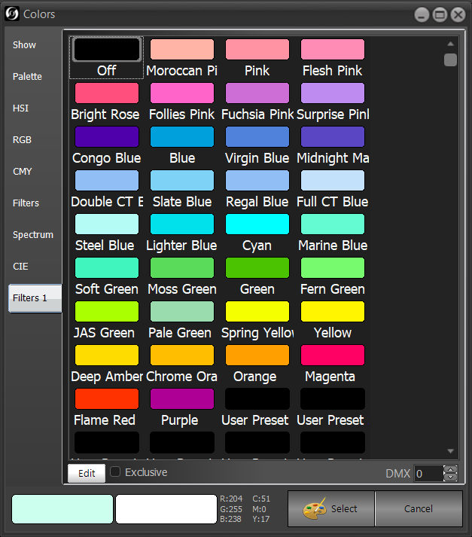
Figure 60
Fixture Filter Colors

Go & Stop
(Figure 61 & Figure 62)
- Select returns the cue list to the master cue list. Pressing [SHIFT] [SELECT] opens up a window (not pictured) that allows the user to select a cue list.
- The Master Playback Faders are between the three buttons. They are customizable from, and discussed in, Figure 167.
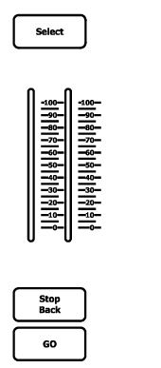
- The Stop Back button, or Stop / Back (Figure 42), if pressed while a cue is running, will stop the cue, turning the green lines seen in Figure 43 red. If there are two lines, only the top one will turn red. Run or Go (Figure 42) or GO will start the cue once more. Run can also rerun the current cue, which can be helpful if changes were made. If pressed while there is no cue running, Stop / Back (Figure 42) will return to the previous cue.
Figure 61
STOP/GO
- GO moves the user to the next cue. Pressing it again before the current cue has finished running will still cause the next cue to run, with possibly unexpected results; however, having Safety Playback Mode enabled (Figure 111) is recommended as it prevents it from doing this and relabel the virtual Go button as Enable. Keyboard Playback Options (Figure 111) is not recommended as it moves the functionality of the button to the keyboard.
- Reset (Figure 42) has the same function as Rel Cue List and Release all cue list control (Figure 80).
- Run (Figure 42) allows the user to rerun the current cue, which can be helpful when the user has made changes to the lighting state that they don’t want to be saved.
- Goto and a number, such as Goto [45], will run cue 45, even if the current cue is cue 45.
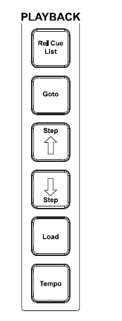
- Step ↑ (Step up) & Step ↓ (Step down) are used to move to the previous and the next cue in the current cue list, respectively. Pressing Shift (Figure 63) while pressing either of these buttons will jump to the first or last cue, respectively.
Figure 62
Playback Keys
- Load can be used in conjunction with a number to make the GO key go to the cue of that number. For example, let’s say that the user is on cue 45, with there being also a cue 46 & 47. Normally, GO would send the user to cue 46, but pressing Load 47 would make the next cue be cue 47. This is shown by the cue that will be next being highlighted in blue.
- Tempo is used to manually enter in tempos for effects and is not useful at Tucker.

Main Functions
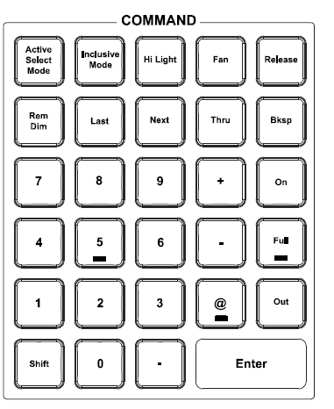
(Figure 63 & Figure 64)
Figure 63
Command keys
- The number and decimal keys are used to enter the related numbers into the command lines and into various fields. The Bksp key removes one character (if typed) or one function (if entered via console button) from the command line. The @ key puts the selected item (group, submaster, fixture) at a certain level.
- Hi Light and Hi Light are accessible from the command keys and the main functions dropdown. Clicking on the top-screen option in Figure 64 pulls up a non-pictured option, Lo Light. Both attributes apply to all fixtures of a given fixture type identically. High light puts a fixture at full intensity and clears beam and color attributes, while low light puts a fixture at zero intensity, unless a certain fixture type has a high or low light recorded in the showfile (just for the show) or in the fixture library (for all shows). These can recorded to the showfile with the screen key popups shown in Figure 85, or by setting a fixture to its high or low state and entering Record Hi Light for high light or Record Shift Lo Light for low light.
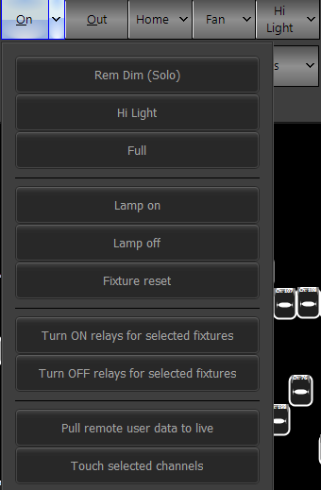
- Fan and Fan open the fan tool, which, given the fact that we have only two moving lights, is outside the scope of this guidebook; please see page 103 of the User Guide for more details. The dropdown next to it opens Matrix Timing, which is again outside of the scope of this guidebook; however, it is not mentioned in the manual.
Figure 64
- Release and Park are discussed in Figure 79.
- Rem Dim and Rem Dim (Solo) turn off all channels except for those selected. This can be undone with (Undo) Rem Dim (Solo) (Figure 83).
- The Active Select Mode, Inclusive Mode, Last, Next, Thru, -, and + keys are discussed in the Selection/Attributes section.
- The On key turns selected lights on at a value described in Figure 167.
- The Full key and Full option turn selected lights on at 100% intensity.
- The Out and Out keys put the selected fixture at 0% intensity.
- Shift provides more functionality to certain keys. See the User Guide for more information.
- Enter is used to complete a command line operation, acknowledge a screen popup, or finish a GUI operation.
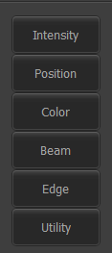
- Lamp on sends the Lamp On command via the Utility channel; Lamp off sends the opposite command, and Fixture reset does both in order with 3-5 seconds in between.
Figure 65
Home
- Turn ON relays for selected fixtures and Turn OFF relays for selected fixtures have unclear functions.
- Pull remote user data to live is not necessary at Tucker.
- Touch selected channels gives selected channels data, usually an intensity of zero, to be recorded in the cue or the group. It is unclear if the channels are given any other data. Based on testing, it seems probable that submaster levels do not allow a ‘touching’ to the level of the submaster. This same option is accessible from Touch selected channels (Figure 33).
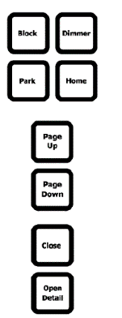
- Home and Home (Figure 66) applies the default values of a light from the Fixture Library (Figure 152) to the selected fixture. Clicking on the dropdown arrow next to it opens up a dialog box as pictured in Figure 65, where the selected fixture can be returned to the home value of the specific attribute selected. Pressing Home and one of the attribute family keys (Figure 68) will make any fixtures selected go the home value for that attribute.
Figure 66
Additional Main Keys (not laid out in same way on console)
- Block is somewhat confusing, but the basic understanding is that it overrides the tracking behavior — the idea that attributes should not change until instructed to do so by console data — of a cue; no matter the cue list setting, it will return the fixtures of a cue to a certain specified state. When pressed, it writes to the command line [CUE] [current cue number] [BLOCK]. This is not necessary for us as we use cue-only mode.
- Dimmer is also somewhat confusing. Dimmers allow the intensity of a light to go down from full. The basic understanding of the key is that it allows the user to set a dimmer level specifically. Typing Dimmer [42] [@] [25] would put a theoretical channel 42’s dimmer at 25, thus making the overall real-world intensity a 75 (though the board would still see a 100) because the operation subtracted 25 from 100. This would bring up a Dimmers unpatched (not pictured) on the bottom right of the screen. Pressing the key twice returns all dimmer levels to normal. At Tucker, most of our lights are intelligent lights, thus largely negating the need for this key — intelligent lights have self-contained dimmers.
- Page Up and Page Down have narrow functions in that they move the submaster page (Figure 139) up by one page; Page Up increases the submaster numbers, while Page Down decreases them.
- Close closes any open window.
- Open Detail is supposed to open an information screen about the selected item in the software; however, I am not sure if this actually works.

Advanced Keys
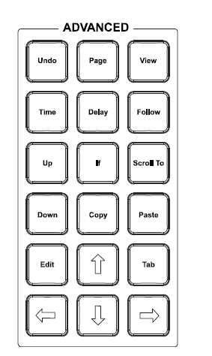
- Undo is discussed in Figure 83.
Figure 67
Advanced Keys
- Page will go down the channel list, while [Shift] [Page] will go up the channel list in certain Live (Figure 21) views.
- View has an unclear usefulness.
- Time, Delay, and Follow are not useful at Tucker.
- Up & Down take fixtures up and down a certain intensity amount governed in Figure 167. They work the same as Up & Down (Figure 67).
- If is not useful.
- Scroll To has an unclear function.
- Copy & Paste are discussed in Figure 93.
- Edit is used as an alternative to double-clicking to edit.
- Tab advances to the next edit cell.
- The arrow keys function as regular arrow keys.

Selection/Attributes
(Figure 68 & Figure 69)
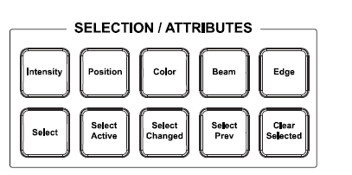
- This portion allows the user to choose fixtures to modify their attributes of selected fixtures. Selecting a light in one Live view will transfer to other views. Selecting fixtures can be done via clicking lights, dragging a square on the screen over lights, or using the command line, or a combination of the three. Selection can be undone with (undo) Channel Selection (Figure 83).
Figure 68
Selection/Attributes Keys

- The Thru (Figure 63) key selects all fixtures between two numbers; for example, typing [152] [thru] [154] would select fixtures 152, 153, and 154.
- Active Select Mode (Figure 63) puts selected fixtures at full if they are at 0, and 0 if they are at full; the same function is available with the “Active” selection mode option. The Select Active key selects any lights that are on; it differs from the mode in that it is a one-time event. Select active fixtures excluding subs selects any fixtures that are on, except those that are on because of submasters. Select Active (Submasters) selects any fixtures that are on because of a submaster. Select inactive (off) fixtures selects any fixtures that are not on.
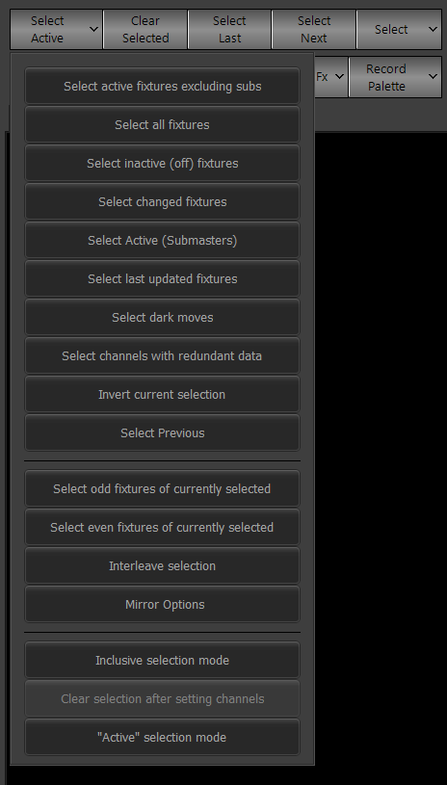
- Inclusive Mode (Figure 63) adds any newly selected fixtures to the current selection. The same function is available with the Inclusive selection mode option. If the mode is on, the Select Active button will appear yellow, and Incl* will appear in its top right corner. This button is quite useful for selecting disparate lights, and will not clear the selection if turned on or off. The Clear selection after setting channels button clears the selection after channel data that is changed by the user is recorded. If Inclusive Mode is not on, it cannot be changed, so Inclusive mode might have to be turned back on to allow it to be turned off.
Figure 69
Selection/Attributes Options
- The + button adds a fixture or group of fixtures to a selection. Using the – button removes a fixture or a group of fixtures from a selection.
- Next (Figure 63) takes a selection of lights made in the magic sheet from the user and selects the right- and topmost one, then goes left and down, and so on and so forth until it reaches the end of the previous selection, where it starts over. Outside of the magic sheet, it takes the left- and topmost and goes right and down. This option is also accessible via the screen with the Select Next option.
- Last (Figure 63) takes a selection of lights from the user and does the opposite of Next. This option is also accessible via the screen with the Select Last option.
- The Intensity, Position, Color, Beam, and Edge keys are used to go to the fixture’s details for that attribute in the Fixture Control (Figure 45) section of the Live menu.
- The Select key opens the Select window (Figure 77).
- The Select Prev key selects the fixtures of the previous selection, a function also accessible with the Select Previous button. Invert current selection inverts the selection. Select all fixtures selects all fixtures. Clear Selected gets rid of any fixture selection.
- Select odd fixtures of currently selected selects the odd fixtures of the current selection, while Select even fixtures of currently selected does the opposite and selects the even fixtures.
- Select Changed and Select changed fixtures select any fixtures that have been manually changed since the last cue record, update, or showfile save.
- Select last updated fixtures selects the fixtures most recently updated by the command line.
- Select dark moves selects any fixtures which have a non-intensity attribute changing in the current cue.
- Select channels with redundant data selects any fixtures with instructions in the currently-running cue that are redundant to instructions from the previous cue.
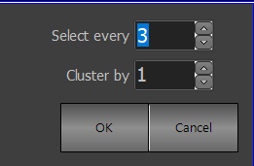
- Interleave Selection opens a dialog box as described inFigure 70. It allows the user to select clusters of fixtures (organized numerically) from every number of fixtures, as set in the Select every box. For example, selecting fixtures 1 through 20, then selecting every 3, clustering by 1, would select fixtures 1, 4, 7, 10, 13, 16, and 19. A cluster value higher than 1 selects that number after the multiplier (giving 1, 2, 4, 5, 7, 8, 10, 11, 13, 14, 16, 17, and 19 from the previous example). 3 and 1 are the defaults that the boxes give.
Figure 70
Interleave Options
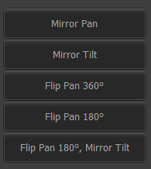
- Mirror Options opens a dialog box as shown in Figure 71.
Figure 71
Mirror Options
  - Mirror Pan and Mirror Tilt make the pan & tilt values, respectively, change their sign (+ or -).
  - Flip Pan 360º adds or subtracts 360 degrees from the pan value. This can help if you want to make the lighting angle on the movers less extreme while still retaining the same position.
  - Flip Pan 180° adds or subtracts 180 degrees from the pan value. This same function is accessible through Flip Pan 180° in Figure 77.
  - Flip Pan 180°, Mirror Tilt adds or subtracts 180 degrees from the pan value and mirrors the tilt. This same function is accessible through Flip Pan 180° & Mirror Tilt (6) in Figure 77.
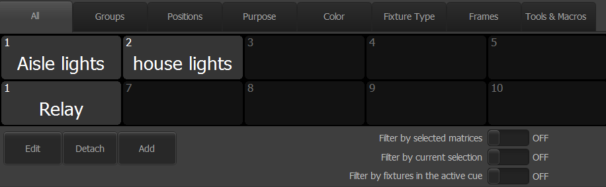
- The All button (Figure 72) allows the user to select all of the lights of category in this window, except for Groups. It is helpful to see all of the different selection options; selecting one after the other will have selected only the lights that match both categories, as long as Inclusive Mode (Figure 63) is not on.
Figure 72
Select All
  - Edit moves the user to the Groups (Figure 96) window.
  - Detach removes the window from the dropdown area and makes it into a new window.
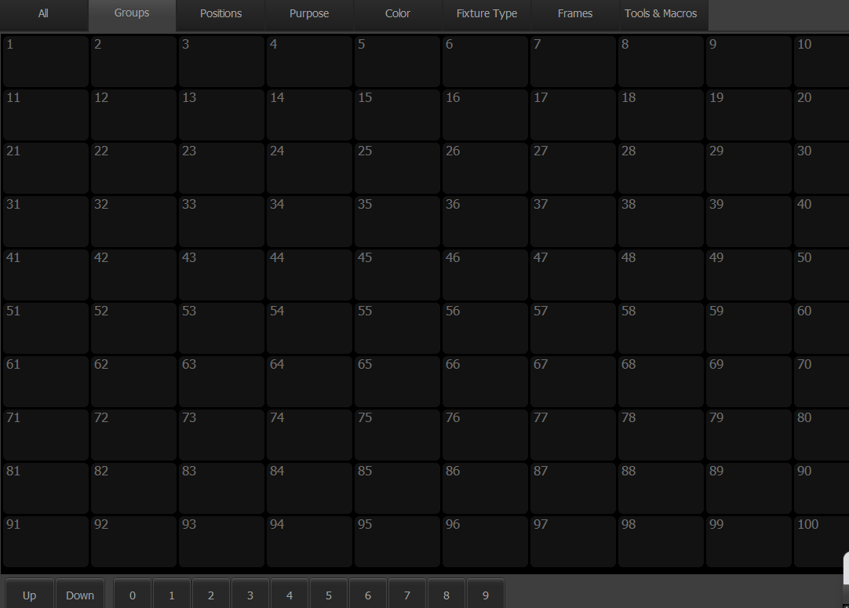
  - Add creates a group.
Figure 73
Select Groups
  - Filter by selected matrices is not useful as we do not use matrices here at Tucker.
  - Filter by current selection selects only from what is currently selected. If nothing is selected, then the selection range will be all fixtures.
  - Filter by fixtures in the active cue makes the selection range only include those channels with data in the current cue, even if that data is for the light to stay at 0.
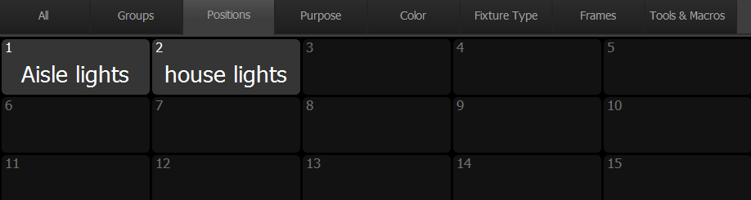
- Groups (Figure 73) allows the user to select all of the lights from certain groups. It is unknown why some groups appear on the window, and some don’t.
Figure 74
Select Position
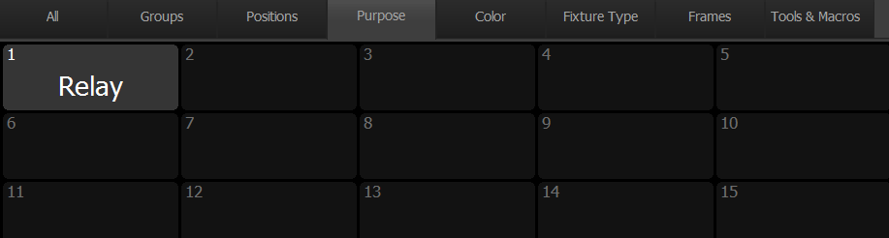
  - The Up key moves the group numbers up by 100; for example, from 1-100 to 101-200. The Down key does the opposite. The number keys on the bottom describe the number in the hundreds place of the group list; for example, pressing 5 would pull up groups 501-600.
Figure 75
Select Purpose
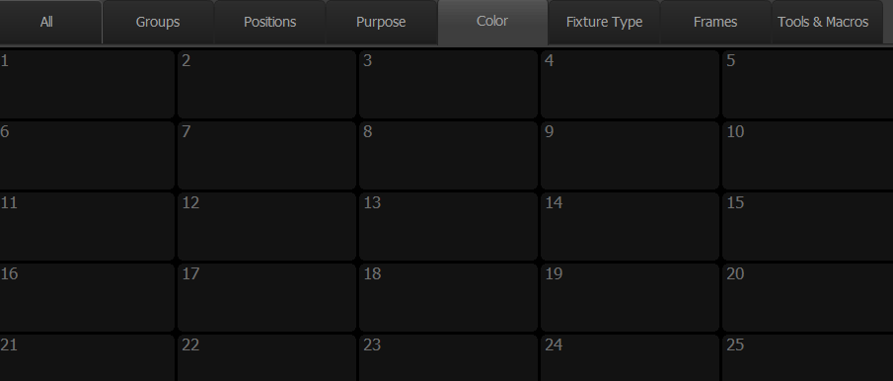
- The Positions (Figure 74) button allows the user to select all lights with associated information in the Purpose field of the Patch (Figure 123) window. The same thing is true for the Purpose (Figure 75) button does the same thing as the Positions button, but for the Purpose field. The Color (Figure 76) button does the same thing, but with color information. The Fixture Type (Figure 57Figure ) button does the same thing, but with the fixture type. This is useful for selecting all lights that are of the same type; at Tucker, we have four types of stage lights. All of these fields can have information populated in them in the Channel Chart (Figure 123) portion of the Patch section.
Figure 76
Select Color
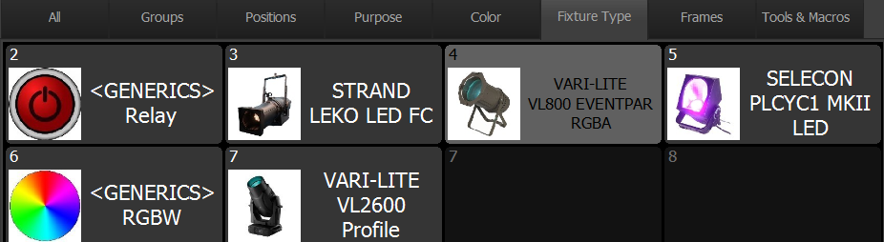
- I think that the Frames (Figure 58) button populates with the physical frames and lenses options that the fixtures have, but I am not sure. In any case, I see no use for it.
Figure 57
Select Fixture Type
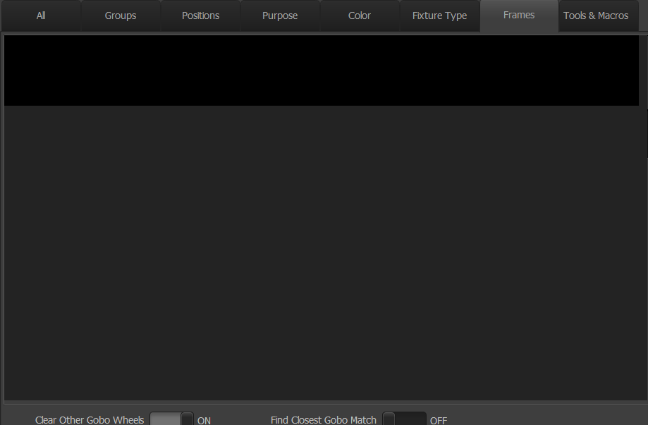
- The Tools & Macros button includes various selection-related buttons. It is unknown whether the affixed numbers do anything.
Figure 58
Select Frames
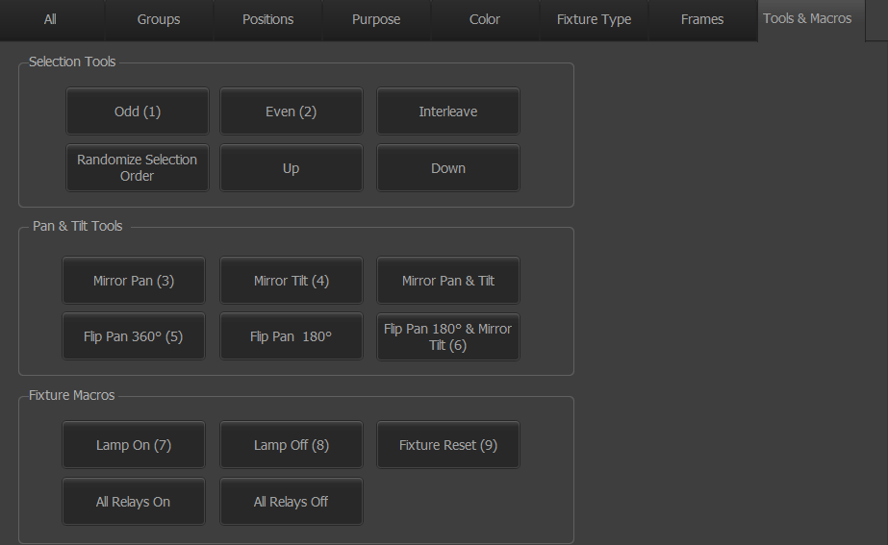
  - Odd (1) and Even (2) have the same function as buttons described in Figure 69.
Figure 77
Select Tools & Macros
  - Interleave pulls up the same dialog box as described in Figure 69.
  - Randomize Selection Order will randomize the selection order when using the [Next] and [Last] (Figure 63) keys.
  - Up and Down work the same as Up & Down (Figure 67).
  - Mirror Pan (3) and Mirror Tilt (4) have the same function as buttons described in Figure 71.
  - Mirror Pan & Tilt combines the function of the Mirror Pan and Mirror Tilt buttons described in Figure 71.
  - Flip Pan 360º (5) will add or subtract 360° from the pan value of selected fixtures.
  - Flip Pan 180° and Flip Pan 180° & Mirror Tilt (6) are both discussed in Figure 71.

  - Lamp On (7) and Lamp Off (8) have unknown functions: it is believed that they send some sort of ‘lamp on/off’ command to the selected fixtures. They pull up a window as shown in Figure 78. Done has to be clicked when the user is finished. Fixture Reset (9) operates similarly. Lamp on, Lamp off, and Fixture reset from Figure 64 have the same function.
Figure 78
Lamp On/Off
  - All Relays On and All Relays Off are not described in the actual manual, and have never been used at Tucker, so it is no great loss to be unaware of their function. Turn ON relays for selected fixtures and Turn OFF relays for selected fixtures from Figure 64 seem to describe the same thing.

Park & Release
(Figure 79 & Figure 80)
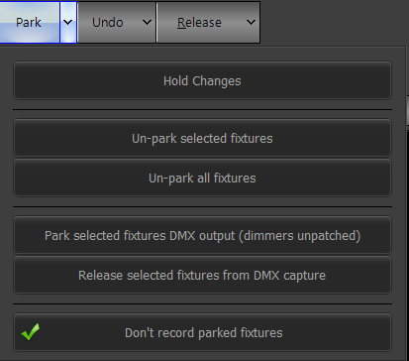
- Park and Park (Figure 66) ‘parks’ the selected fixture at the intensity and other attributes it has been assigned, whether that is from a cue list, submaster, manually setting, or something else. [PARK] [ENTER] will also do that. Staying entirely within the confines of the command line, [PARK] [42] will park fixture 42. The physical button will flash and the screen option become red when a fixture is parked.
Figure 79
Park
- The only thing that will allow the fixture to be re-changed is selecting Un-park selected fixtures or typing [unpark], if the unparking of only selected fixtures is desired, or clicking Un-park all fixtures, if the unparking of all fixtures is desired. [UNPARK] [42] will unpark fixture 42.
- Hold Changes is not in the guidebook, but it does open a flashing popup above the cue list that says ‘CHANGES HELD.’
- Park selected fixtures DMX output (dimmers unpatched) does basically the same thing as Park but with dimmers, which makes it less relevant to us. Release selected fixtures from DMX capture undoes this.
- Don’t record parked fixtures is a checkbox that prevents parked fixtures from being recorded in submasters, cues, groups, etc.
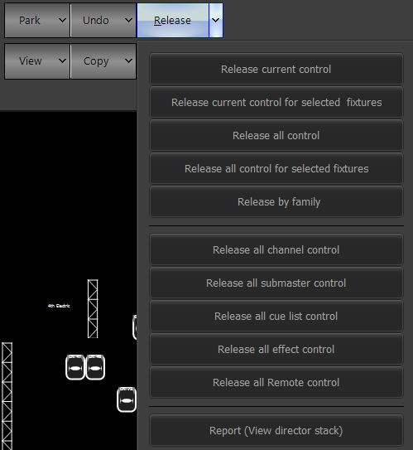
- Release and the Release key (Figure 63) can be somewhat confusing. Basically, the first press makes the selected fixtures whose properties were changed via the command line or GUI return to the state defined via the cue or submaster. The second press makes all of the fixtures return to their default state regardless of cue or submaster, etc. However, if Main release button to release intensity only (Figure 81) is pressed, the buttons only apply to intensity.
Figure 80
Release
- Release current control, it seems, does the same thing as Release; as does Release current control for selected fixtures for selected fixtures, even though it might be more logical for it to be about each command line/GUI operation.
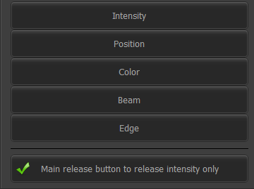
- Release all control gets rid of all control, from command line/GUI and submasters, cues, etc. [SHIFT] [RELEASE] does the same thing. Release all control for selected fixtures does that for selected fixtures.
Figure 81
Release by family
- Release by family opens up a window (Figure 81) to the left of the window pictured in Figure 80 that allows the user to release control by attribute type. Additionally, Main release button to release intensity only allows the Release and Release key to only release intensity control when clicked or selected. Pressing Release & an attribute family button, such as color, allows for the console’s control over that attribute to be released. In this example, color control would be released.
- Release all channel control releases all of the control of the console on a selected channel.
- Release all submaster control releases all active submasters. Release all cue list control does the same thing, but for the cue list.
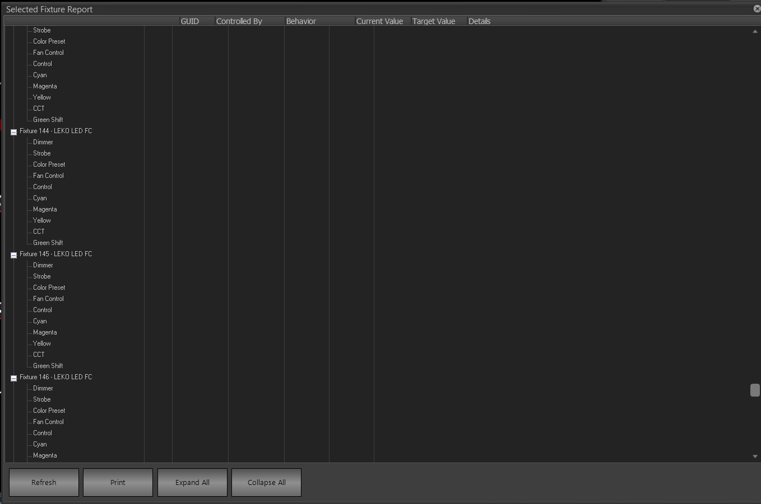
- Release all effect control releases any fixture control from an effect, whether or not that effect has been programmed into a cue, submaster, etc. or not.
Figure 82
Director Stack
- Release all Remote control is not necessary as we do not have this capability at Tucker.
- Report (View director stack) pulls up a window as shown in Figure 82. It allows the user to see each attribute of each light, and what is controlling that attribute. Refresh is used to refresh the list. Print is used to print the list. Expand All and Collapse All are used to make the list of attributes for each fixture expanded and collapsed, respectively.

Undo
(Figure 83)
- Undo undoes the last action, as does Undo (Figure 67).
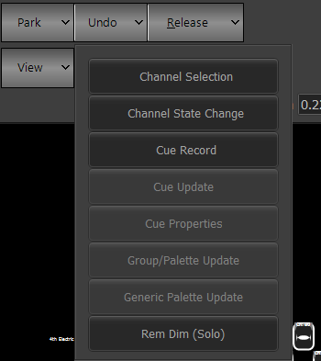
  - Channel Selection undoes the last channel selection by opening up a window (not pictured) with a list of all of the recent channel selections and their times. It is somewhat difficult to determine which list items refer to which selections, so it is often easier to use the other select options.
Figure 83
Undo
  - Channel State Change can undo any channel state change of any attribute, including releases. It opens up a window similar to that of Channel Selection, but a little narrower.
  - Cue Record does the same thing as the previous two, but with cue recordings. Cue Update does the same thing, but with cue updates. Cue Properties does the same thing, but with cue properties — I assume the difference is in active fixture control vs. general cue information.
  - Group/Palette Update undoes any update to a group or palette.
  - Generic Palette Update undoes any update to a generic palette.
  - Rem Dim (Solo) undoes any action of that type, as discussed in Figure 64.

Record & Update
(Figure 84 & Figure 86)
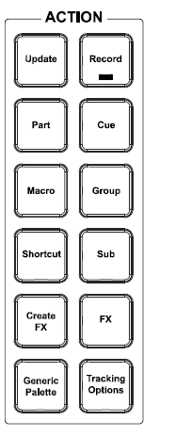
Record allows the user to store many of the data structures of the light board, including cues, submasters, and groups. However, Update allows the user to change many of the same data structures that have already been recorded with the Record key, and is useful in saving valuable seconds instead of re-recording the data structures. Pressing either key opens the command line popup pictured in Figure 85. Cues can be copied by recording the same cue multiple times with different numbers.
Figure 84
- Part allows the user to record cue parts. Cue parts are useful in allowing for a difference in times, but are not necessary at Tucker.
- Cue, in conjunction with Record, allows the user to record a cue into the current cue list. Typing Record Enter or Record twice or Record Cue records a cue of the next logical number after the last cue in the current cue list. Putting a number after that records a cue after that number. If a cue already exists with that number, then a popup (not pictured) will come up, asking the user if they want to overwrite the existing cue — Enter (Figure 63) can be used to allow this to happen. Typing text between the last item and Enter key will add that text to the Cue Description (Figure 87).
- Cue, in conjunction with Update, allows the user to update the current cue, by typing Update Enter, Update twice, or Update Cue, as a cue update is assumed when the console is given no reason to think otherwise. Further, Update 42.5 Enter or Update Cue 42.5 Enter will update cue number 42.5, regardless of the current cue. Typing text between the last item and Enter key will add that text to the Cue Description (Figure 87). It is recommended to update cues, as opposed to recording them.
- Macro is not useful here at Tucker.
- Group and Record Group is discussed in the Groups section (Figure 101).
- Shortcut is not discussed, as I do not know how to record shortcuts.
- Sub is discussed in the submaster section.
- Create FX and FX are not discussed; nor is Record FX.
- Generic Palette and Record Palette are discussed in the Palette section (Figure 119).
Figure 85
Record Options
- Tracking Options is discussed in Figure 42.
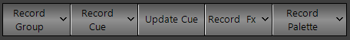
- Record Cue will open a window shown in Figure 87; the arrow next to it will open a window as shown in Figure 89. Update Cue opens a window as shown in Figure 87.
Figure 86
- The Record and Update popups are pictured in Figure 85.
  - 1 Cue (Live) is discussed in Figure 87 as it allows the user to record cues.
  - 2 Group (Selected)
  - 3 Sub (Active) is discussed in Figure 138, as is Submasters.
  - 4 FX is not discussed.
  - 5 Intensity, 6 Position, 7 Color, 8 Beam, 9 Edge, and 10 Utility are not necessary at Tucker as they have to do with specific palettes.
  - VN Preset is not necessary as we are not recording anything related to that at Tucker.
  - Preset has an unclear meaning.
  - Specials brings the user to the options listed below. In that list, 11 Back brings the user to the previous list.
    - 1 GM1 and 2 GM2 are discussed in the Grandmaster section (Figure 142).
    - 3 Hi Light and 4 Lo Light are discussed in Figure 63.
    - 5 Home allows you to record a fixture’s home (resting position) value.
    - 6 Partition is not necessary at Tucker.
    - 9 Position DSC means Position Down Stage Center, but i don’t know what it does.
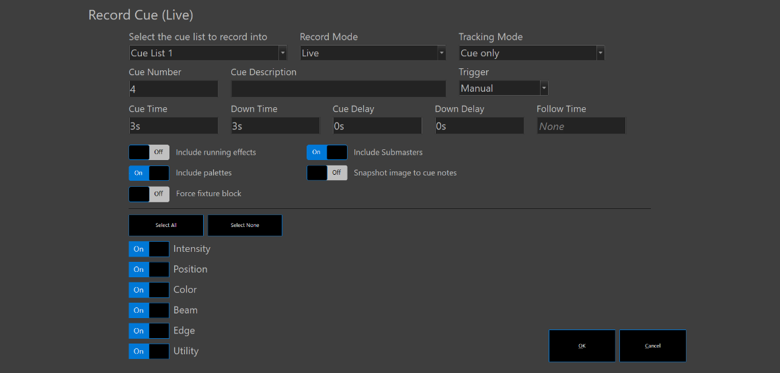
- Record Cue (Figure 86) opens a dialog as shown in Figure 87. The Update Cue dialog is the same, save for the title on the very top. Any cue update affecting fixture can be undone with (Undo) Cue Update (Figure 83), while cue property updates can be undone with (Undo) Cue Property Update (Figure 83).
Figure 87
Record/Update Cue Dialog
  - Select the cue list to record into opens up a window (not pictured) showing a list of all the possible cue lists that the new cue can be recorded or updated into.
  - Record Mode allows the user to change how cues are recorded. The options (not pictured) are Live, Selected, Active, & Changed Only. Live records everything outputting from the cue list. Selected records everything that is selected. Active records only those fixtures that are active. Changed Only records only those fixtures that have been changed. When recording a cue via the command line, the mode can also be changed with the command line popups, referenced in Figure 88.
  - Tracking Mode is discussed in Figure 42.
  - Cue Number allows the user to specify the cue number that they want to be recorded. By default, it will be the next whole number after the last cue in the cue list.
  - Cue Description allows the user to input text to be displayed to the right of the cue in the sidebar cue list (Figure 42).
  - Trigger allows the user to select how the cue will be triggered. Normally, the user will want to trigger the cue with the Go button (Figure 61). However, the button can also be selected to choose another trigger; however, unless the console is controlled by some sort of External Trigger (Figure 161), I do not recommend this.
  - Cue Time describes how long intensities going up from the previous cue will take to arrive at their next state. The lowest possible value for this is 3 seconds. This option often doesn’t allow for decreases once the value is increased. The number here will be displayed in Figure 42.
  - Down Time describes how long intensities going down from the previous cue will take to arrive at their next state. However, this option often doesn’t allow for decreases once the value is increased, so it is better often to just use Cue Time on the next cue, as the same effect will be achieved. The number here will be displayed in Figure 42.
  - Cue Delay is defaulted to zero seconds, but increasing its value will add that many seconds’ time between the trigger and the next cue. Down Delay does the same thing, but delays for the provided number of seconds before intensities begin to decrease. The number here will be displayed in Figure 42.
  - Follow Time is not necessary at Tucker, as we try to have all of our cues manually triggered.
  - Include running effects, if marked yes, will include running effects in the cue. However, if not checked, it will return the fixtures to their pre-effect state and record or update them like that. An indicator seen in Figure 42 will show if this option is automatically marked ‘on’ or ‘off’.
  - Include palettes, if marked yes, will include a reference to palettes in the cue. If not, it will assign the current palette color to the fixture state in the cue. An indicator seen in Figure 42 will show if this option is automatically marked ‘on’ or ‘off’.
  - Force fixture block will force any attribute tracking in the current cue to stop, and all attributes for all of the fixtures to be recorded; however, this is not necessary as we do not use tracking mode at Tucker.
  - Snapshot image to cue notes will add a camera image to a cue’s notes, but is outside of the scope of this guidebook, as we do not have an installed camera.
  - Include Submasters will include the state of submasters in the cue. If unchecked, it will ignore levels given by submasters to the lights when recording or updating a cue. An indicator seen in Figure 42 will show if this option is automatically marked ‘on’ or ‘off’.
  - Attribute family sliders can be somewhat confusing. It does not mean that any data in that attribute family can override the lack of data in a cue; it only means that the data from the live state will not be recorded into the cue. More advanced options can be found in the cue list (Figure 42) section.
- Typing Record Cue or Update Cue will open up a popup, pictured in Figure 88.
Figure 88
Record Cue Options
  - Record Mode pulls up options (not pictured) which are identical to and have the same functionality as discussed in Figure 87.
  - Tracking Mode is not useful here at Tucker.
  - -Sub has an unknown function.
  - Text, followed by the typing of text, allows for that text to be stored in the cue description. Also, just typing the first two words and then text will have the same function.
  - Block is not necessary at Tucker.
  - Mark is not useful at Tucker.
  - I preferred not to record FX via the command line.
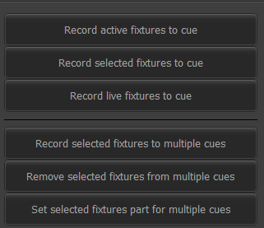
- The arrow next to Record Cue (Figure 86) opens up a window, which is shown in Figure 89.
Figure 89
Record Cue Popup
  - Record active fixtures to cue will record all active fixtures into a new cue. Record selected fixtures to cue will record selected fixtures into a new cue. Record live fixtures to cue will record all active fixtures into a new cue and will open the Record dialog box.
  - Record selected fixtures to multiple cues opens up a window (not pictured) that allows the user to add selected fixtures at their current state to selected cues from selected cue lists, including options to only include some attributes. Remove selected fixtures from multiple cues does the same, but in reverse. Both options are similar, but not identical, to the Channels->Add/Del (Figure 114) windows of the Cue List (Figure 107) section.
  - Set selected fixtures part for multiple cues is not necessary at Tucker.

FX Library
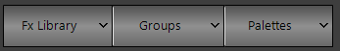
(Figure 90)
Figure 90
FX Library & adjacent buttons
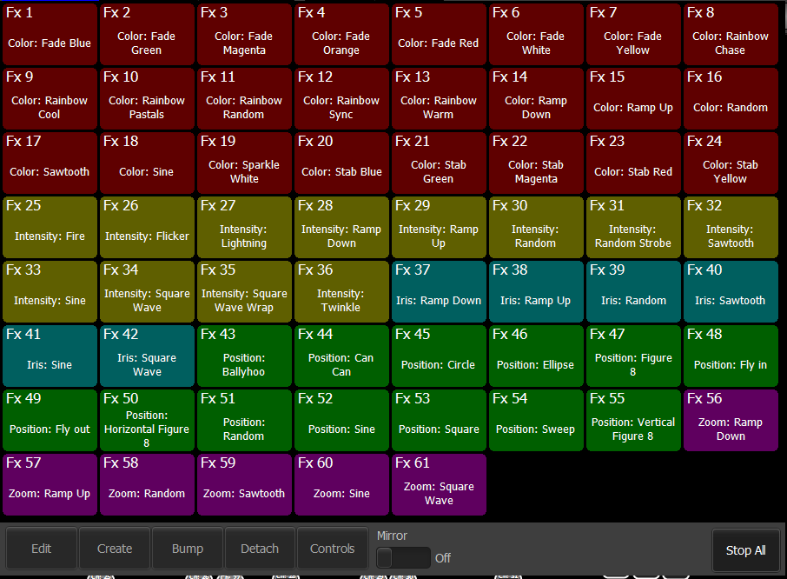
Pictured is the portion of the top of the Live (Figure 20) window. Groups are discussed in Figure 104 and Palettes are discussed in Figure 121. Clicking on FX Library opens a window as seen in Figure 91. All of the colored boxes here describe a different effect; red is for color, yellow for intensity, blue for iris, green for position, and purple for zoom. I will not attempt to describe the different effects as it is the designer’s choice as to which ones will be used.
Figure 91
FX Library
To apply an effect to a light, select the desired lights, open the window, and apply an applicable effect. If trying to apply an effect with an attribute that the selected fixture does not have, nothing will happen. Edit opens Effects Editor (not pictured - Figure 115). Bump will remove a selected fixture from a currently running library effect.
It is extremely finicky to record effects to cues, and have to modify them and write down what you modified; however, even though there is a way to record them to FX Playbacks (Figure 134) and robustly control them, I don’t know how to do that. As it stands, the process is to select your lights, open the FX Library, apply an effect, modify it with the variables in Error! Reference source not found. — Length, Offset, Scale, Stagger, and Cluster (I don’t know what they mean, so will not attempt to describe them) — and record them into the cue. Sometimes there will be multiple FX controls; they go where the Sidebar Cue List (Figure 42) is under a new tab called Library FX Control (not pictured).

Copy
(Figure 93)
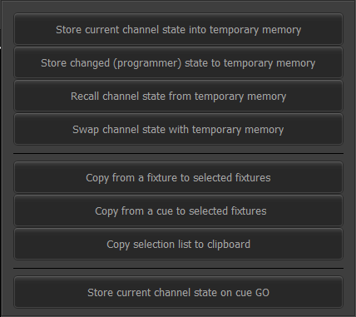
Copy can be used to increase the speed of programming for the board operator. Copy & Paste (Figure 67) can be used as normal copy and paste keys.
Figure 93
Copy
- Store current channel state into temporary memory can be used to save the current output temporarily while doing something else. Store changed (programmer) state to temporary memory does the same thing, but for changed channel data. Recall channel state from temporary memory is used to recall that data. Swap channel state from temporary memory will put the current output into temporary memory and the output previously stored in temporary memory onto the stage.
- Copy from a fixture to selected fixtures allows the user to select fixtures, press the button, then select another fixture whose intensity they want to copy into the originally selected fixtures.
- Copy from a cue to selected fixtures opens up multiple windows (not pictured) allowing the user to make a selected fixture have the intensity that it has in the cue that the user chooses.
- Copy selection list to clipboard allows the user to copy a list of fixtures currently selected, identified by channel numbers interspersed with commas, which can be useful in adding lists of fixtures to places that aren’t directly allowable by the GUI.
- Store current channel state on cue GO can be selected to allow for intensity-setting before a cue has to be run; the operation stores the channel state into temporary memory before the GO.

Blind
(Figure 95 & Figure 94)
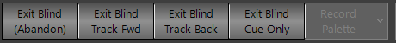
When entering the Blind section, a warning as shown in Figure 95 appears above the Sidebar Cue List (Figure 42).
Figure 94
Blind Options
Figure 95
Blind Warning
Blind mode allows the user to make changes to cues that will not be seen on the stage. The main difference between Blind and Live (Figure 21), apart from the fact that changes will not be seen on stage, is that changes are automatically saved. This means that the Record (Figure 84) button does not have to be pressed, and is thus why the Blind options replace the Record options (Figure 86). Pressing [Record] while in Blind will have unintended consequences.
Most of the lighting controls are the same; however, double-clicking on a light will not change its intensity. When editing a cue in this section, the cue currently outputting will be outlined in yellow, while the cue being edited will be highlighted in blue.
The user can “race” the pace of the show by editing cues before they need to be run. Pressing GO (Figure 61) or running the cue in another way still moves the user to the next cue. If that cue was edited in this section, the changes will appear on stage. This does not change the cue that th user is editing or the modifications that they have made there.
- Exit Blind (Abandon) will exit blind while not saving any changes.
- Exit Blind Track Fwd and Exit Blind Track Back are concerned with tracking changes, which is not something that we do here at Tucker.
- Exit Blind Cue Only is a bit of a misnomer, as it exits the section in cue only mode, not only having changed the current cue — multiple cues can be changed in succession in this section. Clicking on Live (Figure 21) has the same effect.

Groups
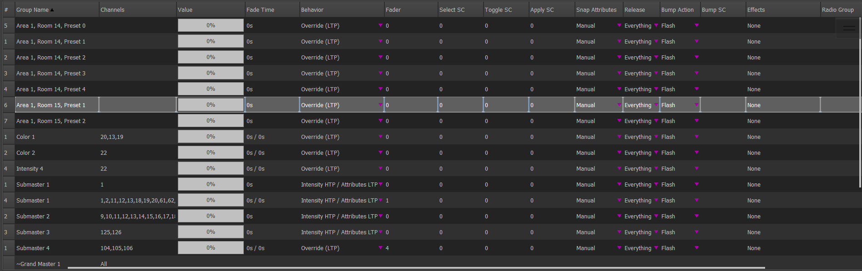
(Figure 96)
Figure 96
Groups List
The Groups section is used to edit groupings of lights. Everything, from Grandmasters to Vision.net presets, can be found here. Displayed in Figure 96 is the chart used by the section to show all of its groups. At Tucker, groups are used primarily as part of submasters and to make selecting sets of lights faster. I can’t imagine any other use for them.
- Group Name can either be specified by the user or come from the software, as is the case with the Vision.net presets. Submaster names specified with Change description (Figure 141) do not appear changed in this section.
- Channels is a comma separated list of all of the channels included in the group. Double-clicking it makes it an editable text field where fixtures can be added and removed.
- Value is a field showing the intensity of the group. Double-clicking it makes it an editable text field where the group’s intensity can be changed.
- Fade Time has an unclear function.
- Clicking on an item in the Behavior section opens up a dropdown (not pictured) that governs how the groups’ values interact with already-existing values; this is not necessary here at Tucker except for submasters; for them, I would recommend Intensity (HTP) / Attributes (LTP)
- Fader defines the physical fader that the group’s intensity control uses.
- Select SC is used to assign a shortcut that, when clicked, can be used to select the group.
- Toggle SC is used to assign a shortcut that, when clicked, can be used to toggle the group.
- Apply SC is used to assign a shortcut that, when clicked, can be used to apply the group.
- Snap Attributes opens a dropdown (not pictured) for how the group behaves when assigned an intensity.
- Release describes how a group behaves when released, and opensa dropdown of options (not pictured) for this.
- Bump Action (Figure 97) affects what the bump button on the console does when pressed.
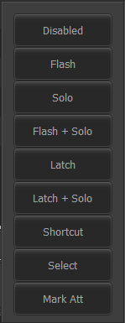
  - Disabled removes any functionality.
Figure 97
Bump Action
  - Flash makes it so that it only operates the submaster when pressed. The Momentary toggle (Figure 138) has the same function.
  - Solo makes it so that the submaster deactivates any other active submasters when activated; it does not go to 100.
  - Flash + Solo is the same as Solo, except that it makes the submaster go to 100.
  - Latch makes the submaster stay at 100, even when the button is released.
  - Latch + Solo combines Solo and Latch.
  - Shortcut makes it so that the submaster bump button activates a shortcut, adjustable in Bump SC.
  - Select selects the channels in the submaster when the button is pressed.
  - Mark Att is not necessary for Tucker.
- Bump SC defines the shortcut run when Shortcut is chosen as the bump button’s behavior.
- Effects allows the addition of an effect to a group, which is not necessary here at Tucker.
- Radio Group is a text field; multiple submasters can be assigned to one number. When one submaster is raised, all of the others go to 0.
Figure 98
Group Sorting
At the top right of the Groups page is this bar, containing All, Selection Shortcuts, Toggle Shortcuts, Apply Shortcuts, Groups, Submasters, Presets, Intensity, Position, Color, Beam, Edge, Utility, and VN Preset. Selecting one or multiple allows the user to see the groups associated with that data. The shortcut fields apply if there is data in those cells. Intensity-Utility are similar to special palettes and are not useful here at Tucker.

Group Options
(Figure 99 & Figure 100)
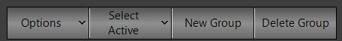
At the top right of the section, there is a bar with options. Options opens a window as shown in Figure 100. Select Active selects all groups with non-zero intensities, while the arrow next to it opens a popup (not pictured). The popup has three options:
Figure 99
Group Options
- Select Inactive Groups selects the opposite of Select Active.
- Select All selects all groups.
- Unselect All deselects all groups.
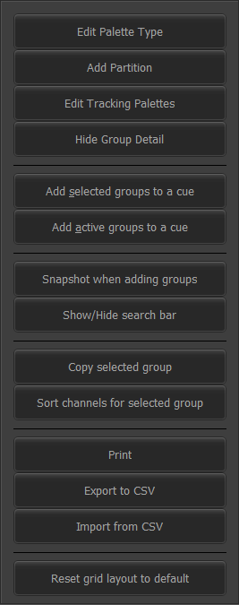
New Group opens a popup (not pictured) with a blank text field allowing the user to define the name of a group; once the user hits OK or presses [ENTER], a new group will be created by that name; Add (Figure 72) has the same function. Delete Group allows the user to select any groups — the user can use control or shift keyboard shortcuts similarly to how they are used in Windows to select rows— and delete them. This is the only way to delete submasters.
Figure 100
Group Options
The arrow next to Options opens up a window as seen in Figure 100.
- Edit Palette Type opens up a table (not pictured) which allows the user to edit which attributes can be recorded to groups; this is not applicable to Tucker.
- Add Partition is not applicable to Tucker.
- Edit Tracking Palettes opens a window with an unclear function.
- Hide Group Detail hides the group detail (Figure 103). When this is chosen, the button switches to Show Group Detail; clicking this does what you think it would.
- Add selected groups to a cue and Add active groups to a cue open up a window (not pictured) similar to Record Cue (Figure 87).
- Snapshot when adding groups is not applicable to Tucker.
- Show/Hide search bar shows the search bar at the bottom of the screen (not pictured). The search bar can be used to search for text in the group rows and has Close, Find Next, and Find Previous buttons and a text field that are all self-explanatory.
- Copy selected group will make a copy of the selected group with a (1) after the original name; it can work with multiple groups selected at a time; a fader will not be assigned for any copied submaster groups.
- Sort channels for selected group is supposed to take the channel list and resort it sequentially, but this did not work when I tried it.
- Print is not useful at Tucker.
- Export to CSV will open the file dialog (not pictured) and export the groups to a ‘.csv’ file. Import from CSV will do the same but in reverse.
- Reset grid layout to default will return the grid to normal, if any heights or widths were automatically or manually adjusted.

Recording Groups
(Figure 101)
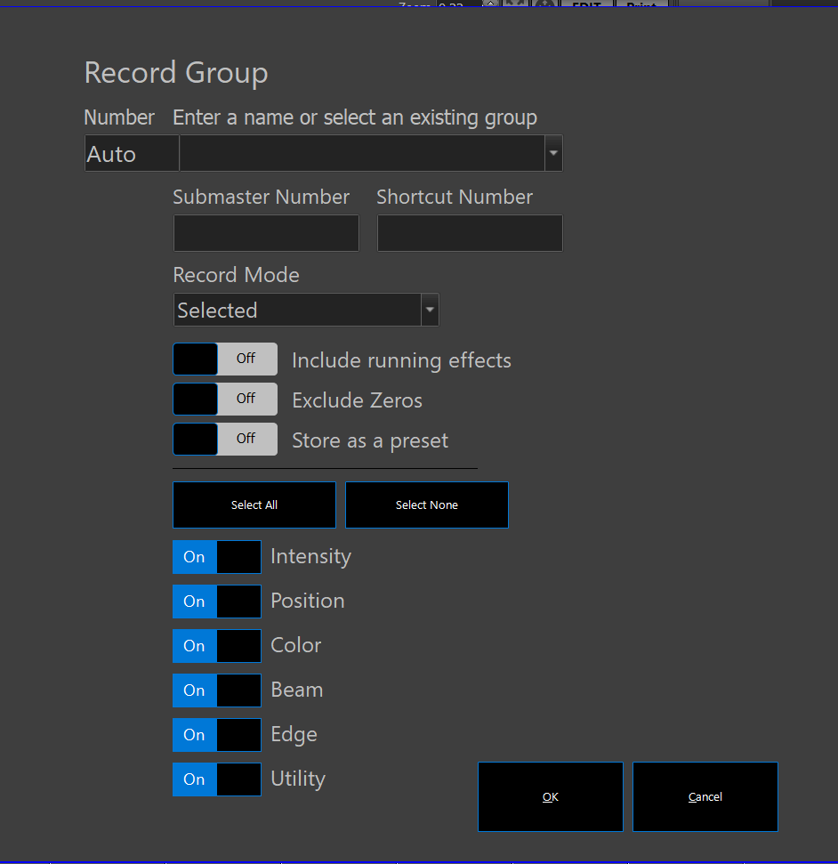
When trying to record a group, the best option is to select the lights that you want and type RECORD GROUP ENTER (it won’t let you select anything other than SELECTED, & you have the option of going through SPECIALS) (Figure 84), or to select the lights that you want and press Record Group for a more verbose option (Figure 86).
Figure 101
Record Group
- Number defaults to Auto, which just uses the next-highest number; however, if the user would like, they can select a number of their own choosing. If the number has already been used for a group, then the screen will change to say Update Group (not pictured).
- Enter a name or select an existing group allows the user to customize the group name. If an already-existing group is selected, once again the screen will change to say Update Group (not pictured).
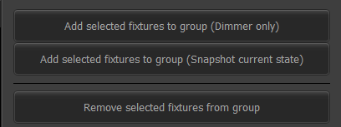
- Submaster Number allows the user to assign a submaster number to the group.
Figure 102
Group Select
- Shortcut Number allows the user to assign a shortcut number to the group.
- Record Mode
- The Record Group toggles are as follows:
  - Include running effects will include any running effects from user input.
  - Exclude zeroes will exclude any fixtures with data specifically a zero from the group.
  - I believe that Store as a preset has to do with Vision.net; we are not recording anything from the console to Vision.net so we should be fine.
- The Update Group toggles are identical to the Record Group toggles except where noted below:
  - In Update Group, there is no option to Store as a preset.
  - Update existing data only will only update any old data which is in conflict with new data.
  - Re-record (replace) will replace the entire group and re-record it.
- Select All and Select None select and deselect all of the attribute toggles. Intensity, Position, Color, Beam, Edge, and Utility are all attributes that the user can choose to include or not include in groups.

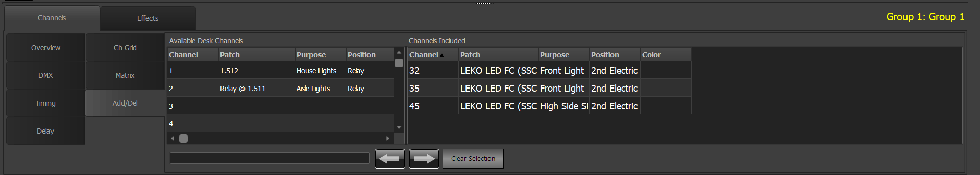
Group Detail
Figure 103
Group Detail
(Figure 103)
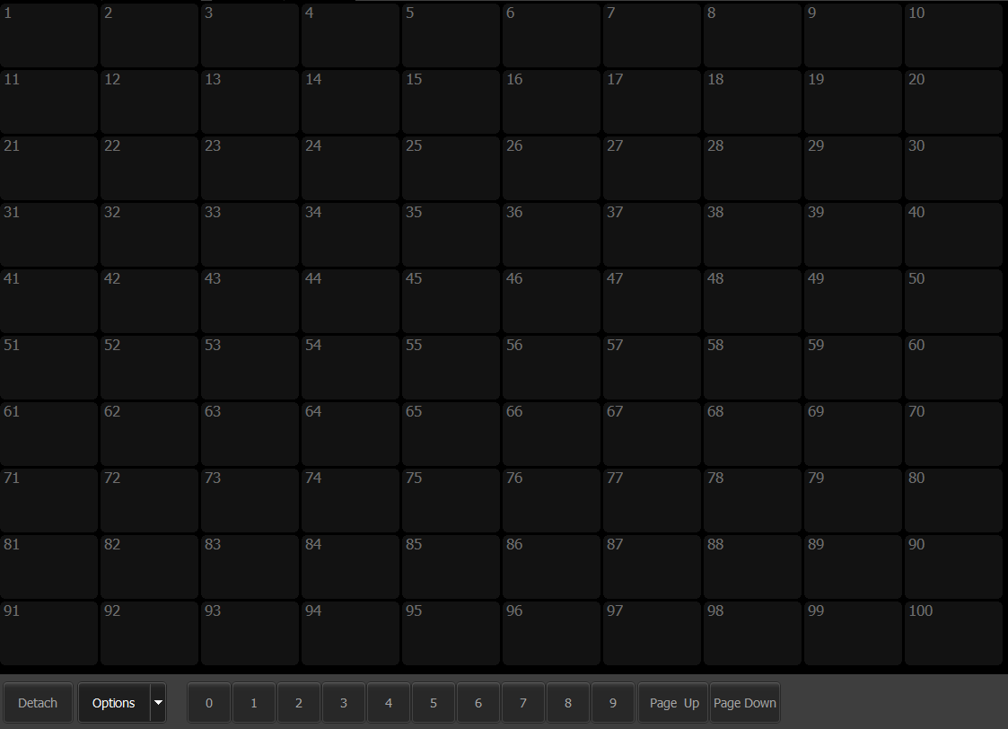
While there are many options here, I would argue that the only one that you really need is Channels->Add/Del. The detail window is navigated by clicking on an option on the top first, and then selecting one of the options from the left; depending on which column you click on, the columns can change order. Keep in mind that every time you click a different group, the detail window returns to Channels->Overview. On the left of this screen, you see a list of all of the channels patched into the console under Available Desk Channels. On the right, under Channels Included, you see a list of all of the channels included in the group. Selecting channels on the right and clicking the left arrow removes them from the group, while selecting channels on the left and clicking the right arrow adds them to the group. Clear Selection is self-explanatory.
Figure 104
Live Groups

Live Groups
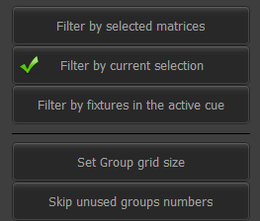
(Figure 104)
Figure 105
Live Group Options
This section is used in the Live (Figure 21) view to select groups. Detach will detach it from its arrow-box. The page numbers and everything are similar to the Submaster page (Figure 138).
Right-clicking on the window will produce options (not pictured) that are pretty self-explanatory in terms of what they do; it is mostly image and color and text editing.
The only important thing in Figure 105, the dropdown from Options in Figure 104, is Filter by current selection — this allows the user to only see those groups which have a currently-selected fixture in them.

Cue List
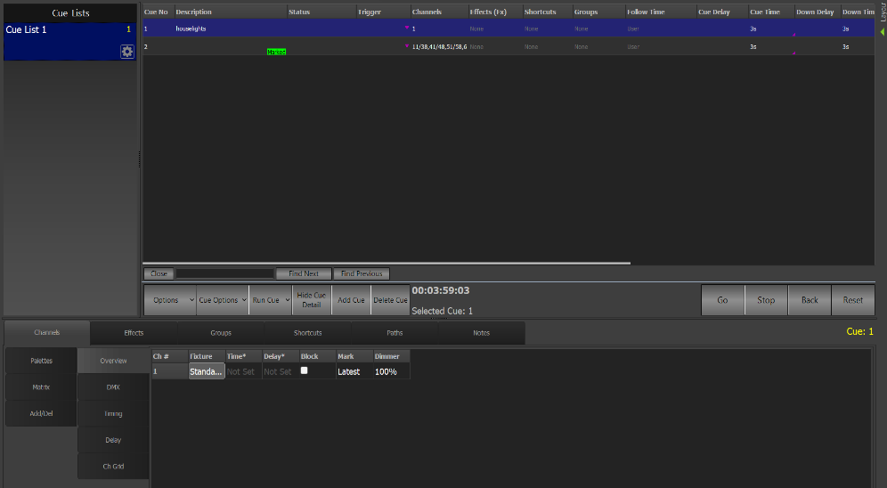
(Figure 106)
Figure 106
Cue List
The Cue List section is where cues are edited. On the left is the list of cue lists; on the right, the list of cues in the current cue list; and on the bottom, the cue list detail screen. Release all cue list control (Figure 80) releases all cue list control, as does Rel Cue List (Figure 62).

Cue List
(Figure 107)
Figure 107
Cue List
This is the chart where the cues for the selected cue list are shown. While most of these things are discussed in greater depth in Record Cue (Figure 87), I will include the names here for searchability: Cue No, Description, Status, Trigger, Channels, Effects(Fx), Shortcuts, Groups, Follow Time, Cue Delay, Cue Time, Down Delay, Down Time, Fx Delay, Timecode, Link, Macro, Notes. FX and groups are, however, not discussed in the Record screen. A cue with a yellow bar in the Status column means that that cue is currently outputting. A blue cue is highlighted.
Figure 108
Cue List Buttons
- Options pulls up a list of options as described in Figure 111.
- Cue Options pulls up a list as described where in Figure 112.Run Cue has a function analogous to that of Run in Figure 42. The arrow next to it pulls up a window as shown in Figure 109.
  - Run Cue has a function analogous to that of Run in Figure 42, as does Goto Cue despite me thinking that it would make more sense to have it open a text entry field with the ability to go to a certain cue.
  - Goto cues with a double click or button press is a checkbox that seems to change nothing in how cues are run in the cue list window, despite its name.
- Hide Cue Detail will hide the cue detail windows, shown in
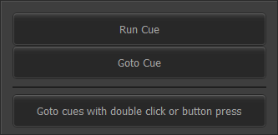
- Add Cue will add a new blank cue below the selected cue, unless Record channel state when adding cues (Figure 111) is activated.
Figure 109
Run Cue Options
- Delete Cue will delete the selected cue(s). If the cue has a yellow bar in the Status column, meaning that it is live in playback, a warning will appear (not pictured) saying that you can’t delete a cue live in playback.
- The following items are analogous to those found in Figure 42: Go, Stop, Back, and Reset.
- The following items are part of the search bar (not pictured) which has a text entry field: Close closes the search bar; Find Previous and Find Next are self-explanatory. Show/Hide search bar (Figure 111) has the same function.

Cue List Properties
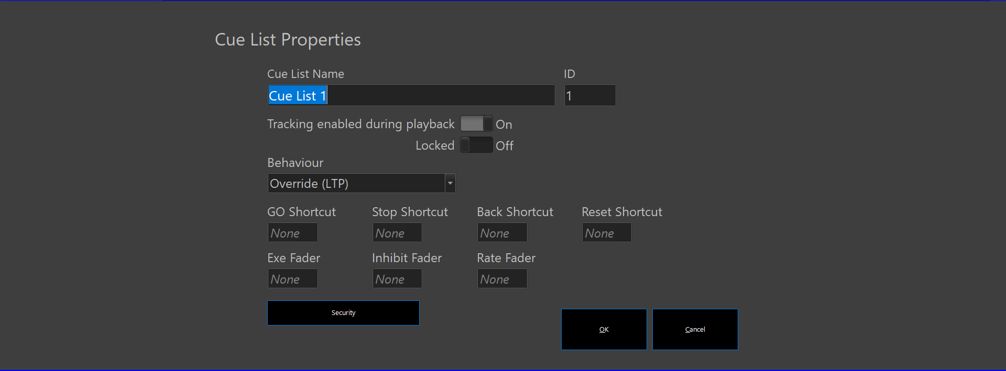
(Figure 110)
Figure 110
Cue List Properties
Clicking on the gear next to the cue list name (Figure 106) opens up a window as shown in Figure 110. Edit Cue List Properties & Create a new cue list (Figure 111) can also open this window.
- Cue List Name is the name of the cue list.
- ID is its number.
- Tracking enabled during playback is not necessary as we do not use tracking; it should be turned off.
- Locked prevents editing of the cue list; it should not be locked.
- Behaviour governs how the cue list interacts with other control elements; Override (LTP) is recommended, as that provides the most intuitive option. More information on behavior can be found on page 352 of the guidebook.
- GO Shortcut, Stop Shortcut, Back Shortcut, and Reset Shortcut can all be assigned as shortcut numbers to engage the respective operations.
- Exe Fader is a submaster that can be assigned to trigger the cue list, but this is not necessary here at Tucker.
- Inhibit Fader is a submaster that can be assigned as a grandmaster for the cue list.
- Rate Fader is a submaster that can be assigned to slow or speed up the cue list’s fade time.
- Security is not necessary at Tucker.

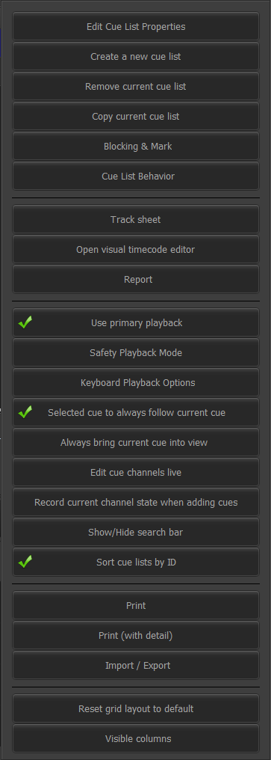
- Edit Cue List Properties opens up a window identical to that of Figure 110, as does Create a new cue list; however, the former is intended to edit the current one, while the latter is intended to create a new one.
Figure 111
Cue List Options
- Remove current cue list will bring up a warning (not pictured) before deleting the current cue list.
- Copy current cue list will generate a copy of the cue list.
- Blocking & Mark is not necessary here at Tucker; this button does, however, open a window to the side.
- The modification of Cue List Behavior is not necessary either but this button also opens a window to the side.
- Track sheet will open up a window (not pictured) that shows a more visual representation of what each fixture is doing during the whole cue list; it just displays intensity and color.
- Open visual timecode editor is not necessary at Tucker.
- Report opens a window (not pictured) that can generate two reports. They are the Channels used in cues and Palettes and groups used in cues. They are console screens and not ‘.pdf’ reports.
- Use primary playback has to do with external fader wings, which is not necessary here at Tucker.
- Safety Playback Mode is discussed in Figure 61.
- Keyboard Playback Options pulls up a window with multiple options to modify how cues are pressed; this is not recommended.
- Selected cue to always follow current cue should be enabled as it ensures that the cue on stage will be selected when it is run.
- Always bring current cue into view has an unclear function.
- Edit cue channels live should be turned off to allow for editing of the cue while it is live on stage.
- Record channel state when adding cues, when checked, makes Add cue (Figure 108) record the current channel state when making a new cue.
- Show/Hide search bar is self-explanatory
- Sort cue lists by ID should be checked, as it sorts cue lists in numerical order.
- Print and Print (with detail) are not necessary at Tucker, as we don’t have a connected printer.
- Import/Export import or export the cue lists to ‘.csv’ files.
- Reset grid layout to default does as it says.
- Visible columns allows the user to adjust which parts of the cue data chart they see.

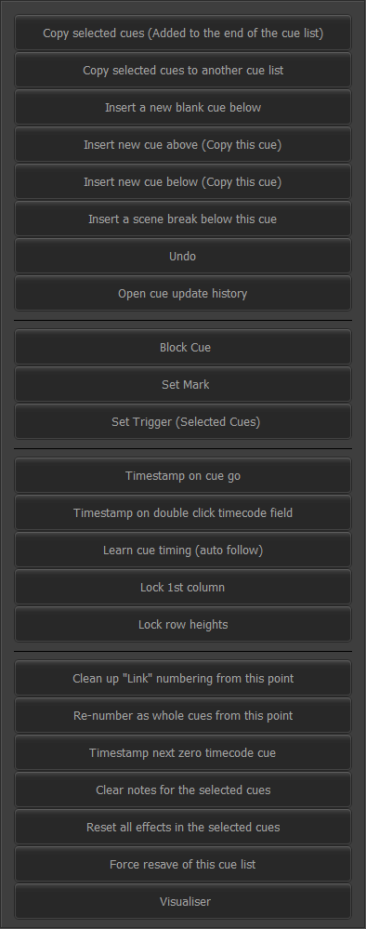
- Copy selected cues (Added to the end of the cue list) will copy selected cues as new cues at the end of the cue list.
Figure 112
Cue Options
- Copy selected cues to another cue list will do the same, but prompt the user which cue list to add cues to.
- Insert a new blank cue below does the same thing as Add Cue (Figure 108), unless Record channel state when adding cues (Figure 111) is activated.
- Insert new cue above (Copy this cue) does as it says.
- Insert new cue below (Copy this cue) does as it says.
- Insert a scene break below this cue inserts a scene break below the cue; I find these helpful to describe actions that happen in between cues, and/or scene breaks and things of that nature.
- Undo will undo the last action undertaken in the cue list.
- Open cue update history opens a window (not pictured) of changes made to the cue list; you can go back and look at what something looked like with Preview, and if you want to return to that, set Apply.
- Block Cue, Set Mark, Set Trigger (Selected cues), Timestamp on cue go, Timestamp on double click timecode field, and Learn cue timing (auto follow) are all unnecessary at Tucker.
- Lock 1st column means that the first column will be locked from editing.
- Lock row heights, does the same, but for the heights of all the rows.
- Clean up “Link” numbering from this point is not necessary at Tucker as we just linearly move from one cue to he next; this would be if we were having to fuss around with the Link column.
- Re-number as whole cues from this point does as it says; this option is not recommended because it may mess with your ability to stay on the script.
- Timestamp next zero timecode cue is not necessary at Tucker.
- Clear notes for the selected cues does as it says — not the descriptions, but the notes, all the way to the right.
- Reset all effects in the selected cues does as it says.
- Force resave of this cue list does as it says.
- Visualiser is not applicable to us because we don’t have visualizer software, nor really the need for it.

Cue List Detail
(Figure 113 & Figure 114)
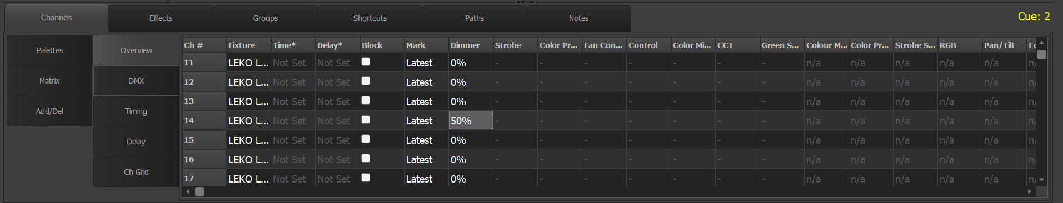
While there are many options here, I would argue that the only ones that you really need are Channels->Add/Del and Channels->Overview. The detail window is navigated by clicking on an option on the top first, and then selecting one of the options from the left; depending on which column you click on, the columns can change order. Keep in mind that every time you click a different group, the detail window returns to Channels->Overview.
Figure 113
Cue List Detail Overview
Channels->Overview is a great place, along with Blind (Figure 95), to edit cues on the fly before they come on stage. The overview displays the data of the selected cue, and any cell except Ch # and Fixture can be edited. I would recommend against editing the Time, Delay, and Block columns, as that leads to having to worry about complex timing and all of that nonsense. Everything else in the chart is attributes, which I will not list here.
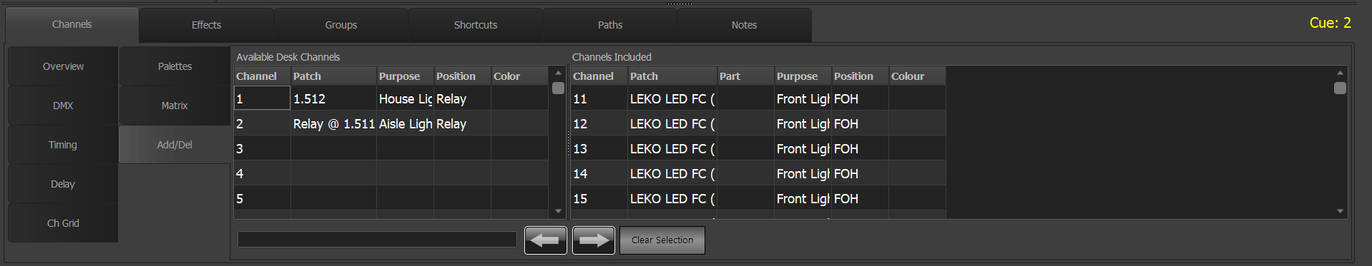
On the left Channels->Add/Del, you see a list of all of the channels patched into the console under Available Desk Channels. On the right, under Channels Included, you see a list of all of the channels included in the cue. Selecting channels on the right and clicking the left arrow removes them from the cue, while selecting channels on the left and clicking the right arrow adds them to the cue. Clear Selection is self-explanatory. This feature is somewhat duplicated in the Record selected fixtures to multiple cues and Remove selected fixtures from multiple cues options (Figure 89).
Figure 114
Cue List Add/Delete

FX List
(Figure 115)
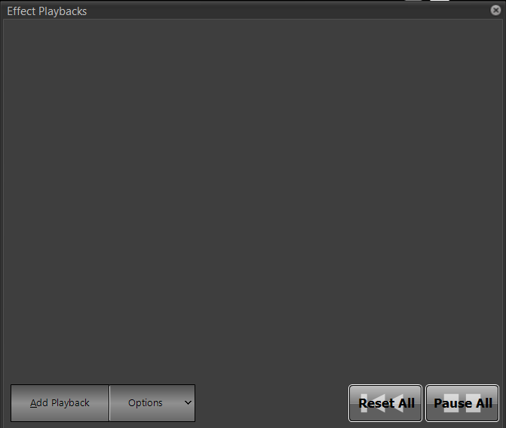
The FX List is pictured here but is described with FX Playbacks (Figure 134).
Figure 115
FX List

Palettes
(Figure 116)
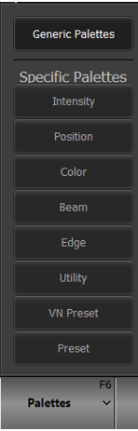
The Palettes section involves two separate concepts: generic palettes, which are places to store attributes for consistency, and specific palettes, which are like cues in that they are specific attribute states for specific lights.
Figure 116
Palettes
This manual will not dive too deeply into the world of specific palettes, as they are more for live shows that require an element of busking, which Tucker does not really have. Instead, Tucker quite often uses generic palettes — storing data usable by any fixture at any time.
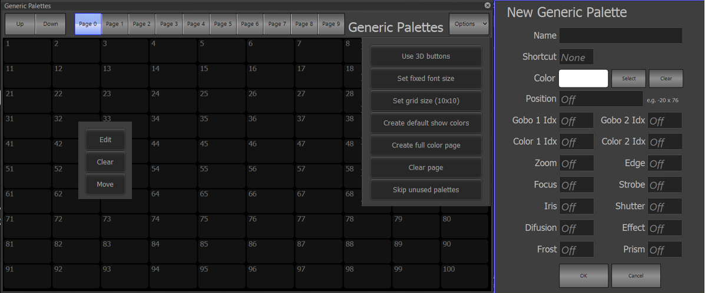
Figure 117
Palettes Options

Pressing Palettes (Figure 116) opens up a popup that allows the user to see and adjust all of the palettes that have been recorded. As discussed previously, the Specific Palettes can be safely ignored; the only important thing is “Generic Palettes.” Pressing this button opens a window pictured on the left of Figure 117. The Page number buttons on the top describe the first number for each palette on the page — thus, under standard settings — not changing Set grid size to a non-10x10 configuration — a palette can be assigned to any number starting at 001, while the last palette reachable by the Page buttons is 1000; after that, only the Up button can be used to reach higher palettes. In any case, the Up button makes the screen move a page higher, while the Down button moves a page lower. Clicking Options opens up a popup with 7 options.
- Use 3D buttons, according to the manual, is intended to make the buttons in this popup appear with a 3D gradient, but it does not seem to work.
- Set fixed font size is unnecessary.
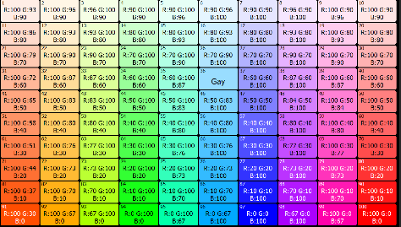
- Set grid size opens up a popup asking the user to change the number of columns per page, then rows per page, and can be used to adjust how many palettes appear on each page. In the Options popup, the current grid configuration is displayed in parentheses after the button name. Pressing Cancel (not pictured) before both numbers are entered will stop the entire operation. 0 cannot be entered.
Figure 118
Full color page
- Create default show colors will create 17 default colors that can be used on the show; this can also be achieved by clicking Auto Create (Figure 52). Create full color page will create a palette of 100 colors to be used in the show, as shown in Figure 118. Both create the same number of palettes regardless of page size. In either case, the software will look for the first available page(s) where either the full 17 or full 100 can fit.
- Clear page will remove all of the palettes from the current page.
- Skip unused palettes has an unclear function.
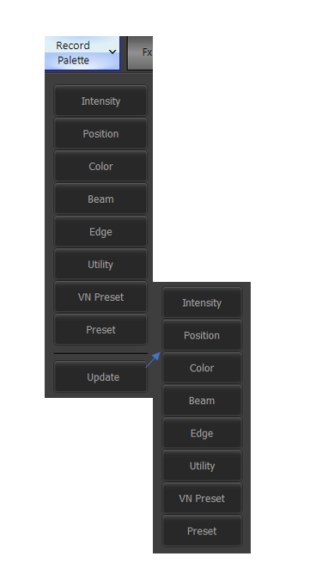
Left-clicking a palette in the Figure 117 window will open a popup with three options. Edit opens up a window identical to the one pictured in the left of Figure 117. Clear will open up a popup asking the user if they want to delete the current palette, and upon selecting Yes (not pictured) the palette will be deleted – No (not pictured) stops the operation. Move has an unclear function.
Figure 119
Record Palette (Live)
New Generic Palette (Figure 117) allows the user to record a palette. Edit (Figure 117) allows the user to reach this window. Name allows the palette to be named – see Figure 118 for an example of a palette named “Gay.” Shortcut allows the user to assign a shortcut to the palette. All of the fields listed below that are for variables, such as Iris and Color.
Additionally, in the Live section (Figure 21), Record Palettes opens up a window (Figure 119) that allows the user to record an attribute to a palette. This is for specific palettes and is not necessary at Tucker.

Live Palettes
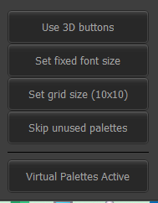
(Figure 121)
Figure 120
Live Palette Options
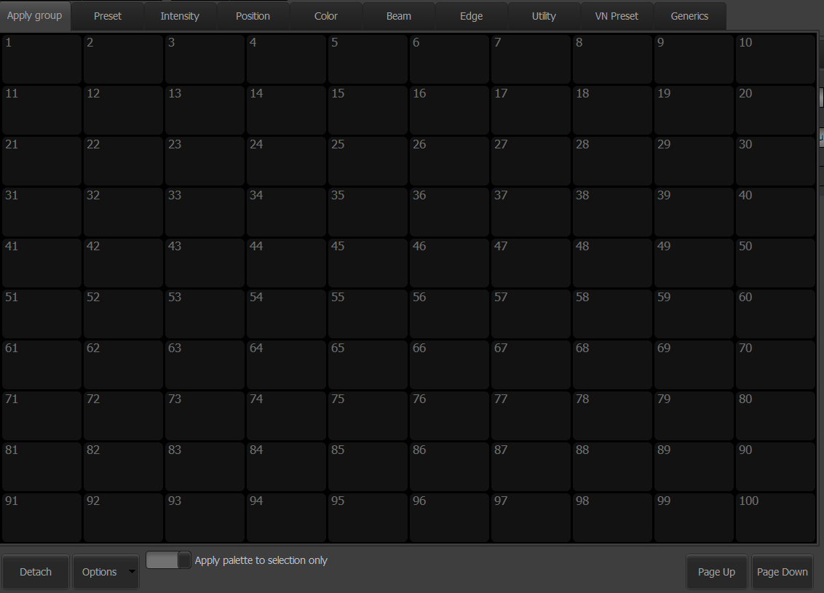
This window is basically the same as the Live Groups (Figure 104). Along the top are all the specific palettes; the farthest to the right is the Generics, which is where all of the Tucker palettes are kept. Apply palette to selection only is not useful for Tucker as it is intended for specific palettes. Detach will detach it from its arrow-box. The page numbers and everything are similar to the Submaster page (Figure 138).
Figure 121
Live Palettes
Right-clicking on the window will produce options (not pictured) that are pretty self-explanatory in terms of what they do; it is mostly image and color and text editing.
Options opens up a window, as seen in Figure 120. The only notable thing here is Virtual Palettes Active insofar as I have to tell you not to worry about it as it is beyond our scope of practice.

Patch
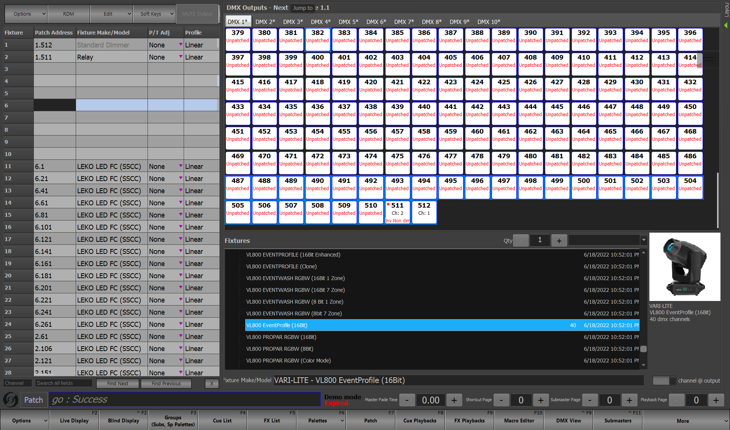
(Figure 122)
Figure 122
Patch
In the Patch section, there are three sections: the left, which is the channel chart — on top of the channel chart are the function groups —; the top right, which shows the DMX universes; and the bottom right, which is the fixture library. The middle line can be recentered, in order to be able to see more of the right side or more of the left side. In the most basic patching operations, fixtures and their quantity are selected from the bottom right library to the top right DMX universe, and then ‘pulled’ to the left desk channels. For best results, patch fixtures below everything else to avoid messing with the other fixtures. When exiting the section after having made changes, a popup opens (not pictured) that asks if the user wants to save the changes that they made. Only one of the four options, Revert to last saved patch, will allow the user to not save the changes to the patch; an option with the same name is available in Figure 129.

Channel Chart
(Figure 123)
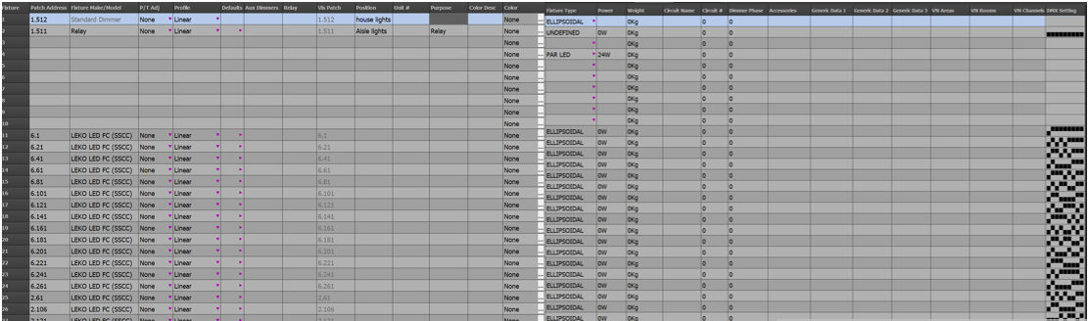
The channel chart displays all of the patched channels. There is a search bar here (not pictured) that can be shown/hidden with Show/hide search bar (Figure 129). Recall from the Our fixtures section that multiple DMX channels can be patched into a desk channel. One desk channel can have multiple sets of data, which are in this chart. Standard Microsoft cell selection keyboard shortcuts apply here. Click and drag from the DMX Universes (Figure 126) part of this section to patch fixtures into this chart. A report of the leftmost attributes, from Fixture to Phase, can be produced via Channels / Fixtures (Figure 150).
Figure 123
Channel Chart
- Fixture is for the desk channel number. We use 1 through 202 here at Tucker.
- Patch Address is for the network address of the fixture. 2.74 would be fixture number 74 in the second universe. The fixture only knows the second half of the number — the 74 — because it is only plugged into the one universe. It is up to the console to know the rest. If Show patched addresses as absolutes (Figure 129) is clicked (not recommended), then this column will show the absolute DMX values. The width of this column can be automatically adjusted to the widest address by clicking Auto size ‘Patch Address’ column (Figure 129).
- Fixture Make / Model is where the make and model of the fixture are displayed, from the fixture library. The fixture library can be edited from More (Figure 146).
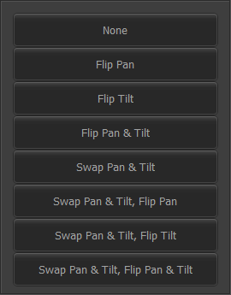
- P/T Adj has a purple dropdown that opens up a window as seen in Figure 124. To Flip an attribute, in this sense, means to make it so that an increase on the console will decrease the actual value in the light, and vice versa. Meanwhile, a Swap will make it so that one attribute on the console controls the opposite in the light. These same functions are achievable via Figure 131. No Pan/Tilt adjustment (Figure 131) will probably clear these adjustments.
Figure 124
Pan and Tilt Adjust
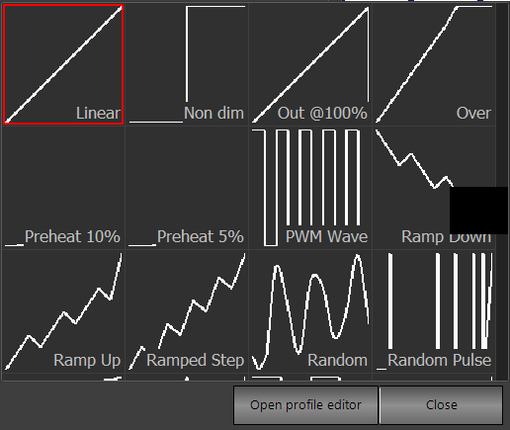
- Profile has a purple dropdown that opens up a window as seen in Figure 125. Open profile editor opens the profile editor, as seen in Figure 153. Close closes the window. If a non-linear profile is selected for the light, it will be displayed in the Live section (described in Figure 41).
Figure 125
Profile
- Defaults opens a window (not pictured) that allows the user to, I believe, edit the default starting value.
- Aux Dimmers and Relay are not applicable to the operations at Tucker, nor is Vis Patch.
- Position, Unit #, Purpose, Accessories, and Color Desc are all text fields that can hold different types of information about light. All of these fields except for Accessories will be displayed in the Verbose (Figure 25) view of the Live (Figure 6) section. Position is used at Tucker for information about where it is located, and then Purpose for information about what type if fixture it is and what it does.
- Color opens up the generic color chooser (Figure 52-Figure 60) that can be used to assign the fixture a color. This color doesn’t affect the output of the console. Color Desc will be autofilled with the name of the color filters (Figure 58), if those are put into the Color field.
- Fixture Type comes from the Fixture Make / Model column and affects the shape of the fixture when adding fixture symbols to the Magic Sheet (Figure 38).
- Power, if information is entered here, will allow the user to approximate the power of selected fixtures in the Live (Figure 6) section using the Power Monitor (Figure 148). Weight, measured in kilograms, will also appear in that window.
- Circuit Name is a textual field for the fixture’s circuit’s name. Circuit # and Dimmer Phase are numerical fields for more information about the fixture’s circuit.
- Generic Data 1, Generic Data 2, and Generic Data 3 are textual fields used to hold additional information about the light.
- VN Areas, VN Rooms, and VN Channels are not necessary here at Tucker as all of our fixtures are in the same space.
- DMX Setting is an indicator of what the dipswitch on the lights should look like. Some of the fixtures at Tucker do not need this, and instead use the screen on them to determine their channel number, found in the second half of the decimal numbering in the Patch Address column.

DMX Universes
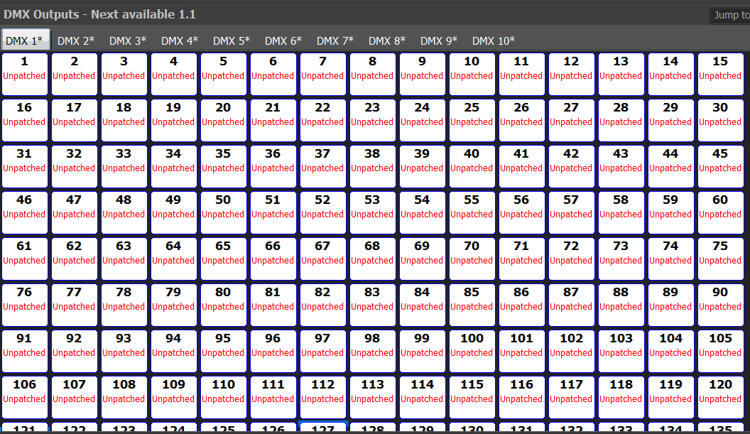
(Figure 126)
Figure 126
DMX Universes
This is the portion of the Patch section where the patched fixtures and their DMX addresses are linked. When patching fixtures, the user can move the mouse over where in the universe, and in which universe, they would like their fixtures. Clicking on a DMX button at the top will take the user to that universe’s 512 DMX channels. The universes that we ‘own’ do not have an asterisk next to their label. Clicking on a channel makes that channel go into its highest possible state — 255 — and clicking it again undoes that. Jump to opens a window (not pictured) that allows the user to enter the number of the DMX universe that they want to view.

Fixture Library
(Figure 127)
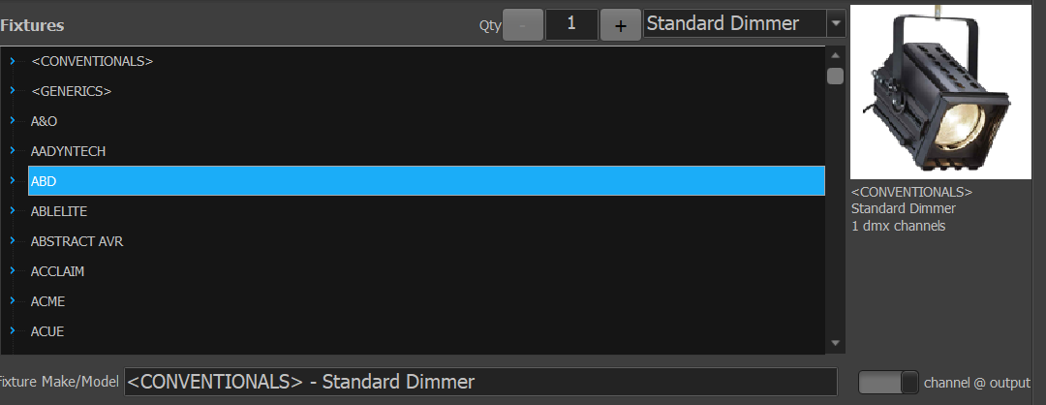
Here is where the fixtures from Figure 152 are able to be patched into the console. To do this, select the brand from the chart in the center of the window. Alternatively, the dropdown on the top right (not pictured) lists fixture types that are already patched into the console.
Figure 127
To patch a fixture, choose a fixture from the chart, and a quantity from the Qty button above it.
The command line below the chart is unnecessary. The channel @ output button should remain on, as it has an unclear function. Above that is a picture of what the fixture might look like, with its fixture group, name, and number of DMX channels below it.

Function Groups
(Figure 128)
Figure 128

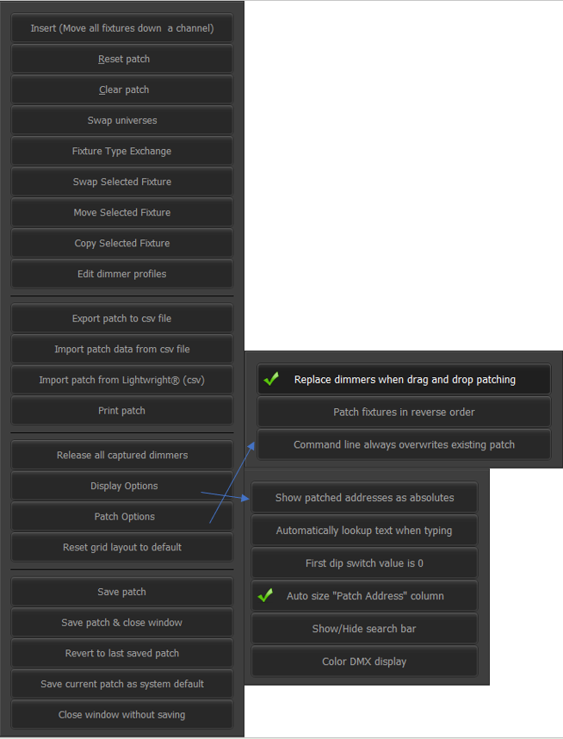
Options will open up a window as shown in Figure 129. RDM (remote device management) allows for bidirectional communication with fixtures, but is not something that ever came up for me; I am not sure if we actually use RDM. Please note that RDM is a more finicky networking protocol than DMX. Edit opens a window as described in Figure 130. Soft Keys opens a window as described in Figure 131. MUTE output will mute the sending of all DMX information. Visible columns will open a window (not pictured) with checkboxes for all of the columns visible in Figure 123.
Figure 129
Options (both right-side windows not displayable at same time)
- Insert (Move all fixtures down a channel) will insert a standard-dimmer fixture with no attributes in the open universe and then move all of the fixtures down a channel, which messes with the supposed dipswitches of fixtures in the same universe and the Magic sheet (Figure 28)
- Reset Patch, Clear Patch, and Release all captured dimmers will mess everything up and are highly inadvisable, so them and their constituent functions are not described here.
- Swap Universes, Move Selected Fixture, and Copy Selected Fixture will most likely not be needed at Tucker as our lighting rig is static. SWAP WITH, MOVE TO, and COPY FROM (Figure 131) have the same functions.
- Edit dimmer profiles will allow the dimmer profile, editable in Figure 153, for each attribute in the DMX Universes (Figure 126) window to be adjusted via opening a window (not pictured) that is basically a copy of the DMX universes window.
- Export Patch to csv file will allow the exportation via a file dialog (not pictured) of all patch data to a ‘.csv’ file. Import patch data from csv file will allow for the importation of patch data from a ‘.csv’ file.
- Import patch from Lightwright (csv) is for users who use visualisers, which is not Tucker at all.
- Print patch is not applicable to Tucker, as we don’t have a printer.
- Display options will open up a window as seen in the bottom right of Figure 129.
- Show patched addresses as absolutes will change the DMX addresses seen in the Patch address column (Figure 123) to absolute DMX values.
  - Automatically lookup text when typing will try to autocomplete typed text in the columns with text from other columns.
  - First dip switch value is 0 has an unclear function, so it is best to remain unchecked.
  - Auto size ‘Patch Address’ column, when checked, will adjust he size of the Patch address (Figure 123) column to accommodate the widest number there.
  - Show/hide search bar will show or hide the search bar at the bottom of the chart in Figure 123, depending on if it is already there or not. It is not pictured currently, but it operates in much the same way as the Find window in Microsoft Word, with an additional X button that closes it and a Channel field to navigate to a specific channel.
  - Color DMX display will make a rainbow with all of the fixtures patched into the DMX universes (Figure 126) portion of the Patch section.
- Patch options will open up a dropdown as seen in the top right of Figure 129
  - Replace dimmers when drag and drop patching has an unclear function, so it should remain checked.
  - Patch fixtures in reverse order should remain unchecked, as its function is also unclear.
  - Command line always overwrites existing patch should be unchecked, as drag-and-drop patching is the preferred method here at Tucker and accidental command-line presses and whatnot could mess things up.
- Save patch will save the current patch information to the showfile. Save patch and close window will do the same thing and return the user to the Live (Figure 6) section. Thes same functions are available by trying to exit the section and not clicking Revert to last saved patch.
- Revert to last saved patch will revert the patch to the last saved state. This has the same function as Revert to last saved patch from the exiting prompt. Save current patch as system default will save the current patch with the name “DEFAULT_PATCH.csv”, which will allow all new showfiles opened in the same folder to be opened with that patch. Close window without saving doesn’t work as intended.

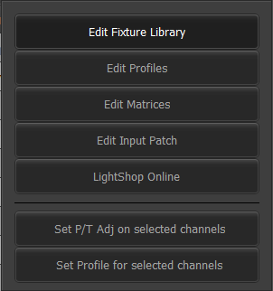
These are the functions in the Edit window (Figure 130).
Figure 130
Edit
- Edit Fixture Library sends the user to Fixture Library (Figure 152).
- Edit Profiles will open the Profile editor window (Figure 153).
- Edit Matrices is not useful as we do not use matrices here at Tucker.
- Edit Input Patch opens a window (not pictured), that seems to affect how the DMX input (Figure 2) affects the rest of the lighting state.
- LightShop Online will open up a window (not pictured) that allows the user to connect to a visualizer.
- Set P/T adjust on selected channels will open up a window (not pictured) with options similar to those on the bottom row of Figure 131 that allow the pan and tilt changes to be adjusted for the selected channels. Set Profile for selected channels does the same thing, but with profiles based off of Figure 125.
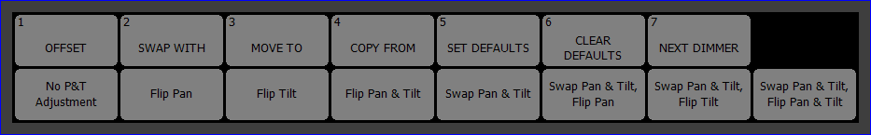
These are the functions in the Soft Keys window (Figure 131).
Figure 131
Soft Keys

- SWAP WITH, MOVE TO, and COPY FROM have the same functions as buttons described in Figure 129.
- SET DEFAULTS and CLEAR DEFAULTS put themselves as text into the command line, thus having unclear functions and uses. NEXT DIMMER puts a number into the command line, but it is unclear what that number describes. OFFSET has an unclear function.
- Flip Pan, Flip Tilt, Flip Pan & Tilt, Swap Pan & Tilt, Swap Pan & Tilt, Flip Pan, Swap Pan & Tilt, Flip Tilt and Swap Pan & Tilt, Flip Pan & Tilt all have functions identical to those described in Figure 124. No P/T Adjustment will clear these adjustments.

Cue Playbacks
(Figure 133 & Figure 132)
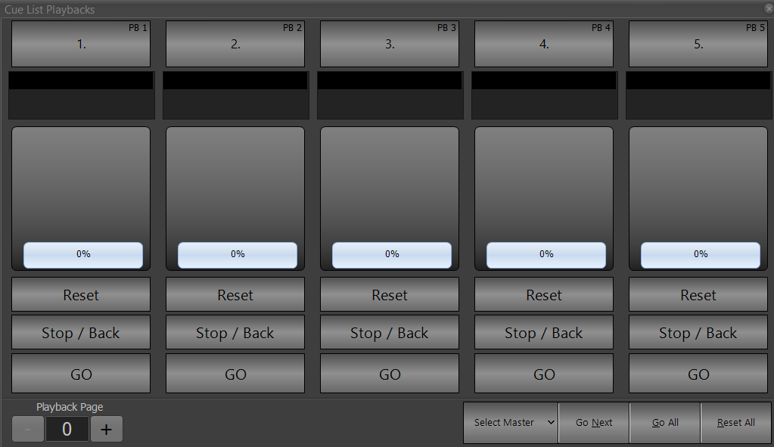
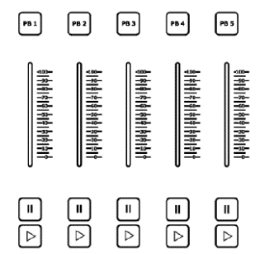
Cue playbacks are not particularly helpful here at Tucker, as they are designed for the usage of multiple cue lists at one time; traditionally, we stay within the confines of one cue list at a time. The only information that is necessary to put here is that the 5 buttons/sliders and 5 screen buttons/sliders are analogous to the main STOP/GO buttons. Also, effects (Figure 134) can be assigned to these playbacks.
Figure 132
Cue Playbacks
Figure 133
Cue Playback Physical Buttons

FX Playbacks
(Figure 134 & Figure 135)
FX Playbacks and the FX List (Figure 115) are a powerful way to create effects and control them. However, I do not know how to use them, and find the FX Library (Figure 91) to be sufficient, so the only information that I will give for this section is that effects can be assigned to cue playbacks (Figure 133). I don’t know the relation between the two sections, or between the FX Library and the two sections.
Figure 134
FX Playbacks
Release all effect control (Figure 80) releases any fixture control from an effect, whether or not that effect has been programmed into a cue, submaster, etc. or not.
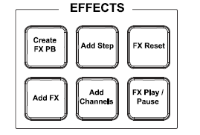
Figure 135
FX Playbacks Physical Buttons

Macro Editor
(Figure 136)
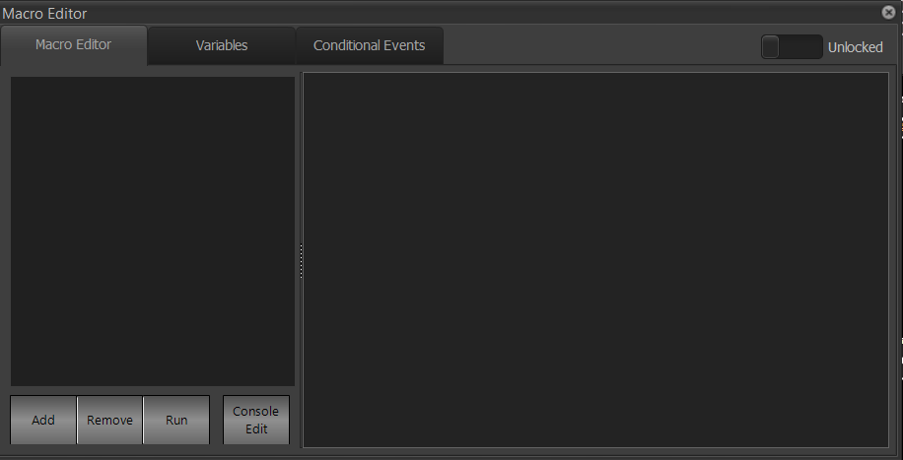
The Macro Editor is used to make complex programming and control shortcuts. At Tucker, we don’t use macros.
Figure 136
Macro Editor

DMX View
(Figure 137)
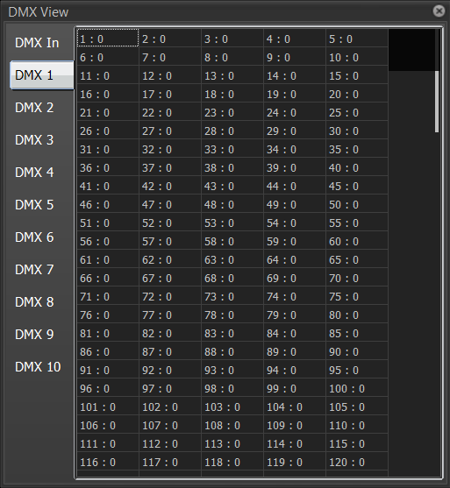
The DMX section can be used to see all of the current DMX outputs on a universe. Different universes can be selected by clicking the buttons on the left. Further, the DMX In allows the user to see any DMX channels coming off of a DMX Line in, which would have little use at Tucker.
Figure 137
DMX View

Submasters
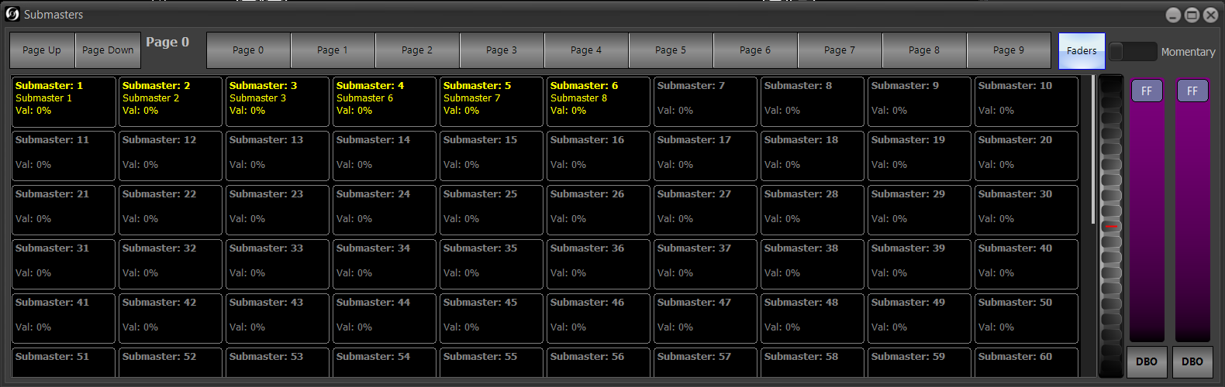
(Figure 138, Figure 139, & Figure 140)
Figure 138
Submaster Grid
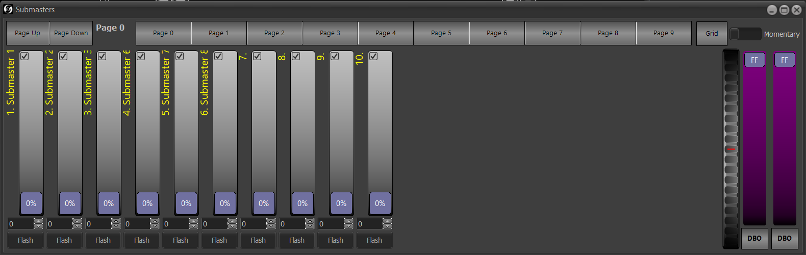
Clicking Submasters will open up a window as seen in Figure 138. Submasters are special groups, permanently assigned to a fader, that allow the intensities of groups to be changed with a physical or software fader. Clicking on Faders in the top left will change the window to 10 virtual faders, as seen in Figure 139. These faders and the physical ones seen in Figure 140 have an identical function and reflect one another’s intensity values. The submasters can have their faders changed via the Groups (Figure 96) window, but the virtual fader will change with it. Their behavior can also change – I would recommend Intensity (HTP) / Attributes (LTP). To record lights to submaster 7, turn the lights that you want to 100 (or another value if you really want — I would recommend against it), type [RECORD] [SUB] [7] (you can’t decide against ACTIVE) and hit [Enter]. To delete submasters, go to the Groups window (Figure 99).
Figure 139
Submaster Faders
Don’t double click in the submaster window; it causes the software to have issues.
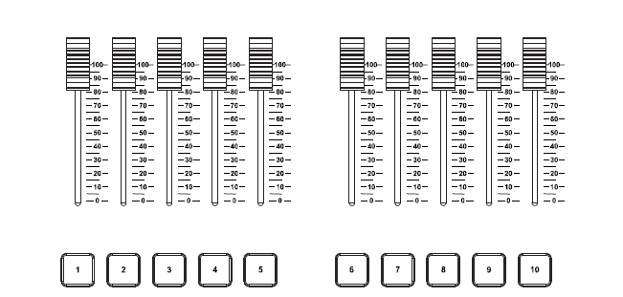
When submasters are assigned, they appear yellow (or whatever other color is assigned via Set description color (Figure 141)), whether that is on the grid, next to the faders, or on the physical buttons. Their text can be changed with Change description (Figure 141). Getting a specific value using the virtual submasters’ text entry or slider is difficult, as the console will attempt to match it with the motorized faders but will then assign the intensity based on where the physical fader is; because the motors are not 100% accurate, this can cause issues. It is instead recommended that the user physically move the faders by themselves. At Tucker, submasters 1-6 work best. The number of submasters is adjustable in Figure 163. All submasters will appear in the Groups (Figure 96) window, as they are a special form of groups. The wheel between the grandmasters and submasters in Figure 138 allows all of the submasters on a given page to change in tandem. Release all submaster control (Figure 80) releases all submaster control.
Figure 140
Physical Submasters
Submasters can also be operated via the command line. Typing [SUB] [1] [@] [100] will put submaster 1 at 100. Pressing the Flash or number buttons at the bottom of the submasters will make them go to their full intensity. Momentary and Latched are described in Figure 96. Keep in mind that the interaction of the toggle in this section and the different options in that section may produce unintended results.
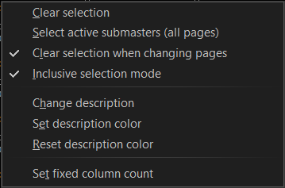
Pressing the Page buttons while on the Grid view will bring the user to the relevant row if far enough: Page 0 will bring the user to 1-9, Page 1 to 10-19, and so on and so forth; on the Fader view, it just changes the page. Page Up and Page Down can also be used to move between the submaster pages — Page Up increases the page number, while Page Down decreases it. The same is true for Page Up and Page Down (Figure 66). Switching between the two views while on a certain page does not move the user from that page.
Figure 141
Submaster popup
Right-clicking on a submaster in the Grid view will produce the popup pictured in Figure 141. Doing so in the Faders view will produce a less-detailed popup that is not pictured here. Because multiple submasters in the grid can be selected at a time, appearing with a red border, Clear selection clears the selection while Select active submasters (all pages) allows to select all of the active submasters. The Clear selection after changing pages does exactly what you would think, and Inclusive Selection Mode works the same as described in Figure 63.
Change description opens a text box (not pictured) allowing the user to edit the submaster's description; these descriptions do not appear in the Groups window (Figure 96). Set description color opens a window (not pictured) that allows the user to change the color in which descriptions appear. Set fixed column count allows the user to change how many columns there are in the submaster grid; doing 10 is the most helpful as it becomes analogous to the fader view. When right-clicking on the Faders view, extra options appear that are not shown here: submasters can be locked to all pages, meaning that they will show up not matter what page the user is on in the Faders view, with Lock/Unlock Submaster to all pages (it also allows for the lock to be removed); while Uncheck all removes the check from the checkbox in the upper left corner of all of the submaster faders. The check box has an unclear function; supposedly, one toggle will allow fixtures to function under Highest Takes Precedence (HTP) rules, while the other will give the submasters precedence by allowing them to hold a fixture’s value at a specific point, but I was not able to replicate that.

Grandmasters
(Figure 142)
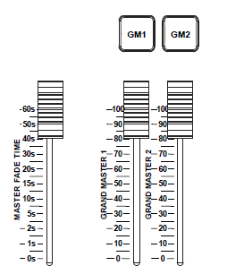
On the side of the Submasters (Figure 138) window, there are two purple faders that control the grandmasters, similarly to how the submasters can be controlled virtually. However, the intention of the grandmasters is to provide control over the entire lighting grid. At Tucker, channel 1 (house lights) is assigned to grandmaster 1 (GM 1), while all of the lighting grid channels are assigned to GM 2. This means that the aisle lights are not controlled by either grandmaster; this is for safety reasons. To record a specific fixture to a grandmaster, the user can either use the Groups (Figure 96) section or select a light and type [RECORD] [GM 1]. When typing [RECORD], a popup appears (Figure 85) that allows the user to click on Specials and then 1 GM 1 or 2 GM 2 to record to the first or second grandmaster window, respectively.
Figure 142
Grandmasters
The buttons at the top are called DBOs, or Dead Black Outs, and depending on settings in Figure 167, send the grandmasters to 0 for blackouts.
Next to the grandmasters, there is a Master Fade Time slider that can change the speed of user-entered lighting changes. It is on somewhat of a logarithmic scale, so it goes from 1 to 60 non-linearly. It does not affect cue or submaster times.

Shortcuts
(Figure 143 & Figure 144)

Figure 143
Shortcut Keys
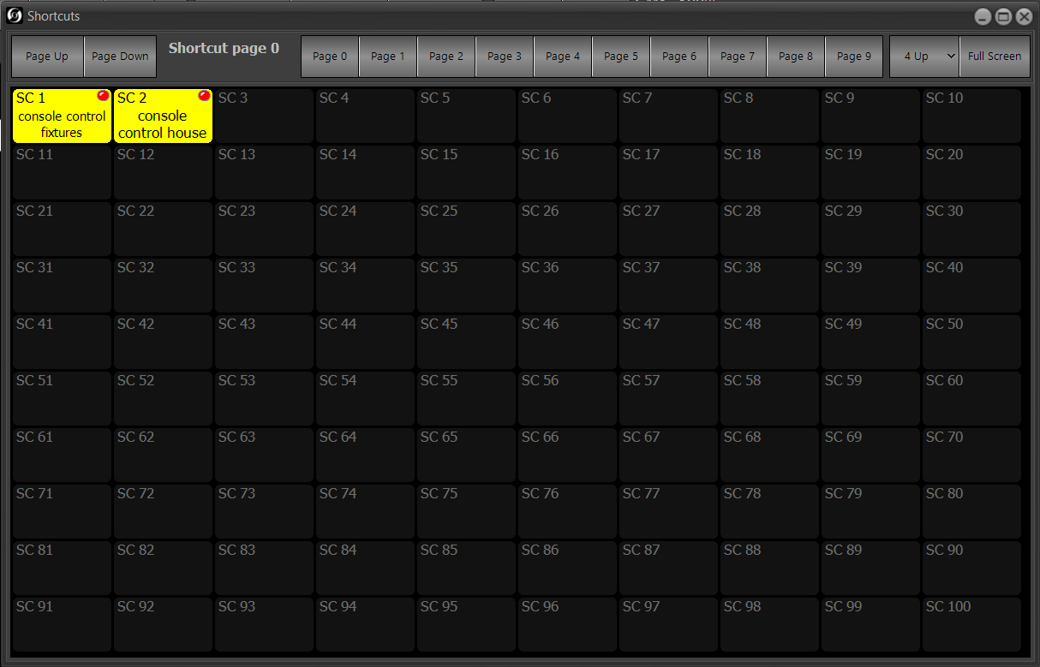
Shortcuts are basically things that make your time at the console quicker. Throughout the guidebook, I’ve written about things that can be assigned to shortcuts. I will not describe the shortcut section’s operation, because it is basically identical to the Submaster section’s (Figure 138) section. Basically, you can assign a task from somewhere that I’ve described, especially the System Properties system shortcuts (Figure 180).
Figure 144
Shortcut Section
- 4 Up divides the section into four quadrants (not pictured).
- Right-clicking pulls up a macro option, which is not useful.
- Use 3D buttons changes the look of the assigned shortcuts to a gradient.
- Set font size does just that,
- Set mode and labels for page allows the 4 Up and normal modes to be set independently for each page — some could have it and others wouldn’t.
- Auto select page based on fixture selected
- Set shortcut grid size does the same thing as in the Submaster section (Figure 138).
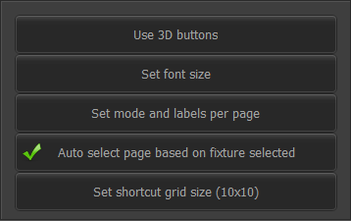
When recording or updating something, the shortcut keys flash white.
Figure 145

More
(Figure 146)
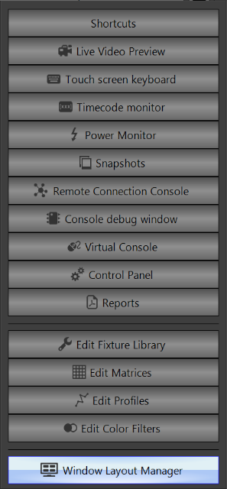
More is where certain extra functions are located, in addition to sections that cannot fit in the bottom row.
Figure 146
Shortcuts is discussed in Figure 143, as the actual console has the buttons in the section screen; More is used for overflow of section buttons.
Live Video Preview opens up a preview of an attached camera but is not applicable to us as we don’t have that; the same is true for Snapshots, which is about images captured via a camera.
Touch Screen Keyboard opens up a touch screen keyboard (not pictured).
Timecode opens up a window, seen in Figure 147, that allows the user to monitor timecode; however, this is not useful for us as we don’t use external triggers. | 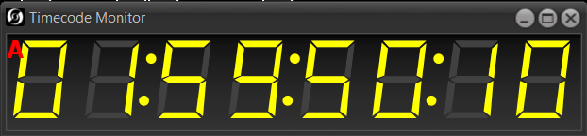  Figure 147  Timecode Monitor
Power Monitor opens up a window, seen in Figure 148, that allows the user to approximate the power usage of selected fixtures, if there is power usage information entered in the channel chart menu (Figure 123). A sum of the selected fixtures’ entered weights will also appear here on the bottom. | 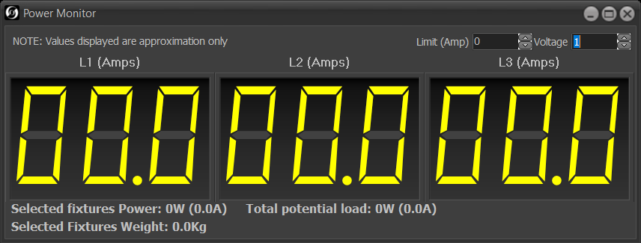  Figure 148  Power Monitor
Remote Connection Console (not pictured) is not necessary at Tucker.
Console Debug Window will open up a window as seen in Figure 149. It has an unclear usage. | 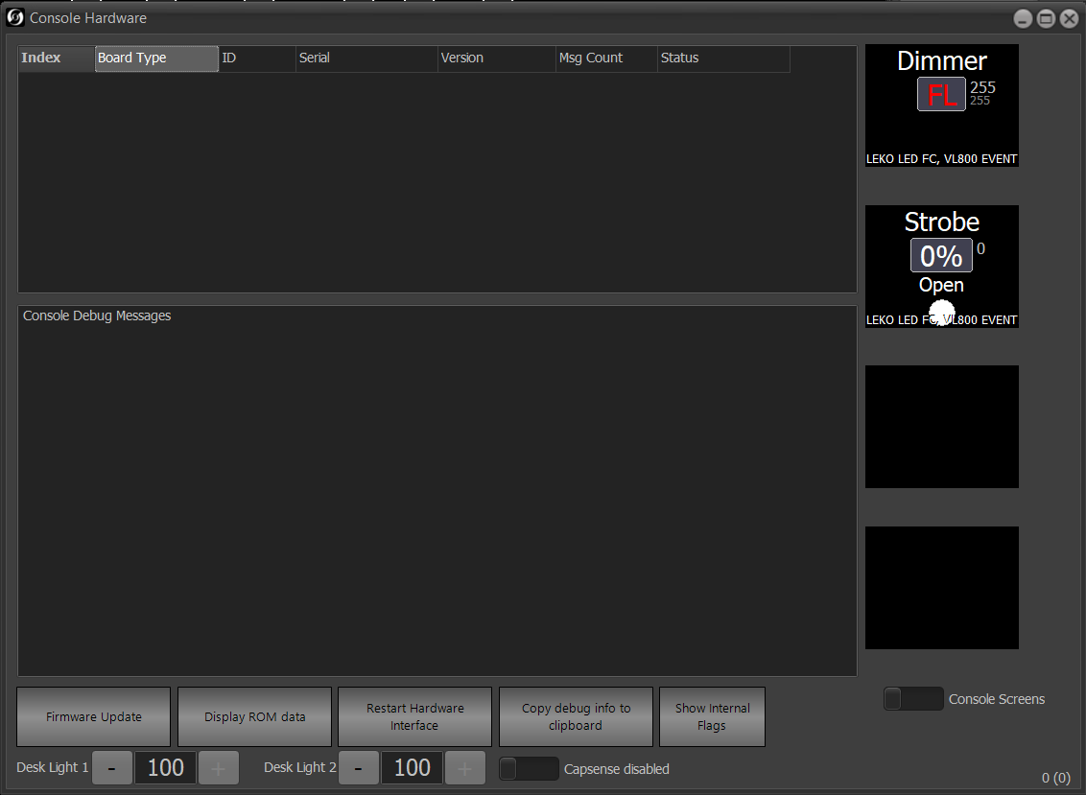  Figure 149  Console Debug Window
Virtual Console will open up a window as seen in Figure 152. This allows the user to access most of the buttons on the console without having to physically press them. There are options (not pictures or described) that allow the user to open a virtual Compact Neo console, which is the smaller version of what we have. | 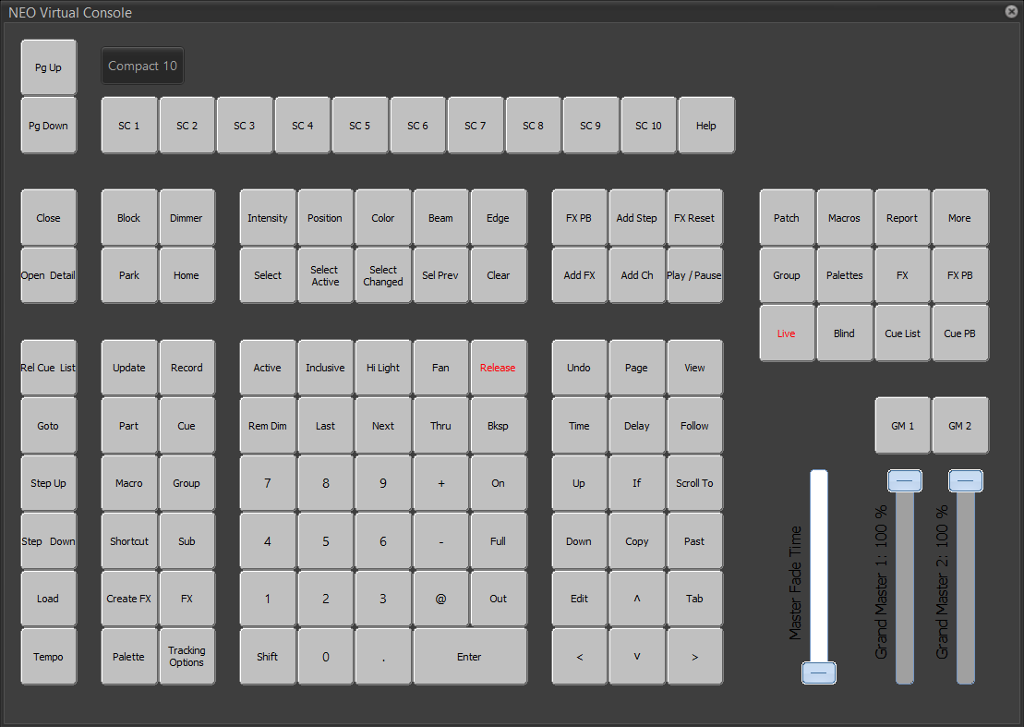  Figure 82  Virtual Console
Control Panel opens windows as described in Figure 156 through Figure 160.

Reports opens a window as seen in Figure 150. All of the buttons open a simple “.pdf” file with certain information, depending on the button selected. This option can also be accessed by clicking Report (Figure 4). | 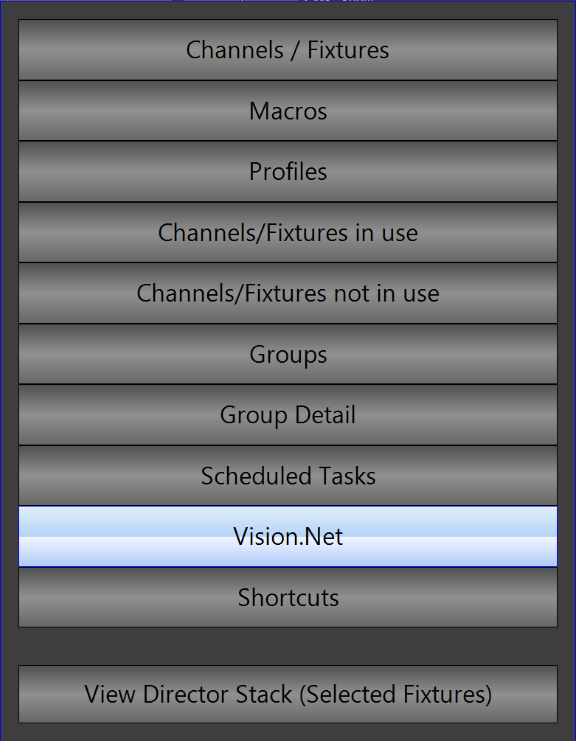  Figure 150  Reports
- Channels / Fixtures is a report of all of the fixtures in the Patch (Figure 123) with all of the data that can fit on a horizontal page, starting with Fixtre andending with Phase.
- Macros is a list of all the macros. Profiles will open up a list of the profiles in the console, along with their pictures, which can be seen in greater detail in Figure 153.
- Channels/Fixtures in use is a report of all of the fixtures that are in use by the currentshowfile, from the cues, submasters, and effects. Channels/Fixtures not in use is the opposite.
- Groups will open up a report of all of the groups in the showfile, while Group Detail will open up a more detailed report.
- Scheduled Tasks is a report of all the scheduled tasks in the showfile, which we don’t use.
- Vision.Net is a report of all the Vision.net related items in the showfile.
- Shortcuts is a report of all the shortcuts in the showfile.
- View Director Stack (Selected Fixtures) opens up a window as seen in Figure 151.
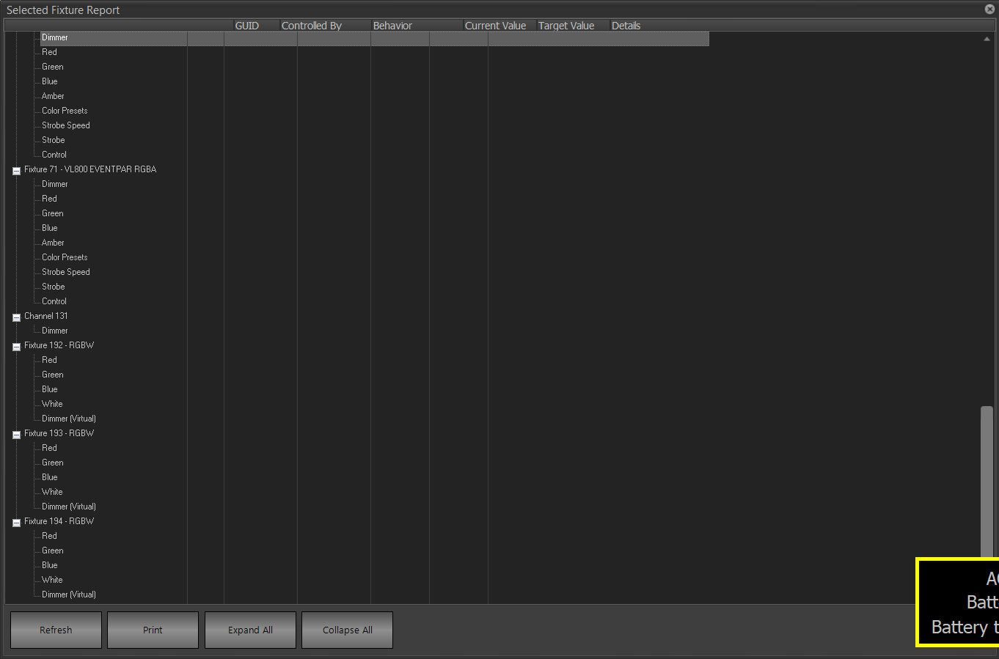
View Director Stack (Selected Fixtures) (Figure 150) opens up a window as shown in Figure 151. It allows the user to see each attribute of each fixture selected in the Live (Figure 21) window.
Figure 151
Director Stack (Selected Fixtures)
- Refresh will refresh the list.
- Print is not useful.
- Expand All will expand all of the attributes of all of the fixtures in the window. Collapse All will do the opposite.
Edit Fixture Library will open a window (Figure 152) that allows the library of fixtures loaded into the console to be edited. This is especially helpful in the Patch section. (Figure 127). A manual for this can be opened from Figure 156, called Fixture Editor Manual. This can be accessed from Edit fixture library (Figure 130) and Fixture Library Editor (Figure 156). A folder of all of the manufacturers on the left can be accessed by clicking Open fixture folder in Figure 160. The manual for this option can be accessed via NEO Fixture Editor (Figure 161). | 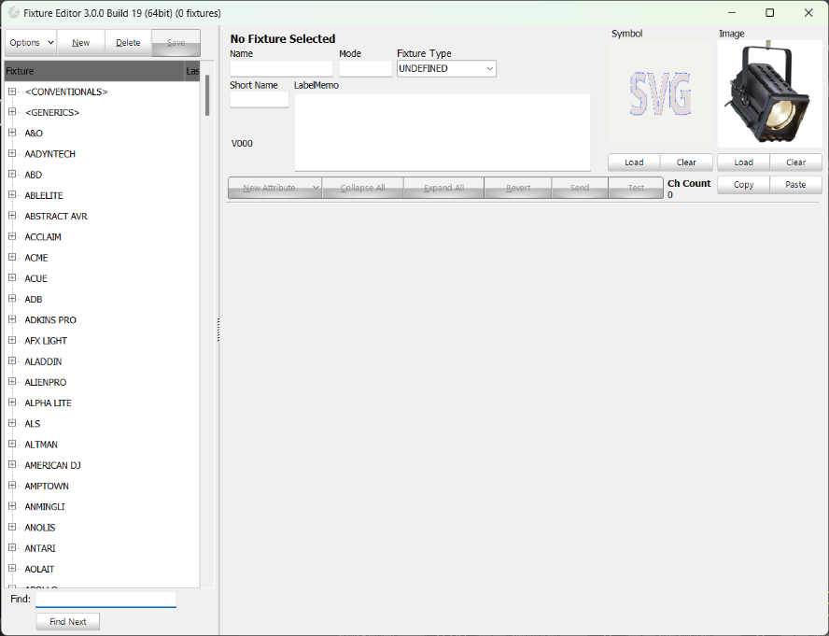  Figure 152  Fixture Library
Edit Matrices is not pictured as matrices are not used here at Tucker.
Edit Profiles (Figure 153) allows the user to edit the dimmer/attribute profile for the light — i.e., the way in which it sends values to be changed — to be changed. Selected profiles are outlined in red. The Channel Chart (Figure 125) is where these can be actually assigned to lights. Both are alphabetized. A report of all the profiles can be seen via the Profiles report (Figure 150).  Create New Profile opens up a window (not pictured) that allows the user to name a new profile. Copy Selected Profile will create a copy of the selected profile with the name ‘Copy of (current profile name).’ Delete Selected Profile will delete the selected profile. Print is not useful. | 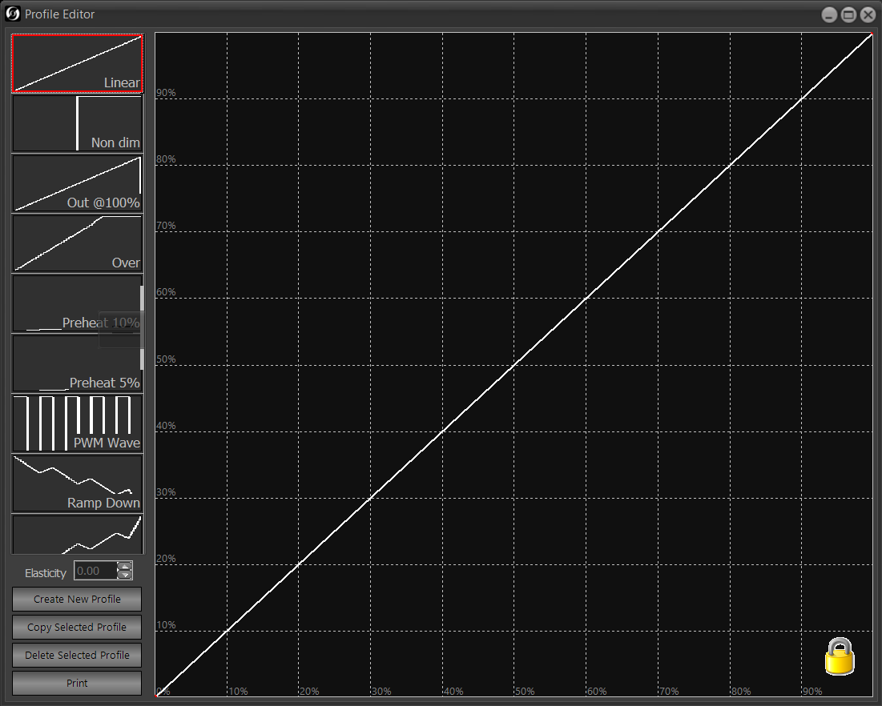  Figure 153  Edit Profiles
Edit Color Filters (Figure 154) allows the user to edit the list of color filters in the console. Before mixable colors, gels had to be attached to lights (and still do, in regard to the spotlights!) but the given filters are a set of color values set to most closely resemble the colors of the gels from days of yore. Selected filters have a dotted outline.  Add opens a window (not pictured) that allows the user to specify a new filter. Edit opens a window (not pictured) that allows the user to edit a selected filter. Remove allows the user to remove a selected filter, which is not recommended. | 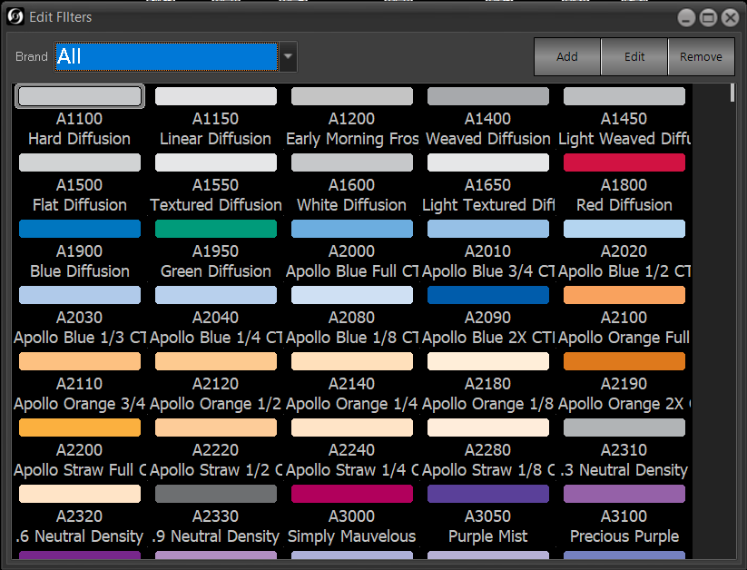  Figure 154  Edit Filters
Window Layout Manager (Figure 146) opens up a window as described in Figure 155. This function is really only useful when there is more than one monitor, which Tucker does not currently have. | 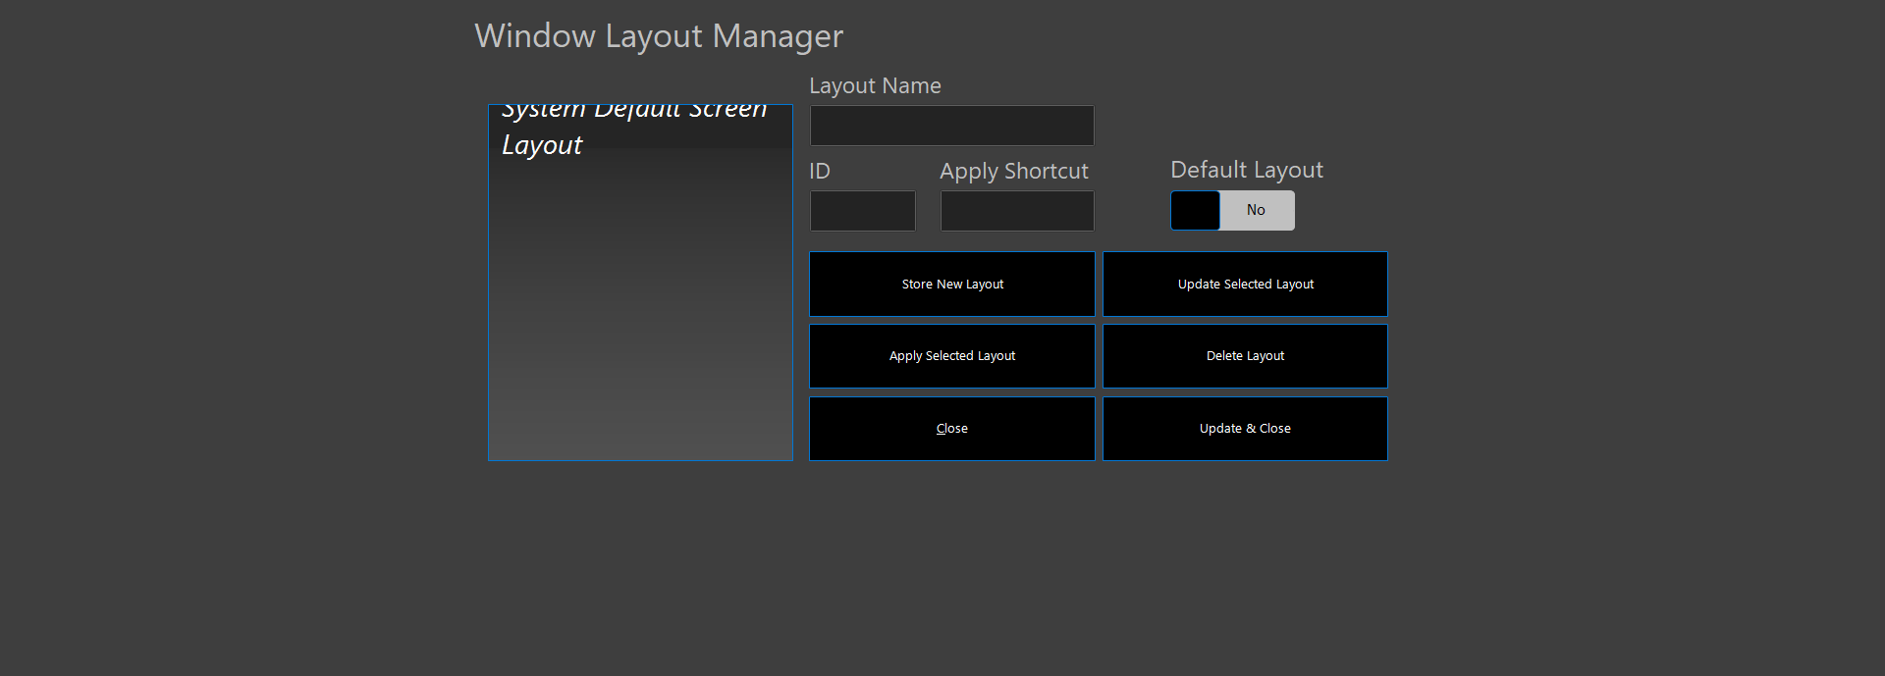  Figure 155  Window Layout Manager

Control Panel
The Control Panel is used for those things that didn’t really fit in anywhere else.
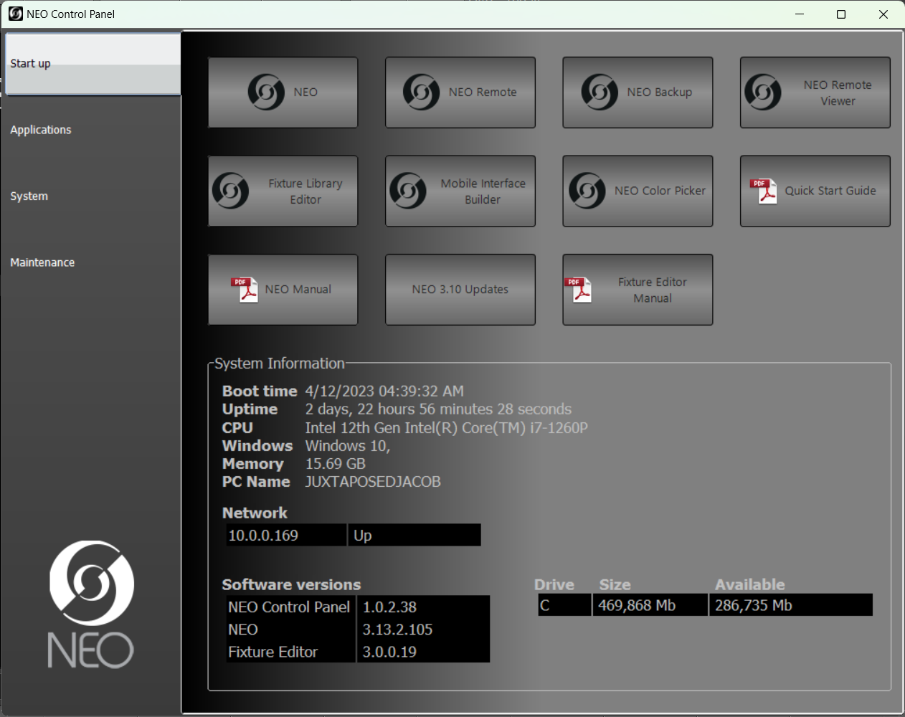
Figure 156
Start Up
- NEO will open up a window (not pictured) that says that they system is already running and the application cannot start once more. This was perhaps the dumbest button to include in the console.
- NEO Remote does nothing of importance for Tucker.
- NEO Backup, I believe, opens up a backup console; however, this is not useful for us.
- NEO Remote Viewer messes everything up. Do not do this.
- Fixture Library Editor will open up a window as seen in Figure 152.
- Mobile Interface Builder is supposed to be able to build a mobile interface for the phone, but that is outside our scope of practice.
- NEO Color Picker opens up a different version (not pictured) of the Generic Color Chooser (Figure 52-Figure 60).
- Quick Start Guide will open up a 2-page ‘.pdf’ document describing simple operations of the lightboard; a printed version of this document was how Jacob initially learned to turn on the console. NEO Manual will open up the 367-page ‘.pdf’ manual, called the NEO user guide, for the lighting console; this guidebook is intended to prevent the user from having to look at that document at all. NEO 3.10 Updates will open a 14-page ‘.pdf’ document with the changes to the software in the newest version. Fixture Editor Manual will open a manual for the Fixture Library (Figure 152).
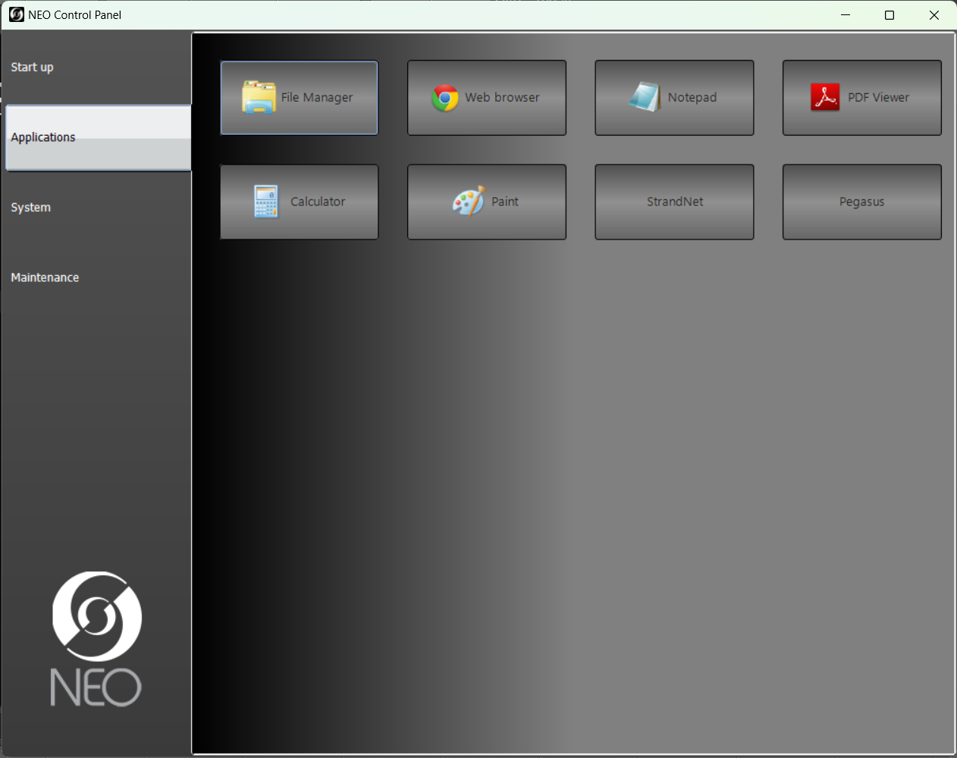
Figure 157
Applications
- File Manager will open up the Windows file manager (not pictured).
- Web Browser will open up Google Chrome (not pictured), which had to be updated when the console was initially received. Upon startup of the browser, http://www.strandlighting.com will open up, which cannot be changed, it seems, from the Google Chrome options menu.
- Notepad will open up Notepad (not pictured), a text editor.
- PDF Viewer will open up the Adobe PDF viewer (not pictured), which does not have to be open for ‘.pdf’ files to be accessed from the console software.
- Calculator will open up the Windows calculator (not pictured).
- Paint will open up Windows paint (not pictured).
- StrandNet will open up StrandNet, which is seen in Figure 158.
- Pegasus will open up the Pegasus software, which allows for the firmware updating of Varilite fixtures, which at the very least include the movers, cycs, and the top lights and could include some of the other fixtures as well.
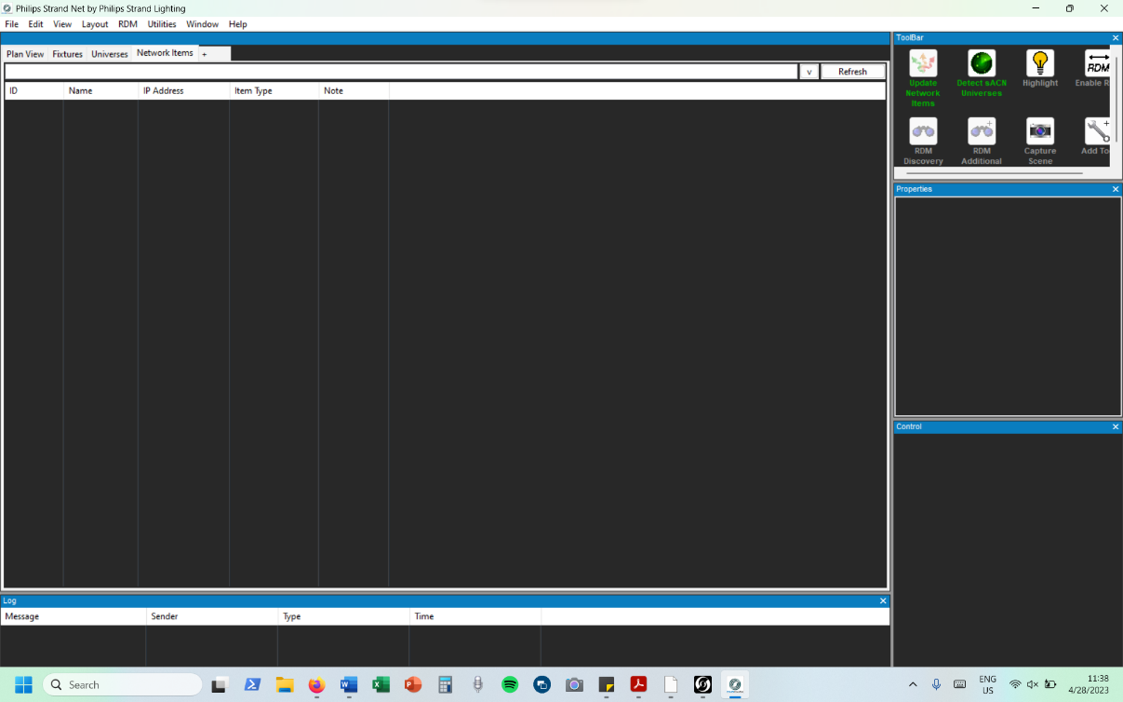
Figure 158
StrandNet

StrandNet is a window that functions somewhat as a network utility; it is where the network nodes, which plug into the stage boxes and can supposedly distribute DMX, can be seen if they are plugged into the network.
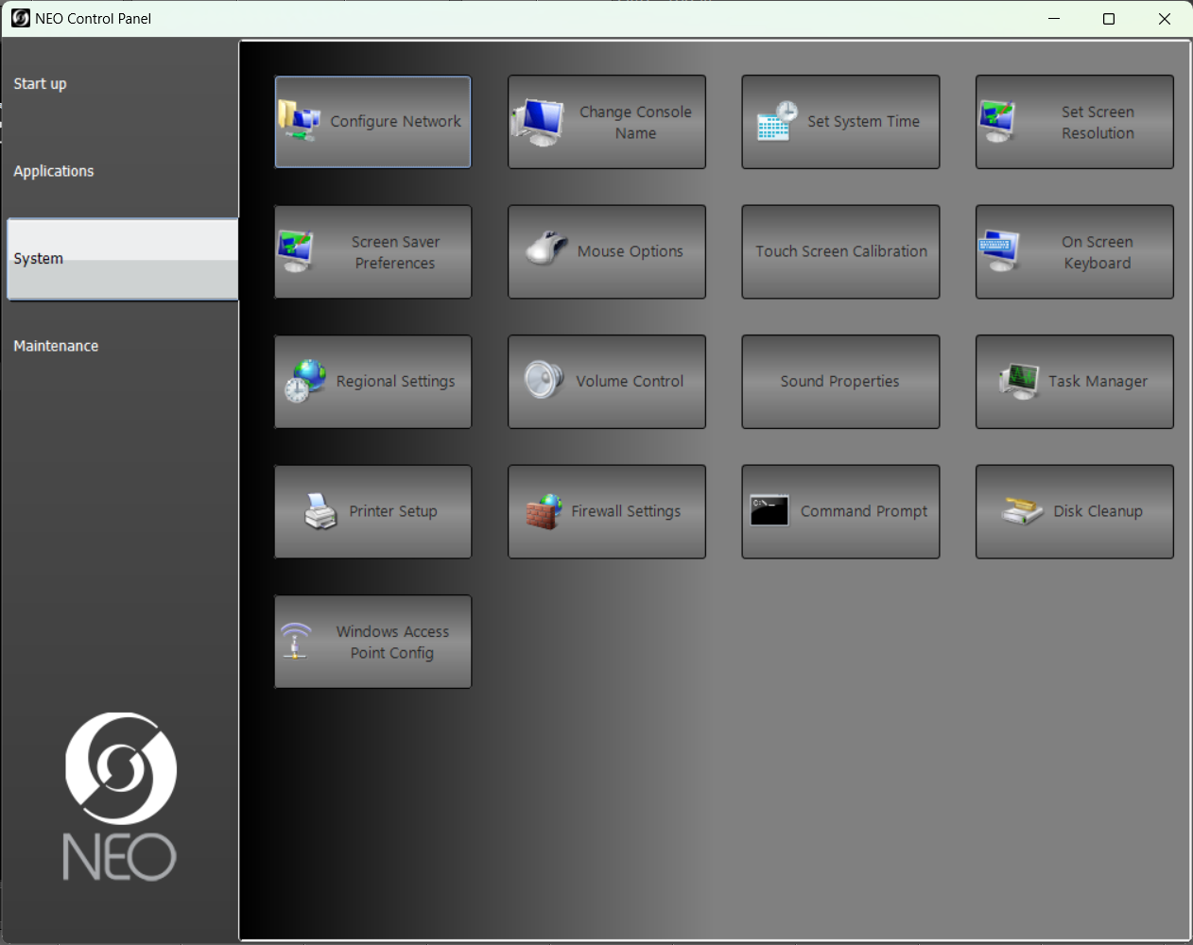
Figure 159
System
All of the functions described here are listed only for searchability as they are identical to those found in standard Windows software. Here they are: Configure Network, Change Console Name, Set System Time, Set Screen Resolution, Screen Saver Preferences, Mouse Options, Touch Screen Calibration, On Screen Keyboard, Regional Settings, Volume Control, Sound Properties, Task Manager, Printer Setup, Firewall Settings, Command Prompt, Disk Cleanup, and Windows Access Point Config.
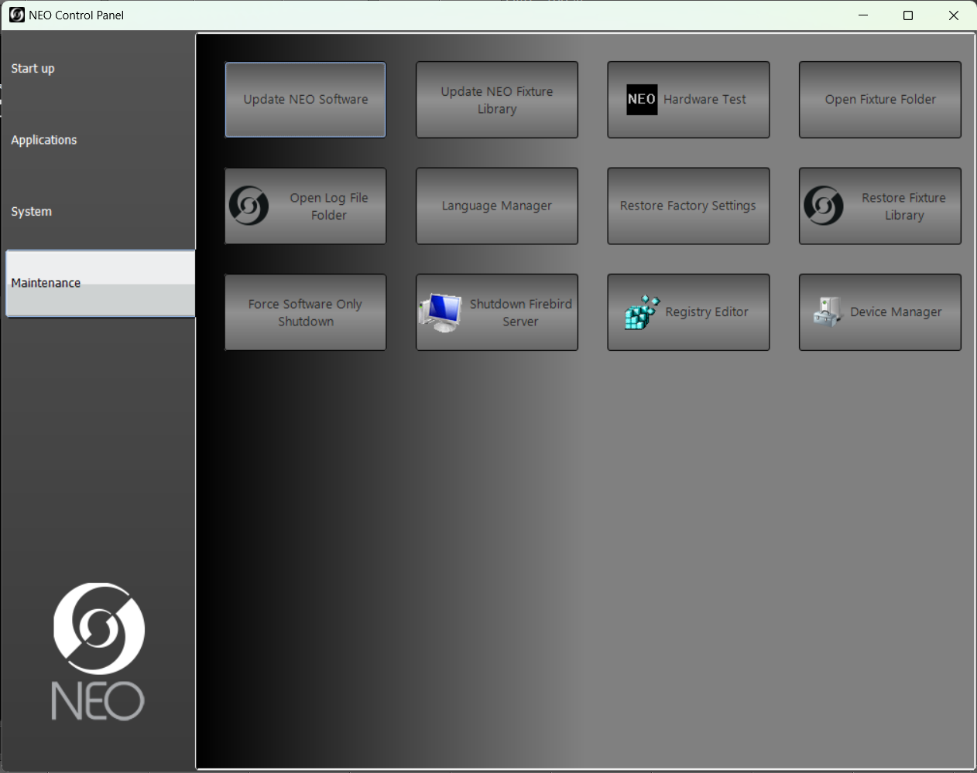
Figure 160
Maintenance
- Update NEO Software allows the user to update the software with a file in the console; the same is true for Update NEO Fixture Library.
- Hardware Test allows the user to test the performance of the hardware, but does not work on the computer; it is unknown if it works on the console.
- Open Fixture Folder will open the folder of all of the fixture manufacturers in the Fixture Library (Figure 152).
- Open Log File Folder is used for tech support.
- Language Manager and Registry Editor are listed only for searchability as they are identical to those found in standard Windows software.
- Restore Factory Settings will restore all settings to default. Restore Fixture Library will do the same, but for the fixture library.
- Force Software Only Shutdown will shutdown the software in anticipation of an update.
- Shutdown Firebird Server will stop the Firebird server so that remote clients cannot connect to the console.
- Device Manager is password-protected and probably dangerous.

Options
(Figure 161)
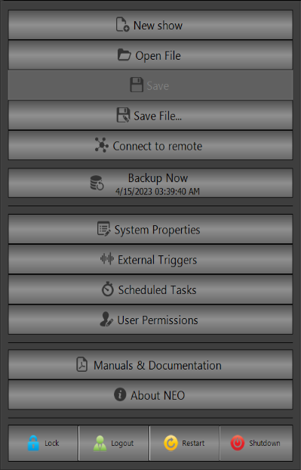
Options is used to access many system management tasks.
Figure 161
Options
- New show creates a new black showfile. This option is not recommended, as making a copy of the default showfile is preferred and will help to transfer most settings and whatnot.
- Open File will allow you to open a different file from a file dialog (not pictured). Trying to open a different showfile while the current one is not saved will prompt a warning (not pictured).
- Save saves the current showfile. Technically, it saves a revision of the showfile, but the old revisions can and should be deleted t save space. Save File allows the user to save the file under a different name and to do more advanced file operations than Save. In either case, Save and Save File are analogous to the operations in Microsoft software.
- Connect to remote is not necessary.
- Backup Now doesn’t need to be pressed all that often; as long as you have scheduled backups in Figure 167, then you should be fine.
- System Properties leads .
- External Triggers leads to a window (not pictured) with the ability to have console events triggered by outside sources, such as Vision.net (related, but not identical to, TOM and the architectural stations), audio via XLR (called “Line-in”), and MIDI, among other things. During my time at Tucker, this never worked, so I don’t want to describe it incorrectly. There are MIDI cables connected between the two consoles in both directions and, of course, a plethora of audio cables.
- Scheduled Tasks could be useful for things like making sure that the console turns on every once in a while to avoid its battery being damaged, but I don’t know how to operate it or if there is even a use case at Tucker.
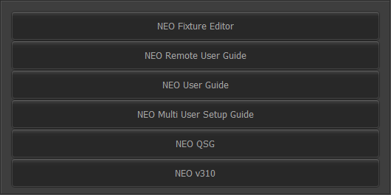
- User permissions could be useful, for example, in trying to protect Mrs. Dyer or someone else from messing with the board. However, its current use is to assign a password to the console — the user can perform all functions when logged in with the account. Clicking on it opens a window (not pictured) that allows the user to do that and to create separate users.
Figure 162
Manuals & Documentation
- Manuals & Documentation opens a window (Figure 162) that allows the user to open various manuals in the console’s ‘.pdf’ viewer app. NEO Fixture Editor is the manual for the Fixture Editor (Figure 152). NEO Remote User Guide & NEO Multi User Setup Guide are not useful. The NEO User Guide can be helpful. The NEO QSG is the 2-page Quick Start Guide, which was used when Tucker 2.0 was built to start the lighting console. NEO v310 describes the changes to the software since the last time the actual manual was updated.
- Lock locks the console. It is highly recommended that the user does not do this, as I have never had success in unlocking the console. Supposedly, the console can be unlocked and locked by pressing Shift Help or maybe by entering a password in Figure 173. Logout logs the user out, requiring a sign-in; for our situation, this is a better solution than the actual Lock. Restart will restart the console, and Shutdown will shut the console down; ensure that the showfile is saved!

System Properties
System Properties is basically the console’s settings. Most of the settings apply regardless of the chosen showfile, but some apply within the showfile. Be sure to click the Advanced toggle at the bottom for advanced settings.
Settings which are unremarked on should not be changed without good reason! I only remarked on things that I thought it would be reasonable to change. The other stuff is just intuitive to have it the way it is, or it’s now too ingrained to change.
System (DMX) – Network/USB (Figure 163) shows all of the different network ports and their inputs and outputs. Number of desk channels can be changed here to increase or decrease the number of channels. Max DMX universes can be used to adjust the number of DMX universes that the console supports; it is not recommended that the user change either of these settings. The Strand Advantage DMX toggle is ON on the console, but on my laptop, it says OFF. Merge DMX input with output and Merge with universe box are described in Figure 166. I took this screenshot on my laptop, so all of the ports and whatnot are incorrectly displayed, but the general idea is that all of the DMX universes are listed as running over sACN. The information here, in general, should not be changed. | 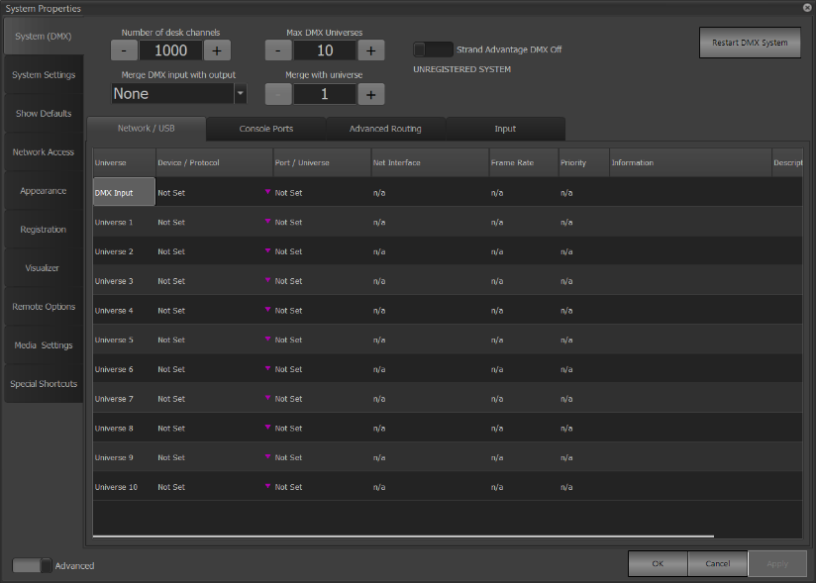  Figure 163
System (DMX) – Console Ports (Figure 164) does the same thing as System (DMX) – Network/USB (Figure 163), but for the physical DMX ports on the console.  Console Settings is used to control the hardware of the console; all levels here go from 1-100. Desk Light 1 and Desk Light 2 control the attachable desk lights. Backlight Level governs the key backlight level. Encoder Backlight Level does the same, but for the 4 encoder screens on the right side of the console. Fan Speed controls the fan speed, which is separate from the motherboard fan. I am not sure what Compact Display Brightness controls. | 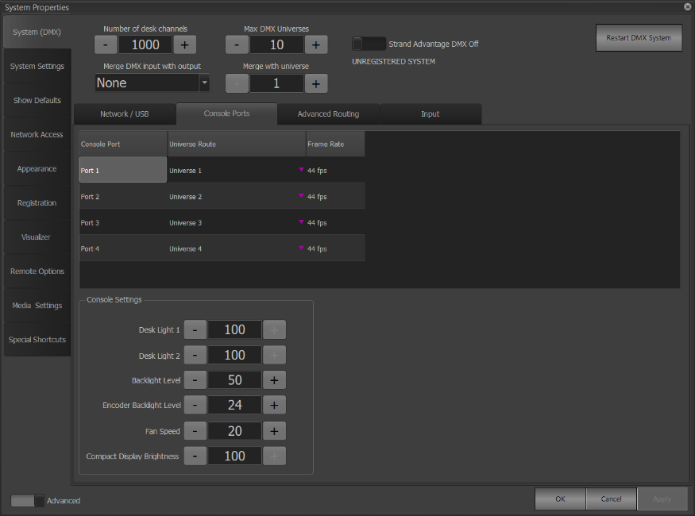  Figure 164
System (DMX) – Advanced Routing (Figure 165) can be used to make complex routes for DMX; this is not necessary at Tucker. | 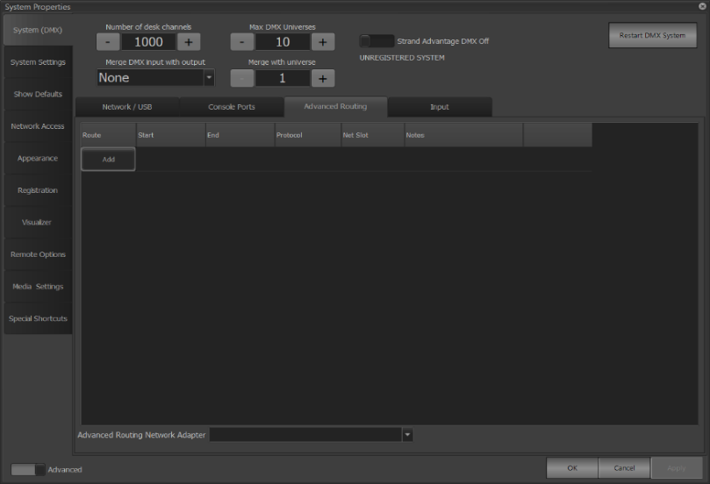  Figure 165
System (DMX) – Input (Figure 166) governs the behavior of the DMX Input port on the console, which is not used at Tucker.  Merge DMX input with output (Figure 163) gives options for how the DMX input and output would be merged; the Merge with universe box (Figure 163) describes what universe the DMX input would output on. | 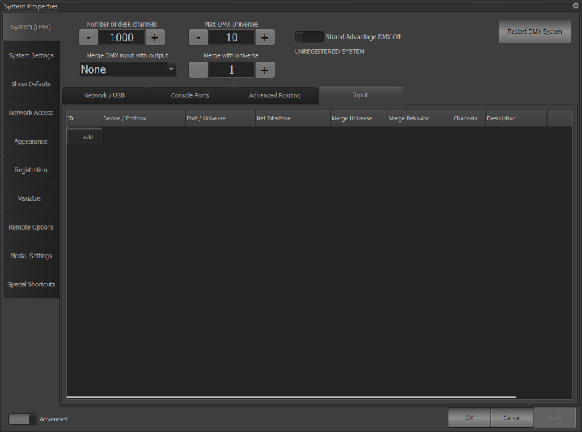  Figure 166
System Settings – Basic (Figure 167):  The On Level changes the intensity that On (Figure 63) changes lights to.  The Up / Down Level governs how much Up & Down (Figure 67) go. Grand Master Submaster has an unclear function. A/B Fader Mode is a dropdown (not pictured) with four options:  - Disabled is what we normally have it at – the A/B faders do nothing.  - PB Master + Disabled has the left fader controlling the cue list intensity, with the right one disabled.  - PB Master + Crossfader has the left has the left fader controlling the cue list intensity, with the right crossfading between cues (up for one crossfade, down for another).  - Cue List Split Crossfader has the left side making intensities go up, while the right hand makes the intensities go down. Again, it switches back and forth.  The grandmaster bump buttons (Figure 142) are governed under GM1 Button and GM2 Button.  - Disabled turns them off.  - DBO Momentary requires them to be held until they are let go and move themselves back up.  - DBO Latch allows the user to press once and let go before having to manually raise them.  - Stop Attributes stops all attributes from changing.  - Full Momentary means all outputs are set to 0 momentarily.  - Full Latch is DBO Latch but with all outputs being set to 0.  Command syntax help is not really necessary, but it’s nice to have. | 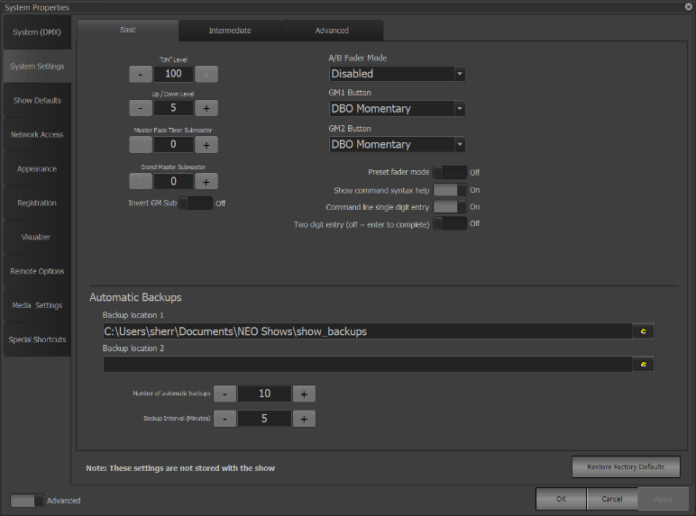  Figure 167
System Settings – Intermediate (Figure 168) governs wheel and fine movement sensitivity. It also governs the number of submaster pages (Figure 140). | 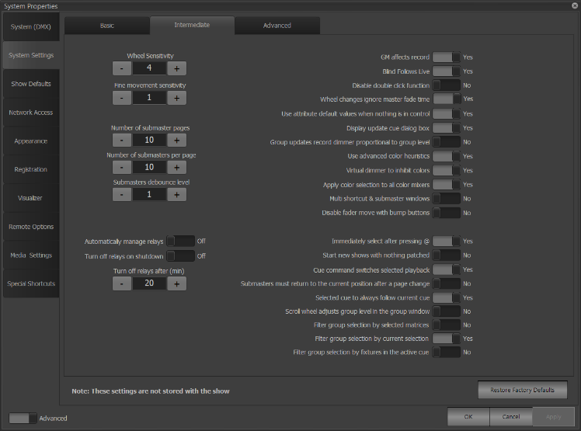  Figure 168
System Settings – Advanced (Figure 169):  Do not change any of the left-side values, as there are networking and computer power reasons for those numbers. Make database file smaller and Purge cue update history should be done every once in a while. | 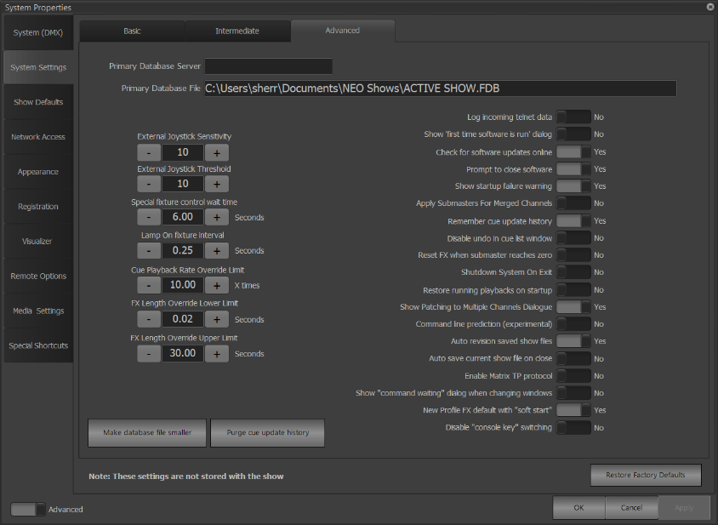  Figure 169
Show Defaults – Cue Lists (Figure 170) has the defaults for a bunch of things. If needed, they can be changed, but I think that the values that they have are a good starting point. It likes to switch Default Tracking Record Mode back to Tracking every once in a while, so make sure that it is on Cue Only. | 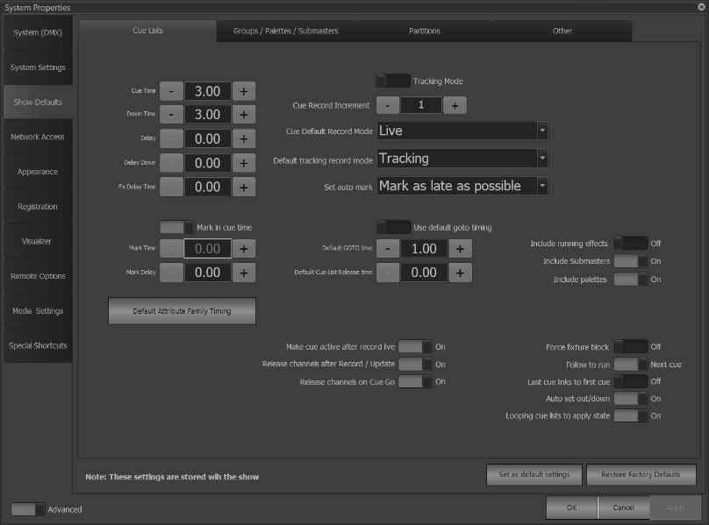  Figure 170
Show Defaults – Groups / Palettes / Submasters (Figure 171) also has good defaults | 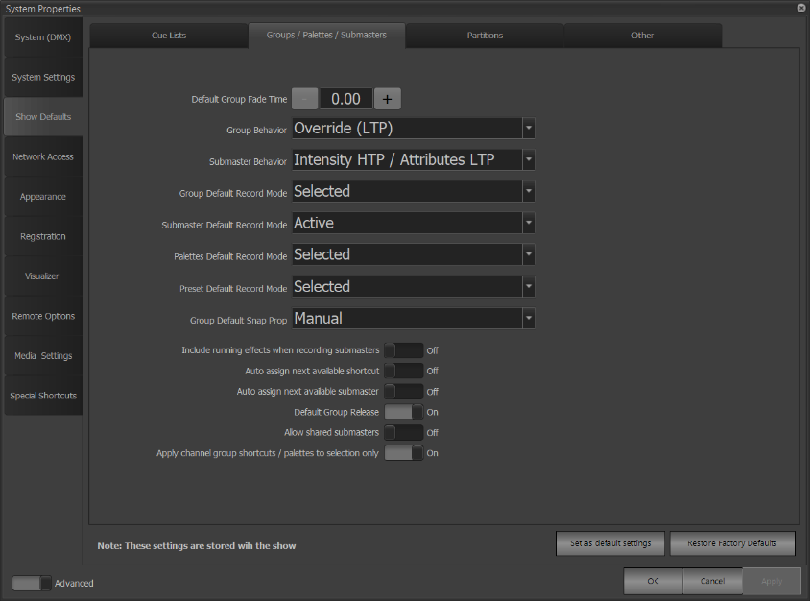  Figure 171
Show Defaults – Partitions (Figure 172) is not necessary for Tucker, as it used to have two or more consoles on the same network control different subsets of lights. | 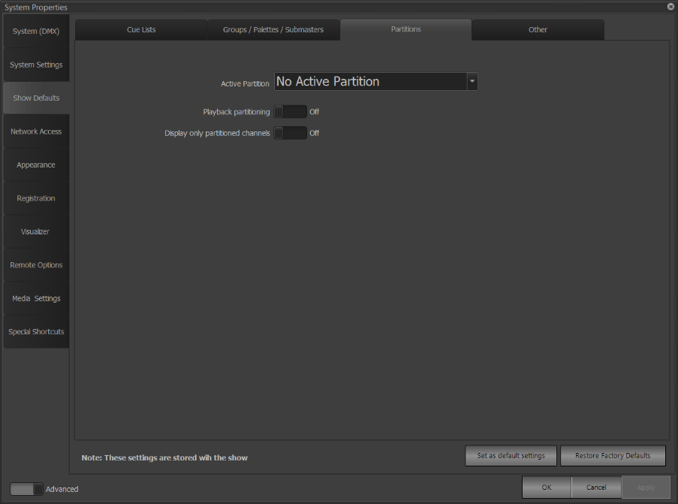  Figure 172
Show Defaults – Other (Figure 173) has nothing, except perhaps the Lock Code. | 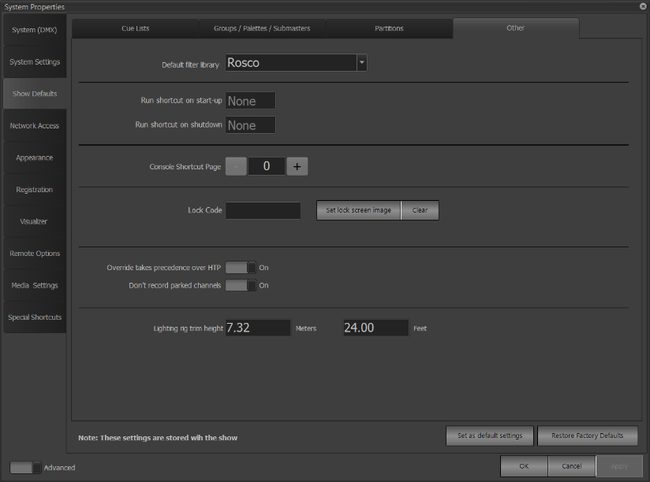  Figure 173
Network Access (Figure 174) has nothing really notable. | 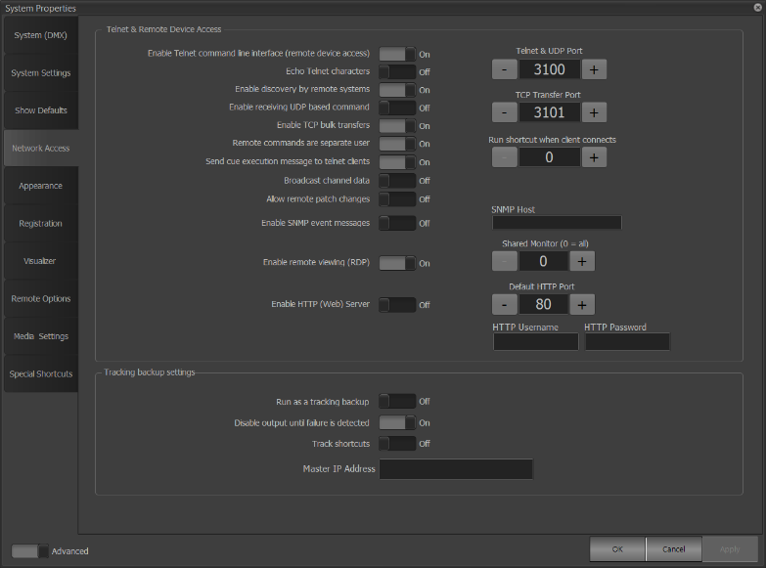  Figure 174
Appearance – Channel Display (Figure 175) has nothing that really needs to be changed. | 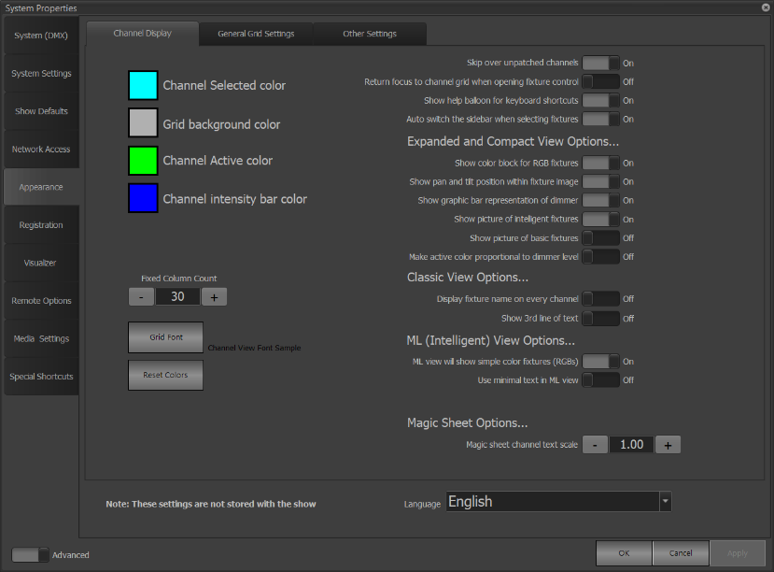  Figure 175
Appearance – General Grid Settings (Figure 176) is the same as Channel Display. | 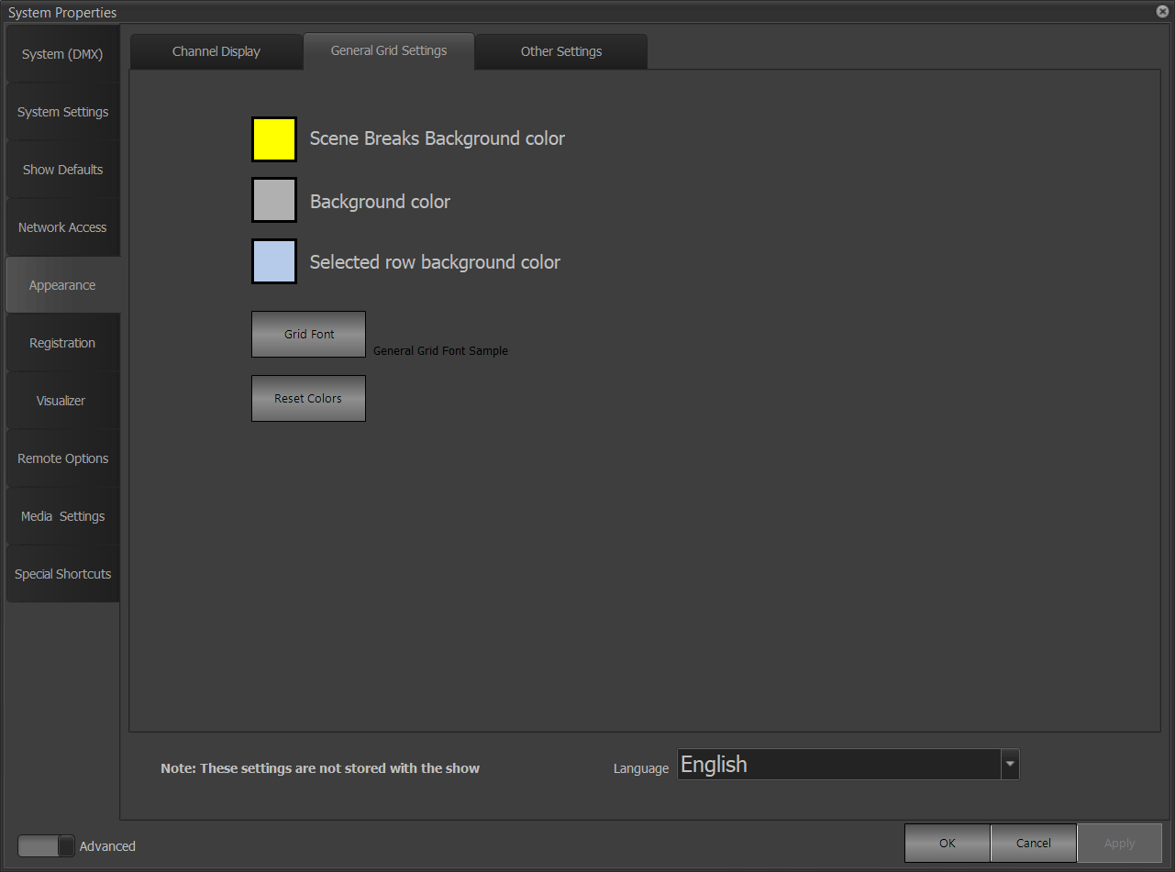  Figure 176
Appearance – Other Settings (Figure 177) is the same as the previous two. | 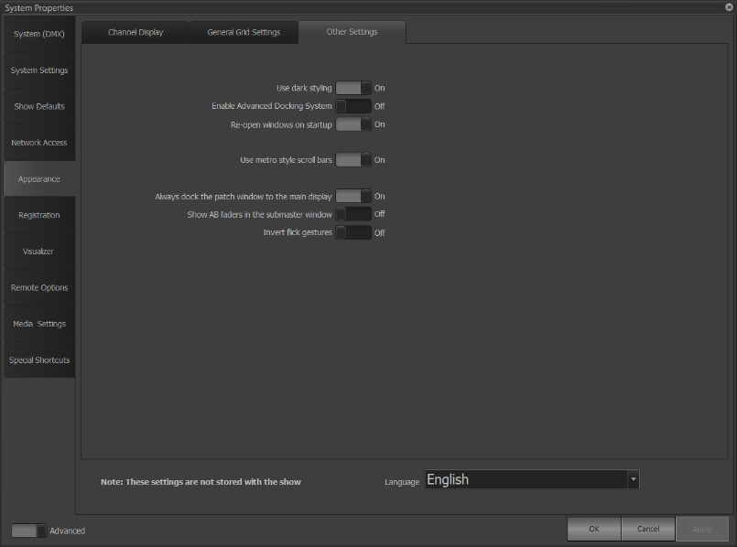  Figure 177
Remote Options (Figure 178) is used to connect to remote consoles and control systems and is not useful here at Tucker. | 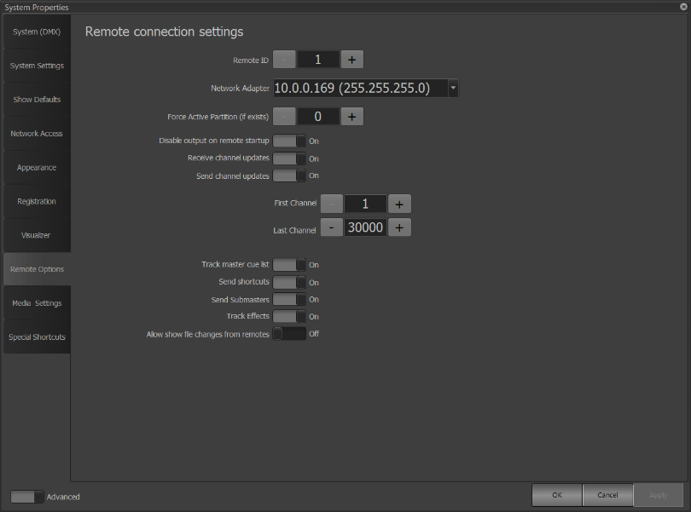  Figure 178
Media Settings (Figure 179) is not useful here at Tucker as we do not use the console as a media server; audio control is located at Volume Control & Sound Properties (Figure 159). | 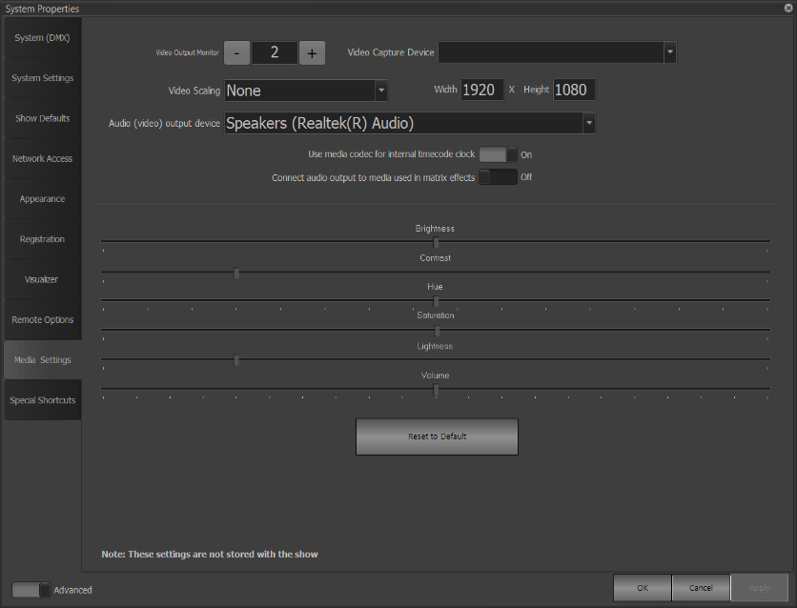  Figure 179
Special Shortcuts (Figure 180) are pre-made shortcuts, initially assigned to the non-existent shortcut 0, whose shortcut number name can be changed to be able to access the associated functions. | 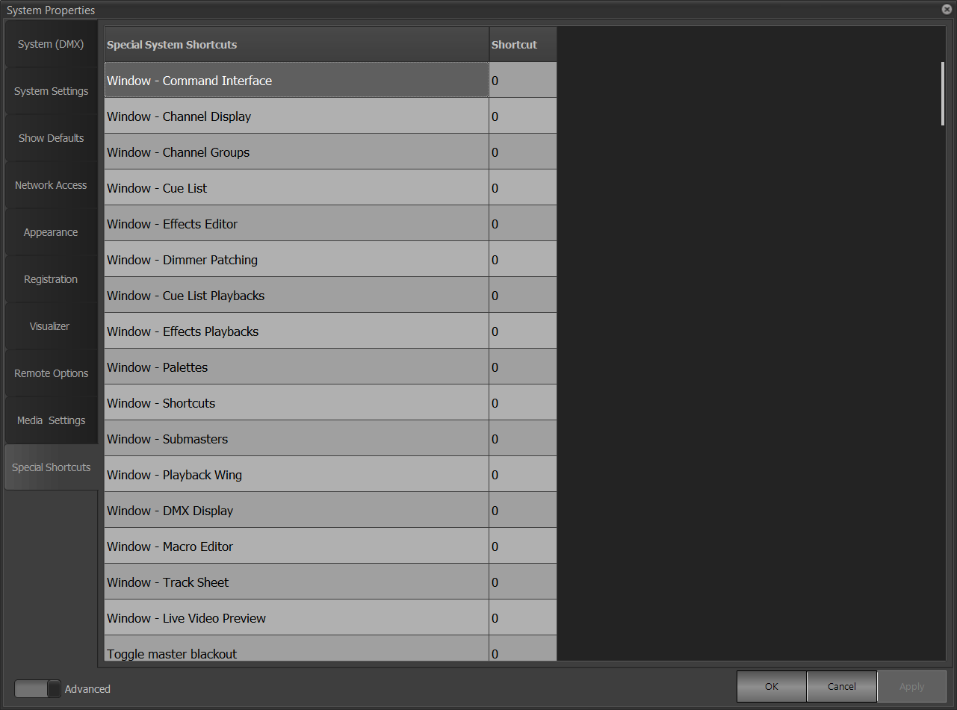  Figure 180

I know what I want to do; how do I do it?
Except for turning the board on and off, these operations are not annotated in order to avoid clunkiness

Turning the board on and off
- The lighting board can be turned on using the switch on the rear of the board on the right. Once you have typed in and confirmed the board’s password, you may begin programming!
- To turn the board off, ensure that all applications are closed. Then, hit Options. Hit Shutdown and then Yes when asked to confirm. Finally, wait for one of the four small screens next to the silver encoder wheels to say Safe to power down system. The board can then be turned off with the same switch.

Creating a new showfile
- Go to Options and click on Save to save the file that you are currently in. Then, use the Open File option to open “JRT Default Show.NEO.”
- Go to Options, then Save File. In the dialog box that opens, type the name of your show with the keyboard. Hit Enter. This makes a copy of the default show file.
- Click on the Live button. Click on the View button to select the Magic Sheet view. Right-click anywhere on the large black area to get a dropdown menu with four options. Select Import sheet from file. Navigate to Documents, and select the file entitled “Default Magic Sheet.MSF.”

Starting a new show
- Take your newly created showfile. Make sure to have a script with you and plan out what you want the lights to look at during different points in the show, either with or without the help of Mrs. Dyer or an outside group. Start identifying cues, and what will “cue” your cue. Start adjusting fixtures to make them look like how you want, including the use of the FX Library — make sure to use TOM to turn the fixtures on and off each evening— and record them into cues. Easier shows can use a set of submasters. Cues can be copied by recording the same cue multiple times with different numbers.

Operating a show
- Be creative about using grandmasters, bump buttons, DBOs, master fade times, crossfades, and cues to achieve the show that you want. Cue times can be adjusted, as can many other things.

Maintenance
- Make sure that you’re taking care of the equipment, especially virtually. Everyone knows how to treat things nicely, but not everyone knows how to keep an online space neat.

Index

A
Active Select Mode, 45
attributes, 8
B
Beam, 37
Behavior, 68
Blind, 59
Block, 44
C
Classic, 24
Color Filters, 40
Copy, 58
CTO, 36
Cue List, 66
cue-only, 32
D
DBO, 90
DEFAULT_PATCH.csv, 83
desk channel, 8
dimmer/attribute profile, 97
dipswitches, 8
DMX section, 87
E
Edge, 38
electrics, 8
Encoder wheels, 33
F
fader, 88
Fan, 43
Frames, 49
framing., 38
Frost, 38
G
Generic Color Chooser, 39
generic palettes, 74
gobo, 37
grandmasters, 90
Green Shift, 36
Groups, 60
GUI, 9
H
High light, 43
home, 53
I
Inclusive Mode, 46
intensity, 8
Iris, 38
L
light abreviations and meanings, 36
Load, 42
low light, 43
M
Macro, 53
macros, 86
Magic Sheet, 24
Mark, 32
Master Fade Time, 90
Matrix, 29
MIDI, 10
N
network nodes, 101
O
Override (LTP), 68
P
Pan, 35
Part, 52
Patch, 77
pixel mapping, 29
playback faders, 42
playbacks, 84
Position, 79
Prism, 37
Purpose, 79
R
RDM, 81
Record, 52
Record Cue, 54
recording mode, 32
Recording types, 32
Rem Dim, 43
S
specific palettes, 74
Strobe, 34
Submasters, 88
T
Tilt, 35
timecode, 22
Timecode, 92
tracking, 44
U
Update, 52
Update Cue, 54
V
Vision.net, 8
Visualiser, 70
Z
Zoom, 38

